EPPO Datasheet: Potato yellowing virus
Last updated: 2018-07-27

IDENTITY
Preferred name: Potato yellowing virus
Taxonomic position: Viruses and viroids: Riboviria: Orthornavirae: Kitrinoviricota: Alsuviricetes: Martellivirales: Bromoviridae: Ilarvirus
Other scientific names: PYV, Potato yellowing alfamovirus
view more common names online...
EPPO Categorization: A1 list
EU Categorization: A1 Quarantine pest (Annex II A)
view more categorizations online...
EPPO Code: PYV000

Notes on taxonomy and nomenclature
Name: Potato yellowing alfamovirus
Taxonomic position: Viruses: Bromoviridae: Alfamovirus
Common names: PYV (acronym)
Notes on taxonomy and nomenclature: Alfalfa mosaic alfamovirus (AMV) itself infects potato, in South America and elsewhere (Dunez, 1988). PYV (originally designated as strain SB-22) is distinct from it serologically. There is also an Andean potato yellowing virus, mentioned by Valkonen et al. (1992a). It should be noted that information on PYV, a very recently described virus, remains incomplete. This is reflected in the relative lack of detail that can be provided in this data sheet.
EPPO computer code: POYEXX
EPPO A1 list: No. 220
EU Annex designation: I/A1

HOSTS
PYV infects potatoes (Solanum tuberosum), and various wild Solanum spp. Other species can be artificially infected: Capsicum annuum, Datura metel, D. stramonium, tobacco (Nicotiana rustica), tomatoes (Lycopersicon esculentum and L. pimpinellifolium), Nicandra physalodes,, Nicotiana benthamiana and Physalis floridana.
Host list: Capsicum annuum, Physalis peruviana, Smallanthus sonchifolius, Solanum fernandezianum, Solanum phureja, Solanum quitoense, Solanum tuberosum, Solanum

GEOGRAPHICAL DISTRIBUTION
EPPO region: Absent.
South America: Chile (Valkonen et al. (1992a), Peru (Fuentes & Jayasinghe, 1993).
EU: Absent.
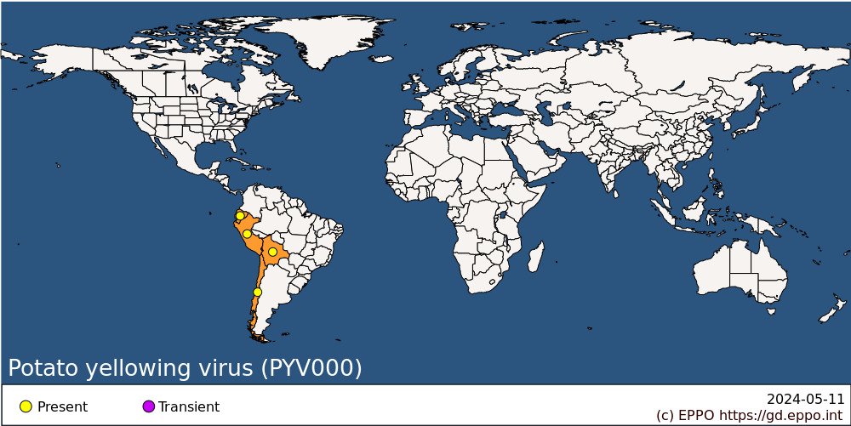
South America: Bolivia, Chile, Ecuador, Peru

BIOLOGY
PYV is transmitted semi-persistently by Myzus persicae,, and through true seed of Physalis floridana, Solanum tuberosum and Capsicum annuum (Valkonen et al., 1992b). Infected seeds germinate poorly.

DETECTION AND IDENTIFICATION

Symptoms
Some infected potato cultivars show yellowing symptoms, and a few react very strongly (see Indicator plants). Other potato cultivars are symptomlessly infected.

Morphology
PYV is a bacilliform virus similar to alfalfa mosaic alfamovirus (Jaspars & Bos, 1980). Particle size ranges from 21 to 368 nm, with a mean diameter of 25 nm. Five types of particles can be distinguished in purified preparations, the predominant size being 21-60 nm. Light and electron microscope studies of infected leaves of potato and P. floridana show the presence of inclusion bodies in epidermal and mesophyll cells. These inclusions are amorphous, of variable size and very stable and numerous in the host tissue.

Detection and inspection methods

Indicator plants
PYV can be transmitted to several indicator plants (e.g. Physalis floridana) (see Hosts). Clone DTO 28 and cv. Mariva of S. tuberosum react with yellowing of the foliage, followed later by necrosis and death of the plant.

Serological detection methods
Since PYV can be distinguished serologically from AMV, it can be detected serologically. DAS-ELISA has been used to test seeds.

PATHWAYS FOR MOVEMENT
PYV is transmitted locally by aphids. In international trade, it could be carried by potato tubers or by true seed of germplasm material.

PEST SIGNIFICANCE

Economic impact
PYV has been found in field samples of potato from Peru, at different localities, with up to 88% infection of the samples. Incidence was higher in the Peruvian highlands than at the coast. The original isolation was from symptomless potato cv. Ticahuasi. PYV causes yellowing symptoms on some potato cultivars and can thus be presumed to be harmful. However, there is no specific information on effects on yield. On artificial hosts, the symptoms it causes are often less severe than those caused by AMV.

Control
As with all potato viruses, control depends on the production of high-quality seed potatoes from virus-free nuclear stock.

Phytosanitary risk
PYV has recently been added to the set of non-European potato viruses of the EPPO A1 quarantine list (OEPP/EPPO, 1984a). In general all regional plant protection organizations outside South America recommend very strict measures for potato material from that continent. The principal perceived risk is the introduction of new viruses into seed-potato production schemes, increasing the cost and difficulty of operating these schemes, and opening up new possibilities for yield losses from single or mixed virus infections. Any seed-potato-exporting country in which PYV was reported would immediately find itself in difficulties with respect to the phytosanitary certification of its exports. The risk is particularly important because of the simple pathway which exists from useful germplasm material (local potato cultivars, wild tuber-forming Solanum spp.) in the potato's centre of diversity in South America through to nuclear stock material of new cultivars in seed potato-producing countries. Thus there is a great risk of introduction due to the increased international exchange of breeding material and germplasm, whether in the form of tubers, rooted cuttings, in vitro cultures or true seeds.
Individually, PYT could be regarded, among the group of South American potato pathogens, as of rather moderate importance for the EPPO region. It would probably have little direct economic effect, like the related AMV (which is not regarded as an important potato virus). It is, however, transmitted by true seed. The International Potato Center in Peru regards it as an important virus which should be considered as a quarantine pest. Though it can relatively easily be excluded by prohibition of commercial trade in potato tubers, there is a risk of introduction with breeding material, in which it could only be detected by careful testing under quarantine. The addition of PYV to the EPPO A1 quarantine list reflects the continued vigilance which is needed with respect to the new viruses which are still being discovered infecting potato in South America (Jeffries et al., 1993).

PHYTOSANITARY MEASURES
Importation of potato tubers from countries where PYV occurs should be prohibited. PYV is one of the group of South American pests of potato which justify strict post-entry quarantine procedures in the EPPO region, together with equivalent checks before export. Only material for scientific purposes, in quantities limited to what is strictly necessary and subject to import permit, should normally be imported from countries where PYV occurs. Because of the probability that any material of wild tuber-forming Solanum spp. originates ultimately from South America, the same tests should be applied whatever the origin. EPPO's specific quarantine requirements (OEPP/EPPO, 1990) outline suitable quarantine measures, while EPPO's phytosanitary procedures lay down the test procedures to be followed both before export and in post-entry quarantine after import (OEPP/EPPO, 1984b).

REFERENCES
Dunez, J. (1988) Alfalfa mosaic virus. In: European handbook of plant diseases, pp. 68-69. Blackwell, Oxford, UK.
Fuentes, S.; Jayasinghe, U. (1993) [Potato yellowing, caused by a new bacilliform virus]. Fitopatología 28, 22-37.
Jaspars, E.M.J.; Bos, L. (1980) Alfalfa mosaic virus. CMI/AAB Descriptions of Plant Viruses No. 229. Association of Applied Biologists, Wellesbourne, UK.
Jeffries, C.J.; Chard, J.M.; Brattey, C. (1993) Coping with plant health risks posed by gene bank collections of potato. In: Plant health and the European Single Market, pp. 145-156. British Crop Protection Council, Farnham, UK.
OEPP/EPPO (1984a) Data sheets on quarantine organisms No. 128, Potato viruses (non-European). Bulletin OEPP/EPPO Bulletin 14, 11-22.
OEPP/EPPO (1984b) Quarantine procedures No. 21, Potato viruses (non-European) and potato spindle tuber viroid. Bulletin OEPP/EPPO Bulletin 14, 73-76.
OEPP/EPPO (1990) Specific quarantine requirements. EPPO Technical Documents No. 1008.
Valkonen, J.P.T.; Contreras, A.; Pehu, E.; Salazar, L.F. (1992a) Naturally occurring viral infections in Solanum brevidens and S. fernandezianum. Potato Research 35, 411-417.
Valkonen, J.P.T.; Pehu, E.; Watanabe, K. (1992b) Symptom expression and seed transmission of alfalfa mosaic virus and potato yellowing virus (SB-22) in Solanum brevidens and S. etuberosum. Potato Research 35, 403-410.

How to cite this datasheet?
EPPO (2024) Potato yellowing virus. EPPO datasheets on pests recommended for regulation. Available online. https://gd.eppo.int

