EPPO Datasheet: Phyllocoptes fructiphilus
Last updated: 2024-05-15

IDENTITY
Preferred name: Phyllocoptes fructiphilus  Authority: Keifer  Taxonomic position: Animalia: Arthropoda: Chelicerata: Arachnida: Acarida: Eriophyidae  view more common names online...  EPPO Categorization: A1 list  EU Categorization: Emergency measures  view more categorizations online...  EPPO Code: PHYCFR | 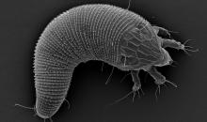  more photos...

Notes on taxonomy and nomenclature
Phyllocoptes fructiphilus, known as the rose bud mite, is a species of eriophyoid mite known primarily for its role in the transmission of Emaravirus rosae (rose rosette emaravirus, RRV), a significant pathogen in roses and the causal agent of rose rosette disease (RRD). There is also a second vector of RRV, a taxonomically distinct species of the same genus, P. arcani (Druciarek et al., 2023).

HOSTS
The native host plant for P. fructiphilus is Rosa woodsii, a rose species common in the western Great Plains and in arctic regions of North America (Amrine, 2014). Other reported host species include: Rosa arkansana var. suffulta, Rosa carolina, Rosa clinophylla, Rosa foliolosa, Rosa glauca, Rosa multiflora, Rosa nitida, Rosa palustris, Rosa roxburghii, Rosa rubiginosa, Rosa rugosa, Rosa setigera, and Rosa virginiana. No hosts outside of the genus Rosa have been reported. Mite reproduction studies on 32 modern rose cultivars have shown they were all suitable hosts (Amrine, 2002; Di Bello et al., 2018; Solo et al., 2019). In the study of Amrine (2002) P. fructiphilus was not able to reproduce on two rose species accessions, R. bracteata and R. carolina.
Host list: Rosa arkansana var. suffulta, Rosa carolina, Rosa clinophylla, Rosa foliolosa, Rosa glauca, Rosa multiflora, Rosa nitida, Rosa palustris, Rosa roxburghii, Rosa rubiginosa, Rosa rugosa, Rosa setigera, Rosa virginiana, Rosa woodsii, Rosa

GEOGRAPHICAL DISTRIBUTION
The distribution of the two RRV vectors, P. fructiphilus and P. arcani, has not been clearly determined, though they have been identified and reported only in the United States. P. fructiphilus is widespread among wild and commercial roses in this country (Amrine, 2002). Because the natural spread of RRV relies on vectors, the distribution of RRV most likely correlates with the distribution of vectoring mites. Reported distribution of P. fructiphilus is presented below.
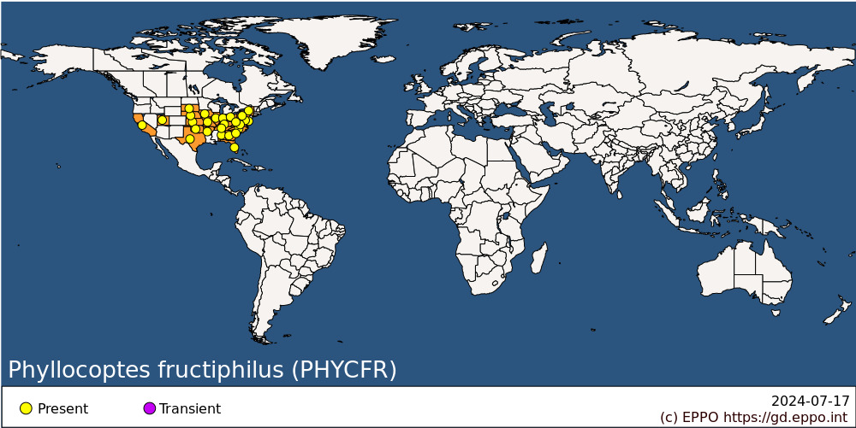
North America: United States of America (Alabama, Arkansas, California, Delaware, Florida, Georgia, Illinois, Indiana, Iowa, Kansas, Kentucky, Maryland, Missouri, Nebraska, New York, North Carolina, Ohio, Oklahoma, Pennsylvania, South Carolina, South Dakota, Tennessee, Texas, Utah, Virginia, West Virginia)

BIOLOGY
All mite life stages (eggs, larvae, nymphs, and adults) can be found on plants in open field conditions from spring to autumn. Under experimental conditions the development from egg to adult ranges from 5 to 14 days (Kassar & Amrine, 1990). Population density increases during the spring and summer and usually peaks in autumn (Otero-Colina et al., 2018), especially when new tender shoots start to reemerge on plants after a hot and dry summer (Amrine, 1996; Amrine et al., 1988). Adult females overwinter on rose plants in protected places, mostly under the bud scales and inside bark crevices. When buds break in spring, the females move to newly developing tissues and lay eggs. Under greenhouse conditions mite populations develop continuously. Observations show that P. fructiphilus has a life cycle with two, morphologically slightly different forms of females: protogynes and deutogynes, but only one form of males. Protogyne females develop from eggs laid in spring by overwintering females. They live about 30 to 60 days and produce new generations of mites in spring and summer. As the season advances, more offspring develop as deutogyne females, the overwintering form, that hide in protected places and presumably do not reproduce until the next season (Amrine, 2014). Due to arrhenotoky in eriophyoid mites (a form of parthenogenesis in which unfertilized eggs develop into males), even a sole, uninseminated female is able to establish a new population.

DETECTION AND IDENTIFICATION
Phyllocoptes fructiphilus mites are generally found under leaf petioles and stipules, especially when these structures are appressed to the stems and on tender apical shoots. They are most abundant towards the tip of growing shoots (Amrine, 2014). P. fructiphilus individuals are yellowish-white to amber in colour with a fusiform body (Keifer, 1940). There are another five Phyllocoptes species identified on rose to date (P. arcani, P. adalius, P. chorites, P. resovius, and P. trilobos) and they all share several morphological features, making species identification based on aspects such as body size or colour impossible (Druciarek et al., 2021). Identifying closely related eriophyoid species morphologically is a task that can only be effectively carried out by skilled acarologists and involves a process of phase contrast microscopic examination (Diakaki et al., 2019). Any stage of P. fructiphilus (including eggs) can be barcoded using a protocol described in Druciarek et al., (2019). The following accession numbers are available in the NCBI database (last consulted in 2024-01) for P. fructiphilus:
- MZ539472-MZ539527 for COX1 gene of mtDNA;
- MZ520395-MZ520408 for ITS1-5.8S-ITS2 region of rDNA;
- MH626104-MH626116 for 28S region of rDNA.

Symptoms
Generally, direct damage from P. fructiphilus feeding on the host plant is not noticeable. However, under certain conditions, dense population of P. fructiphilus has the potential to cause harm independently as a pest. In such a case leaf and flower malformation as well as delayed bud development and stunting of the plant might be observed (EPPO, 2018).

Morphology
Egg
Spherical, translucent to milky-yellow in colour, about 30 µm in diameter.
Larva
Body fusiform, yellowish-white in colour, between 70 and 130 µm in length and between 40 and 50 µm in width.
Nymph
Body fusiform, yellowish-white in colour, between 140 and 170 µm in length and between 40 and 60 µm in width.
Adult
Body fusiform, yellowish-white to amber in colour, between 140 and 240 µm in length and between 40 and 60 µm in width.

Detection and inspection methods
Phyllocoptes fructiphilus is a refuge-seeking mite that prefers to congregate in petiole stem interfaces, under septal trichomes, in young folded leaves, and in flower buds, therefore, these preferred niches should be sampled. Early in flower development, the tightness of sepals and petals restricts access, but as buds loosens in later stages, mites can enter the buds and likely stay through the flower's development. They show a preference for feeding at the sepal base, under trichomes, near bulbous, glandular hairs. P. fructiphilus individuals might be also present in winter-collected flower buds and in bark crevices, therefore, imported budwood should be thoroughly inspected (EPPO, 2018; Otero-Colina et al., 2018).

PATHWAYS FOR MOVEMENT
Eriophyoid mites use wind currents for passive aerial dispersal to new locations (Sabelis & Bruin, 1996; Zhao & Amrine, 1997). This mode of spread is also characteristic for P. fructiphilus, although the maximum distance that mites can spread is not known. The ambulatory dispersal of eriophyoid mites is quite limited, primarily due to their small size. Nevertheless, they are capable of moving from one plant to another when parts of the plants are in direct contact with each other. Human activities, especially transport of infested rose plants contribute to the spread of P. fructiphilus (EPPO, 2018).

PEST SIGNIFICANCE

Economic impact
Entry and establishment of vectoring mites in new areas increase the risk of RRV entry and impact. The disease is having a devastating impact on nurseries, gardens and repositories across the United States, posing a significant threat to the industry's future (Vazquez‐Iglesias et al., 2020). As a vital element of the landscape industry, garden roses have seen a notable decline in this country. From 2014 to 2019, there was a 32 % reduction in their production, as reported by the USDA in these years (USDA, 2014; USDA, 2019). Additionally, the risk associated with rose rosette led to a near halt in the export of roses (Diakaki et al., 2019; Druciarek et al., 2023). The extent of rose rosette epidemic's impact on the invasive multiflora rose (R. multiflora) in the United States is yet to be determined. Classified as a noxious weed in several states, multiflora rose has spread extensively across various regions, causing ecological disturbances, and reducing usable land (Amrine, 2002). An evaluation is necessary to conclusively determine the impact that this pathosystem has put on noxious multiflora rose.

Control
Use of miticides can be considered, although there is a huge knowledge gap on the effectiveness of available products on P. fructiphilus (EPPO, 2018). Little is also known regarding natural enemies that could be used to suppress populations of P. fructiphilus in protected environments and in the field. Predatory mites, especially of the Phytoseiidae family, are being used to control other eriophyoid species; thus, more research is needed to evaluate their effectiveness against P. fructiphilus and P. arcani.

Phytosanitary risk
Phyllocoptes fructiphilus poses a significant risk to the EPPO region primarily due to its role as a vector of RRV. The existing phytosanitary measures in EPPO countries are not sufficient to substantially reduce the introduction probability of RRV or its vectors. The small size of eriophyoid mites and tendency to reside in refuges or specialized areas of their plant host make detection challenging. Additionally, the limitations of visual inspections and testing at the production sites, coupled with the challenges in controlling the mite and virus spread, underline the need for more effective management strategies in the EPPO region. This complexity highlights the risk P. fructiphilus, P. arcani and RRV pose to the rose industry within this region.

PHYTOSANITARY MEASURES
Effective phytosanitary measures should include monitoring and early detection of infestations, destruction of RRV-infected plant material, and control of mite populations. Quarantine regulations and restrictions on the movement of rose plants from areas where rose rosette and vectoring mites were reported are essential. It can be recommended that rose plants for planting and cut flowers should originate from pest-free areas for P. fructiphilus, P. arcani and RRV and have been packed in conditions preventing mite infestation during transport (EPPO, 2018).

REFERENCES
Amrine JW (2014) What happens to Phyllocoptes fructiphilus the vector of Rose rosette virus in the winter? American Rose 42(12), 118–121.
Amrine JW (2002) Multiflora Rose. In: Biological Control of Invasive Plants in the Eastern United States. USDA Forest Service, pp. 265–292.
Amrine JW (1996) 4.1. 2 Phyllocoptes fructiphilus and biological control of multiflora rose. In: World Crop Pests. Elsevier, pp. 741–749.
Amrine JW, Hindal DF, Stasny TA, Williams RL & Coffman CC (1988) Transmission of the rose rosette disease agent to Rosa multiflora by Phyllocoptes fructiphilus (Acari: Eriophyidae). Entomological News 99, 239-252.
Di Bello PL, Thekke-Veetil T, Druciarek T & Tzanetakis IE (2018) Transmission attributes and resistance to rose rosette virus. Plant Pathology 67, 499–504. https://doi.org/10/ggrf8g
Diakaki M, Kinkar M, Lillo E de, Rosace MC & Vos S (2019) Pest survey card on rose rosette virus. EFSA Supporting Publication 16, 1748E. https://doi.org/10.2903/sp.efsa.2019.EN-1748
Druciarek T, Lewandowski M & Tzanetakis I (2021) Molecular phylogeny of Phyllocoptes associated with roses discloses the presence of a new species. Infection, Genetics and Evolution 95, 105051. https://doi.org/10.1016/j.meegid.2021.105051
Druciarek T, Lewandowski M & Tzanetakis I (2019) A new, sensitive and efficient method for taxonomic placement in the Eriophyoidea and virus detection in individual eriophyoids. Experimental and Applied Acarology 78, 247–261. https://doi.org/10.1007/s10493-019-00382-4
Druciarek T, Lewandowski M & Tzanetakis IE (2023) Identification of a second vector for rose rosette virus. Plant Disease 107(8), 2313-2315. https://doi.org/10.1094/PDIS-11-22-2686-SC
EPPO (2018) Pest risk analysis for Rose rosette virus and its vector Phyllocoptes fructiphilus. Available at: https://gd.eppo.int/taxon/RRV000/documents
Kassar A & Amrine JW (1990) Rearing and development of Phyllocoptes fructiphilus (Acari:Eriophyidae). Entomological News 101, 276–282.
Keifer HH (1940) Eriophyid studies VIII. Bulletin of the California Department of Agriculture 29(1), 21–46.
Otero-Colina G, Ochoa R, Amrine JW Jr, Hammond J, Jordan R & Bauchan GR (2018) Eriophyoid mites found on healthy and rose rosette diseased roses in the United States. Journal of Environmental Horticulture 36, 146–153. https://doi.org/10.24266/0738-2898-36.4.146
Sabelis MW & Bruin J (1996) 1.5.3. Evolutionary ecology: Life history patterns, food plant choice and dispersal. In: Lindquist EE, Sabelis MW, Bruin J (Eds.) World Crop Pests, Eriophyoid Mites Their Biology, Natural Enemies and Control. Elsevier, pp. 329–366. https://doi.org/10.1016/S1572-4379(96)80020-0
Solo KM, Collins SB, Schneider LG, Hajimorad MR, Hale FA, Wilkerson JB, Windham AS, Byrne DH & Windham MT (2019) Evaluation of Rosa species accessions for resistance to Eriophyid mites. Journal of Environmental Horticulture 37, 108–112. https://doi.org/10.24266/0738-2898-37.4.108
Vazquez‐Iglesias I, Ochoa‐Corona FM, Tang J, Robinson R, Clover GRG, Fox A & Boonham N (2020) Facing Rose rosette virus: A risk to European rose cultivation. Plant Pathology 69, 1603–1617. https://doi.org/10.1111/ppa.13255
Zhao S & Amrine JW (1997) Investigation of snowborne mites (Acari) and relevancy to dispersal. International Journal of Acarology 23, 209–213. https://doi.org/10.1080/01647959708683565

ACKNOWLEDGEMENTS
This datasheet was prepared in 2024 by Tobiasz Druciarek [Department of Plant Protection, Institute of Horticultural Sciences, Warsaw University of Life Sciences, Poland]. His valuable contribution is gratefully acknowledged.

How to cite this datasheet?
EPPO (2024) Phyllocoptes fructiphilus. EPPO datasheets on pests recommended for regulation. Available online. https://gd.eppo.int

Datasheet history
This datasheet was first published online in 2024. It is maintained in an electronic format in the EPPO Global Database. The sections on 'Identity', ‘Hosts’, and 'Geographical distribution' are automatically updated from the database. For other sections, the date of last revision is indicated on the right.

