EPPO Datasheet: Marchalina hellenica
Last updated: 1970-01-01

IDENTITY
Preferred name: Marchalina hellenica  Authority: (Gennadius)  Taxonomic position: Animalia: Arthropoda: Hexapoda: Insecta: Hemiptera: Sternorrhyncha: Marchalinidae  Common names in English: giant pine scale  view more common names online...  EPPO Categorization: Alert list (formerly)  view more categorizations online...  EPPO Code: MARCHE | 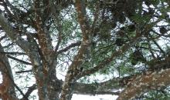  more photos...

GEOGRAPHICAL DISTRIBUTION
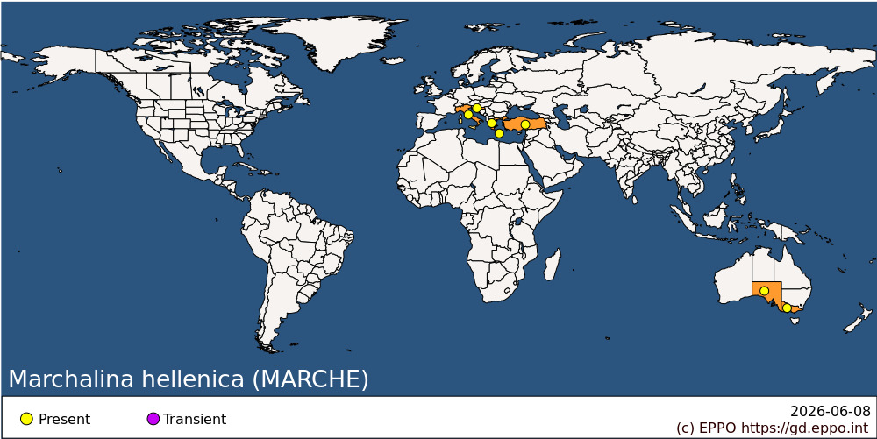
EPPO Region: Croatia, Greece (mainland, Kriti), Italy (mainland), Türkiye
Oceania: Australia (South Australia, Victoria)

How to cite this datasheet?
EPPO (2026) Marchalina hellenica. EPPO datasheets on pests recommended for regulation. Available online. https://gd.eppo.int

