EPPO Datasheet: Halyomorpha halys
Last updated: 1970-01-01

IDENTITY
Preferred name: Halyomorpha halys  Authority: Stål  Taxonomic position: Animalia: Arthropoda: Hexapoda: Insecta: Hemiptera: Heteroptera: Pentatomidae  Other scientific names: Halyomorpha mista (Uhler), Pentatoma halys Stål  Common names in English: brown marmorated stink bug  view more common names online...  EPPO Categorization: Alert list (formerly)  view more categorizations online...  EPPO Code: HALYHA | 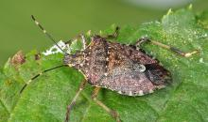  more photos...

GEOGRAPHICAL DISTRIBUTION
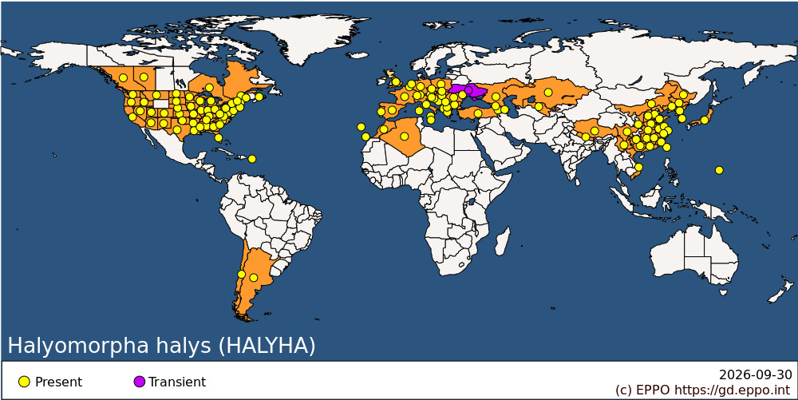
EPPO Region: Albania, Algeria, Armenia, Austria, Azerbaijan, Belgium, Bosnia and Herzegovina, Bulgaria, Croatia, Czechia, France (mainland), Georgia, Germany, Greece (mainland), Hungary, Italy (mainland, Sardegna, Sicilia), Kazakhstan, Liechtenstein, Malta, Moldova, Republic of, Morocco, Netherlands, North Macedonia, Poland, Portugal (mainland, Madeira), Romania, Russian Federation (Southern Russia), Serbia, Slovakia, Slovenia, Spain (mainland, Islas Canárias), Switzerland, Türkiye, Ukraine, United Kingdom (England), Uzbekistan
Africa: Algeria, Morocco
Asia: China (Anhui, Fujian, Guangdong, Guangxi, Guizhou, Hebei, Heilongjiang, Henan, Hubei, Hunan, Jiangsu, Jiangxi, Jilin, Liaoning, Neimenggu, Shaanxi, Shandong, Shanghai, Shanxi, Sichuan, Xizhang, Yunnan, Zhejiang), Japan (Honshu), Kazakhstan, Korea, Democratic People's Republic of, Korea, Republic of, Nepal, Taiwan, Uzbekistan, Vietnam
North America: Canada (Alberta, British Columbia, Ontario, Prince Edward Island, Québec), United States of America (Alabama, Arizona, Arkansas, California, Colorado, Connecticut, Delaware, District of Columbia, Florida, Georgia, Idaho, Illinois, Indiana, Iowa, Kansas, Kentucky, Louisiana, Maine, Maryland, Massachusetts, Michigan, Minnesota, Mississippi, Missouri, Montana, Nebraska, Nevada, New Hampshire, New Jersey, New Mexico, New York, North Carolina, North Dakota, Ohio, Oklahoma, Oregon, Pennsylvania, Rhode Island, South Carolina, South Dakota, Tennessee, Texas, Utah, Vermont, Virginia, Washington, West Virginia, Wisconsin)
Central America and Caribbean: Puerto Rico
South America: Argentina, Chile
Oceania: Guam

How to cite this datasheet?
EPPO (2026) Halyomorpha halys. EPPO datasheets on pests recommended for regulation. Available online. https://gd.eppo.int

