EPPO Datasheet: Phthorimaea absoluta
Last updated: 2017-08-03

IDENTITY
Preferred name: Phthorimaea absoluta  Authority: Meyrick  Taxonomic position: Animalia: Arthropoda: Hexapoda: Insecta: Lepidoptera: Gelechiidae  Other scientific names: Gnorimoschema absoluta (Meyrick), Scrobipalpula absoluta (Meyrick), Scrobipalpuloides absoluta (Meyrick), Tuta absoluta (Meyrick)  Common names in English: South American tomato moth, tomato borer, tomato leaf miner, tomato leafminer, tomato leafminer moth  view more common names online...  EPPO Categorization: A2 list  view more categorizations online...  EPPO Code: GNORAB | 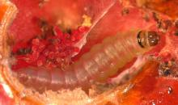  more photos...

HOSTS
The main host of T. absoluta is tomato, but potato is also reported as a host (CIP, 1996; Galarza, 1984; Notz, 1992), together with Lycopersicon hirsutum, Solanum lyratum and various wild solanaceous species such as Solanum nigrum, Solanum elaeagnifolium, Solanum puberulum, Datura stramonium, Datura ferox and Nicotiana glauca. In laboratory studies (Galarza, 1984), aubergine was reported as a potential host (with other solanaceous species), but there are no references to its importance in the field. There is an old record of tobacco being attacked in Argentina (Mallea et al., 1972).
Host list: Lycium chilense, Nicotiana glauca, Oxybasis rubra, Phaseolus vulgaris, Solanum aethiopicum, Solanum coagulans, Solanum elaeagnifolium, Solanum habrochaites, Solanum lasiocarpum, Solanum lycopersicum, Solanum melongena, Solanum muricatum, Solanum nigrum, Solanum sarrachoides, Solanum tuberosum

GEOGRAPHICAL DISTRIBUTION
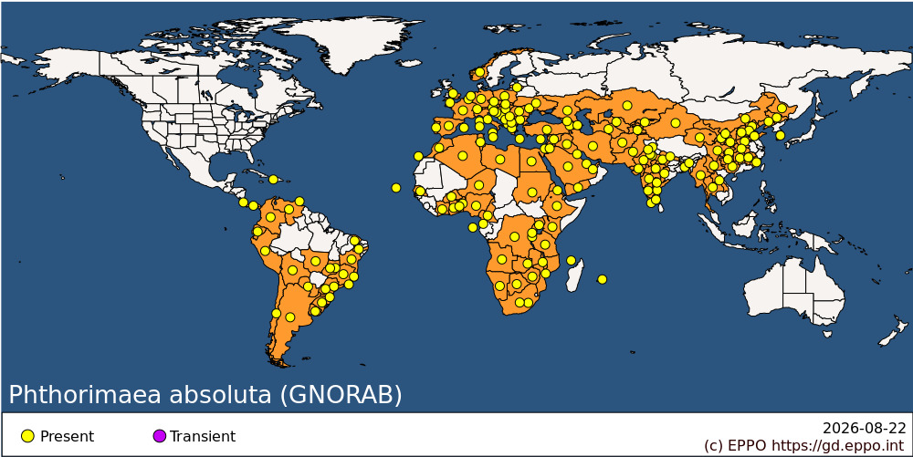
EPPO Region: Albania, Algeria, Armenia, Austria, Azerbaijan, Belgium, Bosnia and Herzegovina, Bulgaria, Croatia, Cyprus, Czechia, France (mainland, Corse), Georgia, Germany, Greece (mainland, Kriti), Guernsey, Hungary, Israel, Italy (mainland, Sardegna, Sicilia), Jordan, Kazakhstan, Kyrgyzstan, Lithuania, Malta, Moldova, Republic of, Montenegro, Morocco, Netherlands, North Macedonia, Norway, Poland, Portugal (mainland), Romania, Russian Federation (Southern Russia), Serbia, Slovakia, Slovenia, Spain (mainland, Islas Baleares, Islas Canárias), Switzerland, Tunisia, Türkiye, Ukraine, United Kingdom (England), Uzbekistan
Africa: Algeria, Angola, Benin, Botswana, Burkina Faso, Burundi, Cabo Verde, Cameroon, Congo, The Democratic Republic of the, Cote d'Ivoire, Egypt, Equatorial Guinea, Eritrea, Ethiopia, Ghana, Kenya, Lesotho, Libya, Malawi, Mauritius, Mayotte, Morocco, Mozambique, Namibia, Niger, Nigeria, Rwanda, Sao Tome and Principe, Senegal, South Africa, Sudan, Tanzania, United Republic of, Togo, Tunisia, Uganda, Zambia, Zimbabwe
Asia: Afghanistan, Bangladesh, China (Beijing, Chongqing, Fujian, Gansu, Guangxi, Guizhou, Hebei, Heilongjiang, Henan, Hubei, Hunan, Jiangxi, Jilin, Liaoning, Neimenggu, Ningxia, Qinghai, Shaanxi, Shandong, Shanxi, Sichuan, Xinjiang, Yunnan), India (Andhra Pradesh, Chhattisgarh, Delhi, Gujarat, Haryana, Himachal Pradesh, Karnataka, Kerala, Madhya Pradesh, Maharashtra, Meghalaya, Punjab, Rajasthan, Tamil Nadu, Telangana, Uttar Pradesh), Iran, Islamic Republic of, Iraq, Israel, Jordan, Kazakhstan, Korea, Republic of, Kuwait, Kyrgyzstan, Lao People's Democratic Republic, Myanmar, Nepal, Pakistan, Qatar, Saudi Arabia, Syrian Arab Republic, Tajikistan, Thailand, Turkmenistan, United Arab Emirates, Uzbekistan, Yemen
Central America and Caribbean: Costa Rica, Haiti, Panama, Trinidad and Tobago
South America: Argentina, Bolivia, Brazil (Bahia, Ceara, Distrito Federal, Espirito Santo, Goias, Mato Grosso, Minas Gerais, Parana, Pernambuco, Rio de Janeiro, Rio Grande do Sul, Santa Catarina, Sao Paulo), Chile, Colombia, Ecuador, Paraguay, Peru, Uruguay, Venezuela

BIOLOGY
T. absoluta has a high reproductive potential. Larvae do not enter diapause as long as food is available, and there may be 10–12 generations per year (5 in Argentina). The biological cycle is completed in 29–38 days depending on environmental conditions. Studies in Chile have shown that development takes 76.3 days at 14°C, 39.8 at 19.7°C and 23.8 at 27.1°C (Barrientos et al., 1998). Adults are nocturnal and usually hide during the day between leaves. Females lay eggs on aerial parts of their host plants and a single female can lay a total of about 260 eggs during its lifetime. Four larval instars develop. In Argentina, young larvae appear at the end of winter. Pupation may take place in the soil, on the leaf surface or within mines, depending on environmental conditions. When T. absoluta does not pupate in the soil, a cocoon is usually built. The pest may overwinter as eggs, pupae or adults.

DETECTION AND IDENTIFICATION
Symptoms
After hatching, young larvae penetrate into tomato fruits, leaves or stems on which they feed and develop, thus creating conspicuous mines and galleries. Fruits can be attacked as soon as they are formed, and the galleries bored inside them can be invaded by secondary pathogens leading to fruit rot. On leaves, larvae feed only on mesophyll tissues, leaving the epidermis intact. Leaf mines are irregular and may later become necrotic. Galleries in stems alter the general development of the plants. Tomato plants can be attacked at any developmental stage, from seedlings to mature plants. The pest is generally easily found because it prefers apical buds, ﬂowers or new fruits, on which the black frass is visible. On potato, only aerial parts are attacked, and T. absoluta does not develop on tubers (Caffarini et al., 1999; Notz, 1992).
Morphology
Egg
Small (0.36 mm long and 0.22 mm large), cylindrical, creamy white to yellow. Eggs are mainly deposited on the underside of leaves. Hatching takes place after 4–5 days.
Larva
Cream in colour with dark head, becoming greenish to light pink in the second to fourth instars. First instar is 0.9 mm long and fourth is 7.5 mm long. Duration: 13–15 days.
Pupa
Brown. Duration: 9–11 days.
Adult
About 10 mm long, ﬁliform antennae, silverish-grey scales, black spots on anterior wings.

PATHWAYS FOR MOVEMENT
T. absoluta can be carried by consignments of plants for planting and fruits of tomato. It does not attack potato tubers and is therefore not likely to enter with consignments of potato. T. absoluta is reported as being easily detected.

PEST SIGNIFICANCE
Economic impact
In Latin America, T. absoluta is considered as a key pest of tomato both in the field and under protected conditions. Both yield and fruit quality can be significantly reduced by the direct feeding of the pest and the secondary pathogens which may then enter through the wounds made by the pest. Severely attacked tomato fruits lose their commercial value. 50–100% losses have been reported on tomato (mainly under low rainfall). On potato, CIP (1996) considers that T. absoluta is one of the major pests of foliage, occurring in warm zones of low altitudes (below 1000 m).
Control
IPM strategies are being developed in South America to control T. absoluta. Studies are being done on the use of synthetic sex pheromones in order to monitor population levels and trigger applications of chemicals (Salas, 2004). Various active substances are effective and can be used in combination with biological control agents. Concerning chemical control, several treatments are required per growing season and it must be noted that a decrease of the efficacy of products used against T. absoluta has been observed since the 1980s in tomato crops. Resistance to some insecticides has been reported in several countries, for example to abamectin, cartap and permethrin in Brazil (Siqueira et al., 2000). Parasitoids (e.g. Trichogramma pretiosum) or predators (e.g. Podisus nigrispinus) can be used, and research is being done on biological control (Villas Boas & Franca, 1996; Torres et al., 2002). Other control methods include cultural practices (rotation with non-solanaceous crops, ploughing, adequate fertilization, irrigation, destruction of infested plants and of post-harvest plant debris, etc.). Finally, the susceptibility of tomato cultivars to T. absoluta varies and plant resistance is being investigated.
Phytosanitary risk
T. absoluta is potentially a serious pest of tomato in the warmer parts of the EPPO region, both in the field and in protected conditions. On potato, the risk appears more limited as T. absoluta does not attack tubers in the field or in storage (unlike Tecia solanivora). T. absoluta has spread from Central America to most of South America, where significant damage is reported. In addition, control may be complicated by the appearance of pest resistance to insecticides.

PHYTOSANITARY MEASURES
T. absoluta was added in 2004 to the EPPO A1 action list of pests recommended for regulation as quarantine pests. Plants for planting and fruits of tomato originating from countries where T. absoluta occurs should be free from the pest.

REFERENCES
Barrientos ZR, Apablaza HJ, Norero SA & Estay PP (1998) [Threshold temperature and thermal constant for development of the South American tomato moth, Tuta absoluta (Lepidoptera, Gelechiidae).] Ciencia e Investigacion Agraria 25, 133–137 (in Spanish).
Caffarini PM, Folcia AM, Panzardi SR & Pérez A (1999) [Incidence of low levels of foliar damage caused by Tuta absoluta (Meyrick) on tomato.] Boletín de Sanidad Vegetal, Plagas 25, 75–78 (in Spanish).
CIP (1996) Major Potato Diseases, Insects, and Nematodes, 3rd edn. Centro Internacional de la Papa, Lima (PE).
Clarke JF (1962) New species of microlepidoptera from Japan. Entomological News 73, 102.
Galarza J (1984) Laboratory assessment of some solanaceous plants as possible food plants of the tomato moth Scrobipalpula absoluta. IDIA Nos 421/424, 30–32.
García MF & Espul JC (1982) Bioecology of the tomato moth (Scrobipalpula absoluta) in Mendoza, Argentine Republic. Revista de Investigaciones Agropecuarias 17, 135–146.
Mallea AR, Macola GS, Garcia SJG, Bahamondes LA & Suarez JH (1972) [Nicotiana tabacum var. virginica, a new host of Scrobipalpula absoluta] Revista de la Facultad de Ciencias Agrarias, Universidad Nacional de Cuyo 18, 13–15 (in Spanish).
Notz AP (1992) [Distribution of eggs and larvae of Scrobipalpula absoluta in potato plants.] Revista de la Facultad de Agronomía (Maracay) 18, 425–432 (in Spanish).
Salas J (2004) [Capture of Tuta absoluta in traps baited with its sex pheromone.] Revista Colombiana de Entomología 20, 75–78 (in Spanish).
Siqueira HQA, Guedes RNC & Picanco MC (2000) Insecticide resistance in populations of Tuta absoluta. Agricultural and Forest Entomology 2, 147–153.
Torres JB, Evangelista WS, Barras R & Guedes RNC (2002) Dispersal of Podisus nigrispinus nymphs preying on tomato leafminer: effect of predator release time, density and satiation level. Journal of Applied Entomology 126, 326–332.
Villas Boas GL & Franca FH (1996) [Use of the parasitoid Trichogramma pretiosum for control of Brazilian tomato pinworm in tomato grown in the greenhouse.] Horticultura Brasileira 14, 223–225 (in Portuguese).

How to cite this datasheet?
EPPO (2026) Phthorimaea absoluta. EPPO datasheets on pests recommended for regulation. Available online. https://gd.eppo.int

