EPPO Datasheet: Cydalima perspectalis
Last updated: 1970-01-01

IDENTITY
Preferred name: Cydalima perspectalis  Authority: (Walker)  Taxonomic position: Animalia: Arthropoda: Hexapoda: Insecta: Lepidoptera: Crambidae  Other scientific names: Diaphania perspectalis (Walker), Glyphodes perspectalis (Walker), Palpita perspectalis (Walker), Phakellura perspectalis Walker  Common names in English: box tree moth, box-tree pyralid  view more common names online...  EPPO Categorization: Alert list (formerly)  view more categorizations online...  EPPO Code: DPHNPE | 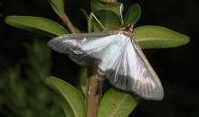  more photos...

GEOGRAPHICAL DISTRIBUTION
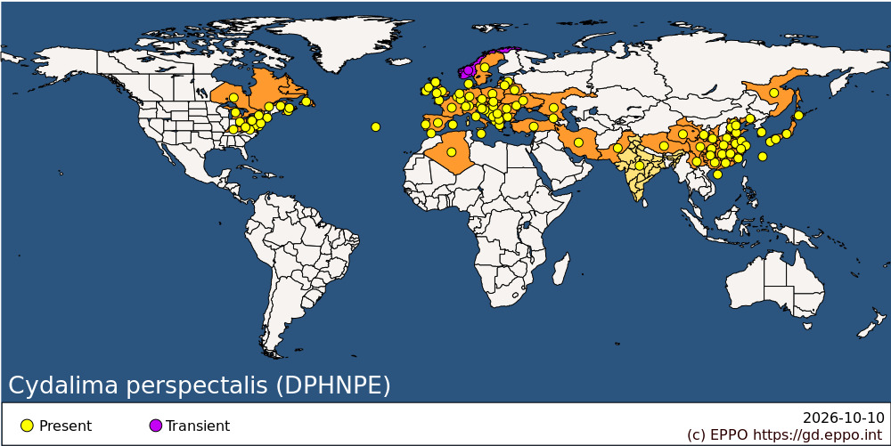
EPPO Region: Albania, Algeria, Austria, Belarus, Belgium, Bosnia and Herzegovina, Bulgaria, Croatia, Czechia, Denmark, France (mainland), Georgia, Germany, Gibraltar, Greece (mainland), Guernsey, Hungary, Ireland, Italy (mainland), Latvia, Liechtenstein, Lithuania, Luxembourg, Malta, Moldova, Republic of, Montenegro, Netherlands, North Macedonia, Norway, Poland, Portugal (mainland, Azores), Romania, Russian Federation (Far East, Southern Russia), Serbia, Slovakia, Slovenia, Spain (mainland, Islas Baleares), Sweden, Switzerland, Türkiye, Ukraine, United Kingdom (England, Northern Ireland, Scotland, Wales)
Africa: Algeria
Asia: China (Anhui, Beijing, Chongqing, Fujian, Gansu, Guangdong, Guangxi, Guizhou, Hainan, Hebei, Henan, Hubei, Hunan, Jiangsu, Jiangxi, Liaoning, Qinghai, Shaanxi, Shandong, Shanghai, Sichuan, Tianjin, Xizhang, Yunnan, Zhejiang), India, Iran, Islamic Republic of, Japan (Hokkaido, Honshu, Kyushu, Ryukyu Archipelago, Shikoku), Korea, Republic of, Pakistan
North America: Canada (New Brunswick, Newfoundland, Nova Scotia, Ontario, Prince Edward Island, Québec), United States of America (Delaware, Kentucky, Maryland, Massachusetts, Michigan, New Jersey, New York, Ohio, Pennsylvania, Virginia, West Virginia)

How to cite this datasheet?
EPPO (2026) Cydalima perspectalis. EPPO datasheets on pests recommended for regulation. Available online. https://gd.eppo.int

