EPPO Datasheet: Ditylenchus destructor
Last updated: 2019-03-14

IDENTITY
Preferred name: Ditylenchus destructor  Authority: Thorne  Taxonomic position: Animalia: Nematoda: Chromadorea: Rhabditida: Anguinidae  Common names in English: potato root nematode, potato rot nematode, potato tuber nematode  view more common names online...  EPPO Categorization: A1/A2 (formerly)  EU Categorization: RNQP ((EU) 2019/2072 Annex IV)  view more categorizations online...  EPPO Code: DITYDE | 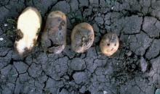  more photos...

Notes on taxonomy and nomenclature
Before D. destructor was described in 1945 as a good species, it was regarded for a long time as a strain or race of D. dipsaci. Much of the earlier literature, therefore, provides confused information on the two species, especially in relation to potatoes.

HOSTS
Potatoes are the main host of D. destructor, but the nematode can also occasionally be found on bulbous Iris, carrots, Trifolium spp., groundnuts and garlic. Overall, some 70 crops and weeds and a similar number of fungus species have been recorded as hosts.
Host list: Allium sativum, Arachis hypogaea, Beta vulgaris, Codonopsis pilosula, Crocus, Dahlia hybrids, Daucus carota subsp. sativus, Gladiolus hybrids, Gladiolus, Hyacinthus, Ipomoea batatas, Iris x hollandica, Solanum tuberosum, Tigridia pavonia, Trifolium, Tulipa hybrids, Zea mays

GEOGRAPHICAL DISTRIBUTION
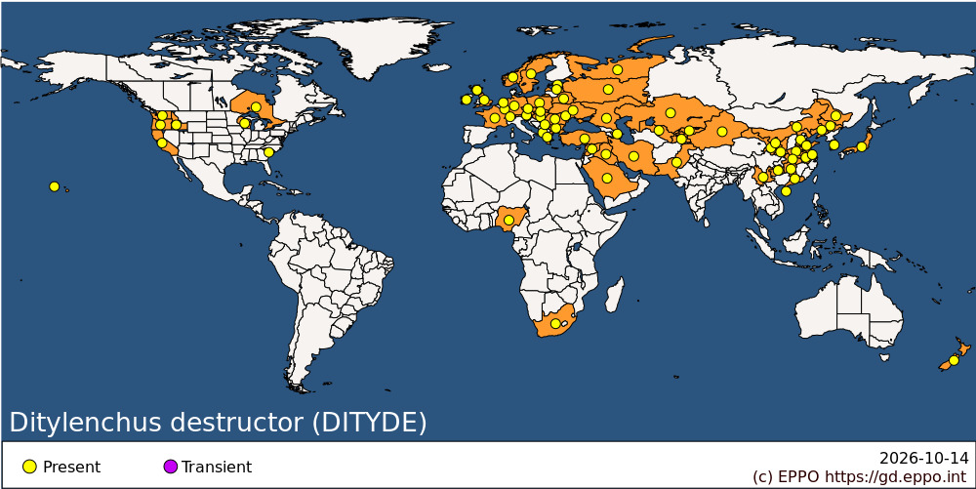
EPPO Region: Albania, Austria, Azerbaijan, Belarus, Bulgaria, Czechia, Estonia, France (mainland), Germany, Greece (mainland), Hungary, Ireland, Jersey, Kazakhstan, Kyrgyzstan, Latvia, Luxembourg, Moldova, Republic of, Netherlands, Norway, Poland, Romania, Russian Federation (Central Russia, Northern Russia, Southern Russia), Serbia, Slovakia, Sweden, Switzerland, Türkiye, Ukraine, United Kingdom (England, Scotland), Uzbekistan
Africa: Nigeria, South Africa
Asia: China (Anhui, Gansu, Guangdong, Guizhou, Hainan, Hebei, Heilongjiang, Henan, Hubei, Hunan, Jiangsu, Jilin, Liaoning, Neimenggu, Ningxia, Shaanxi, Shandong, Xinjiang, Yunnan), Iran, Islamic Republic of, Iraq, Japan (Honshu), Kazakhstan, Korea, Republic of, Kyrgyzstan, Pakistan, Saudi Arabia, Syrian Arab Republic, Tajikistan, Uzbekistan
North America: Canada (Ontario), United States of America (California, Hawaii, Idaho, Oregon, South Carolina, Washington, Wisconsin)
Oceania: New Zealand

BIOLOGY
Unlike the closely related species D. dipsaci, D. destructor is unable to withstand excessive desiccation, and for this reason is usually only important in cool, moist soils. Without a resistant resting stage, the species overwinters in soil as adults or larvae and may even multiply by feeding on alternative weed hosts (e.g. Mentha arvensis, Sonchus arvensis) and on fungal mycelium. It may also possibly overwinter as eggs. These hatch in the spring and larvae are immediately able to parasitize hosts. In South Africa, it was found that the optimum temperature for egg hatch was 28°C (De Waele & Wilken, 1990), but this was considered to be an adaptation of the species to different climatic conditions, and it is assumed that temperature requirements are much lower in Europe. Egg hatch at 28°C begins 2 days after egg laying, with an average interval of 4.4 days between egg laying and hatch, and development from egg to adult takes between 6 and 7 days.
The nematodes attack only subterranean and not aerial parts of plants. They enter potato tubers through the lenticels, and then begin to multiply rapidly and invade the whole tuber.
They can continue to live and develop within harvested tubers. For further information, see Thorne (1961) and Hooper (1973).

DETECTION AND IDENTIFICATION
Symptoms
On potatoes
There are, in general, no obvious symptoms in the aerial parts of the plant, although heavily infested tubers give rise to weak plants which usually die. Early infections can be detected by peeling the tuber which can reveal small, off-white spots in the otherwise healthy flesh. These later enlarge, darken, are woolly in texture and may be slightly hollow at the centre. On badly affected tubers there are typically slightly sunken areas with cracked and wrinkled skin which is detached in places from the underlying flesh. The flesh has a dry and mealy appearance, varying in colour from greyish to dark brown or black. This discoloration is largely due to secondary invasion of fungi, bacteria and free-living nematodes (the latter are easily confused with D. destructor). In contrast, the skin of potatoes infested with D. dipsaci is not usually cracked, and the rot darkens towards the inside of the tuber. The symptoms are more obvious in the foliage, which is shortened and malformed.
On Iris and tulips
Infestations usually begin at the base and extend up the fleshy scales, causing grey to black lesions; roots may be blackened, and leaves poorly developed, with yellow tips.
On groundnuts
Hulls of groundnuts show black discoloration which appears first along the longitudinal veins. The kernels are shrunken. The infected testae are brown to black and the embryo shows a brown discoloration (Jones & De Waele, 1988). For further details, see Thorne (1961), Hooper (1973), Anon. (1974).
Morphology
Adults of D. destructor are minute worm-like animals, 0.8-1.4 mm in length and 23-47 µm in diameter. Considerable morphometric variation occurs in adults according to their host and/or age. Males and females are similar in general appearance. In females, the ost-vulval sac extends about three-quarters of the distance to the anus, and the tail has a narrow rounded terminus. Males have ventrally curved, anteriorly expanded spicules. There are four juvenile stages (the first preceding hatching of the egg), superficially similar to adults, but differing in size and in lacking developed reproductive organs.
Detection and inspection methods
Prior to planting, soil can be sampled using a standard extraction procedure for nematodes of this size (Hooper, 1986). It is difficult to detect the presence of D. destructor from external tuber appearance alone. Sample tubers should be cut or peeled to look for the characteristic whitish pockets in which most of the nematodes are found. Microscopic examination of the nematode is necessary for correct identification of the species.

PATHWAYS FOR MOVEMENT
The nematodes can move only short distances in the soil and have no natural means of long-range movement. The main means of dispersal is with infested potato tubers or other subterranean organs of host plants, e.g. bulbs and rhizomes (especially of Iris). Transport in infested soil is another important means of spread. Irrigation water can also carry the nematodes.

PEST SIGNIFICANCE
Economic impact
In general, D. destructor is of extremely minor importance as a pest of potatoes in the EPPO region. Problems only occur at temperatures of 15-20°C and at relative humidity above 90%. In recent years it has been detected as a problem in all the groundnut-producing areas of South Africa (Jones & De Waele, 1988). It is suspected that the population in South Africa may be a separate ecotype or pathotype and may be confined to groundnuts; it has not been reported to attack potatoes there.
Control
Treatment with soil-applied nematicides can provide a high level of control but can be expensive. Granulated nematicides such as carbofuran were reported to be effective against the nematode (Chukantseva, 1983; Vorona, 1984). D. destructor has apparently been eradicated from the state of Wisconsin, USA, by means of repeated fumigation with ethylene dibromide, combined with official restriction of movement of infected tubers (Darling et al., 1983). Seed dressing of garlic prior to planting with thiram or benomyl wettable powder gave very good control (Fujimura et al., 1989).
Control by crop rotation is possible using non-host crops such as sugarbeet (Winslow, 1978), but it is important to control weeds carefully because of the polyphagous habit of D. destructor. The use of nematode-free seed potatoes is an essential component of any control programme.
Phytosanitary risk
D. destructor was considered to be an EPPO A2 quarantine pest (OEPP/EPPO, 1978) but was deleted from the quarantine list in 1984 because of its minor importance and very wide distribution throughout the EPPO region, in particular in those areas where it would be likely to cause crop damage. D. destructor is of quarantine significance for the APPPC and COSAVE.
The requirement of the nematode for high relative humidity means it would be unlikely to become a problem in areas with warm, dry soils; it may therefore be of concern to potato production only in the northern parts of the EPPO region. However, its establishment as a groundnut pathogen in South Africa has shown its potential to adjust to different (and normally unfavourable) climatic conditions (De Waele & Wilken, 1990).

PHYTOSANITARY MEASURES
Fumigation under vacuum (650 mm Hg) with hydrogen cyanide (initial dose, 4 g/m3 ) for 1 h at above 10°C gives good control of the nematode in bulbs, rhizomes and tubers, and especially asparagus roots and strawberry plants.
Infestation in Iris bulbs can be controlled by immersion in water containing 0.5% formaldehyde at 43.5°C for 2-3 h, but some varieties may be injured during this treatment.
In garlic bulbs, nematodes were controlled by drying at 34-36°C for 12-17 days (Fujimura et al., 1989).

REFERENCES
Anonymous (1974) Potato tuber eelworm. Ministry of Agriculture, Fisheries and Food (GB), Advisory Leaflet No. 372 (amended).
Chukantseva NK (1983) [Some aspects of the study of the potato stem nematode in the Central Chernozem zone of the RSFSR.] Steblevye Nematody Sel'skohhozyaistvennnykh Kul'tur i Mery Bor'by s Nimi, pp. 11-27.
Darling HM, Adams J, Norgren RL (1983) Field eradication of the potato rot nematode, Ditylenchus destructor: a 29-year history. Plant Disease 67, 422-423.
De Waele D, Wilken R (1990) Effect of temperature on the in vitro reproduction of Ditylenchus destructor isolated from groundnut. Revue de Nématologie 13, 171-174.
Foot MA, Wood FH (1982) Potato rot nematode, Ditylenchus destructor (Nematoda: Tylenchidae), infecting hops in New Zealand. New Zealand Journal of Experimental Agriculture 10, 443-446.
Fujimura T, Ichita T, Kimura T (1989) Occurrence of potato-rot nematode, Ditylenchus destructor Thorne, in garlic and control. 1. Evaluation of treatments applied before planting and after harvest for control. Japanese Journal of Nematology 18, 22-29.
Hooper DJ (1973) Ditylenchus destructor. CIH Descriptions of Plant-parasitic Nematodes No. 21. CAB International, Wallingford, UK.
Hooper DJ (1986) Extraction of free-living stages from soil. In: Laboratory methods for work with plant and soil nematodes (Ed. by Southey, J.F.), pp. 5-30. Ministry of Agriculture, Fisheries and Food Reference Book No. 402. HMSO, London, UK.
Jones BL, De Waele D (1988) First report of Ditylenchus destructor in pods and seeds of peanut. Plant Disease 72, 453.
OEPP/EPPO (1978) Data sheets on quarantine organisms No. 123, Ditylenchus destructor. Bulletin OEPP/EPPO Bulletin 8 (2).
Thorne G (1961) Principles of nematology, 533 pp. McGraw-Hill Book Co. Inc., New York, USA.
Vorona VF (1984) [Trials with heterophos against the potato stem nematode.] Byulleten' Vsessoyuznogo Instituta Gel'mintologii im. K.L. Skryabina No. 34, pp. 69-70.
Winslow RD (1978) An overview of the important nematode pests of potato. In: Developments in control of nematode pests of potato. Report of the 2nd Nematode Planning Conference, pp. 138- 153. International Potato Centre, Lima, Peru.

How to cite this datasheet?
EPPO (2026) Ditylenchus destructor. EPPO datasheets on pests recommended for regulation. Available online. https://gd.eppo.int

