EPPO Datasheet: Diabrotica speciosa
Last updated: 2017-08-02

IDENTITY
Preferred name: Diabrotica speciosa  Authority: (Germar)  Taxonomic position: Animalia: Arthropoda: Hexapoda: Insecta: Coleoptera: Chrysomelidae  view more common names online...  EPPO Categorization: A1 list  view more categorizations online...  EPPO Code: DIABSC | 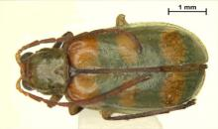  more photos...

HOSTS
The larvae of D. speciosa feed on roots of maize, wheat, groundnut, soybean and potato, and various other crop and non-crop hosts. The adults are highly polyphagous, being recorded on over 60 species, mainly vegetables, but are particularly associated with Cucurbitaceae (e.g. Cucurbita maxima, Cucurbita pepo).
Host list: Arachis hypogaea, Brassica napus, Brassica oleracea var. capitata, Brugmansia suaveolens, Citrus, Cucurbita maxima, Cucurbita pepo, Glycine max, Ipomoea batatas, Malus domestica, Phaseolus vulgaris, Prunus, Solanum lycopersicum, Solanum tuberosum, Sorghum halepense, Triticum aestivum subsp. aestivum, Vaccinium corymbosum, Zea mays

GEOGRAPHICAL DISTRIBUTION
Distribution map: see CABI/EPPO (2003)
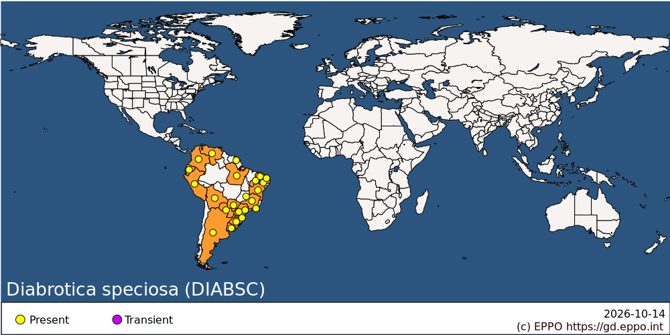
South America: Argentina, Bolivia, Brazil (Bahia, Ceara, Distrito Federal, Mato Grosso do Sul, Minas Gerais, Para, Parana, Pernambuco, Piaui, Rio de Janeiro, Rio Grande do Norte, Rio Grande do Sul, Santa Catarina, Sao Paulo), Colombia, Ecuador, French Guiana, Paraguay, Peru, Uruguay, Venezuela

BIOLOGY
D. speciosa overwinters as an adult, and is fairly tolerant of cold. It can be found in winter in small numbers concealed in the rosette and crowns of winter-growing plants. Eggs are laid on the soil near a larval host plant, and hatch in 8 days. There are three larval instars, developing over about 25 days. The first-instar larvae feed throughout the root system of the host, but older instars feed in the upper 10 cm under the crown. The pupal stage lasts 6 days. Young adults are yellowish or pale brown colour, becoming green with bright yellow spots. Mating occurs 4–6 days after emergence, and each female lays over 1000 eggs, mostly on days 16–56. The number of overlapping generations depends on the latitude and the climate. In tropical areas, D. speciosa multiplies continuously. In northern Argentina, there are three generations per year. Adult beetles feed on pollen-rich plant structures, such as the flowers of cucurbits, thistle and sunﬂower. Like other Diabrotica spp., they are especially associated with Cucurbitaceae, and are tolerant to cucurbitacins. When flowers become scarce, beetles may feed on the tender green parts of other hosts, such as lucerne, potatoes, maize, beans, soybean, lettuce and cabbage.

DETECTION AND IDENTIFICATION
Symptoms
Root feeding causes stunted growth, and in particular ‘goose neck’ in maize (bending of the first internodes). In groundnut and potato, the pods or tubers may be externally damaged or bored. Adults cause defoliation and general feeding damage to leaves, flowers and fruit. On maize, they feed on the tassels, preventing pollination, and thus reducing the number of ripening grains from the tip of the ear to the base.
Morphology
Eggs
Ovoid, about 0.74 × 0.36 mm, clear white to pale yellow.
Larva
Larvae are about 8.5 mm long at maturity, subcylindrical; chalky white; head capsule dirty yellow-light brown. A detailed description has been published by Defago (1991).
Pupa
Pupae are 5.8–7.1 mm long; white, formed in a 8 × 4 mm oval cell in the soil.
Adult
Adults are 5.5–7.3 mm long; antennae 4–5 mm. General colour grass-green, with yellow spots (recalling the colours of the Brazilian flag). Antennae dark, first three basal segments lighter; head ranging from reddish brown to black; labrum, scutellum, metathorax, tibiae and tarsi black; elytra with three large oval transverse spots on each, basal spots larger and usually reddish toward the humeral callus, the rest yellow. Ventrally, head and metathorax dark brown, prothorax green, mesothorax and abdomen light brown or yellow-green. Pronotum bi-foveate, convex, smooth, shiny, 1/4 wider than long. Male antennae proportionally longer than female. Males with an extra sclerite on the apex of the abdomen that makes it look blunt, compared with the rather pointed female apex. Full descriptions of D. speciosa are given by Baly (1886), Araujo Marques (1941) and Christensen (1943).

PATHWAYS FOR MOVEMENT
D. speciosa can move locally by adult flight, and probably by movement of eggs, larvae or pupae in soil contaminating vehicles or farm machinery. For long-distance spread, adults could be present on host plants for planting, but these are not of the kind normally moved in international trade, and the active adults will not necessarily remain on their hosts. Larvae could be associated with groundnuts or potatoes, but the underground parts of maize, wheat or soybean are unlikely to be moved. Nor is it likely that the larval hosts would be traded as plants with soil. Accordingly, the main potential pathway is soil as such.

PEST SIGNIFICANCE
Economic impact
Like the North American Diabrotica spp. (EPPO/CABI, 1997; OEPP/EPPO, 1999), the South American D. speciosa has larvae which feed on the roots of Poaceae, especially maize, and adults which feed on the foliage, flowers and fruits of many hosts, especially Cucurbitaceae. Maize is a major larval host in South America, but also various other crops. In Argentina, D. speciosa particularly affects groundnuts, and in southern Brazil, potatoes and wheat. The adults do more damage than those of the North American species, attacking especially watermelon, squash and tomatoes in Brazil, vegetables in Paraguay, also ornamental flowers such as dahlias and chrysanthemums (USDA, 1957). Significant damage is also caused by adults feeding of the tassels of maize, and reducing grain set. An economic threshold of 2 insects per plant of Phaseolus vulgaris was determined by Pereira et al. (1997).
Control
Plant protection products are widely used to control D. speciosa, either applied to the soil to control larvae or to the above-ground parts to control adults (according to the crop concerned). Intensive use of products is required to control larvae in soil. In southern Brazil, IPM programmes combine no-till agriculture, rotation of soybeans with maize or wheat, and use of insecticides only when damage is evident. Using this system, wheat is produced with virtually no pesticides in this area. Adults can be lured to baits composed of insecticide on the cucurbitacin-rich roots of wild cucurbits (Hamerschmidt, 1985; Roel & Zatarin, 1989). Although some natural enemies of D. speciosa are known (Heineck-Lionel & Salles, 1997), there is no prospect of biological control of this species.
Phytosanitary risk
D. speciosa presents a risk to the EPPO region similar to that for the North American Diabrotica undecimpunctata (OEPP/ EPPO, 1999), and also to a certain degree Diabrotica virgifera and Diabrotica barberi (EPPO/CABI, 1997). Its introduction into the EPPO region would lead to increased use of insecticides on a variety of important crops, or else to the need for a restrictive crop rotation (as is now happening for D. virgifera which has established and is spreading). Trade pathways for introduction of Diabrotica spp. from America are not obvious, and it seems in the case of D. virgifera that adults were probably carried from America on aircraft, while spread in Europe could be partly on ground vehicles. A similar pathway could operate for D. speciosa at any time.

PHYTOSANITARY MEASURES
D. speciosa was added in 2002 to the EPPO A1 action list of pests, and endangered EPPO member countries are thus recommended to regulate it as a quarantine pest. In general, most EPPO countries prohibit the import of soil, and restrict the import of plants with soil (OEPP/EPPO, 1994), from other continents. This measure should be effective against D. speciosa. Host plants should be free from the pest.

REFERENCES
Araujo Marques M (1941) [Contribution to the study of chrysomelids of genus Diabrotica.] Boletím da Escola Nacional de Agronomia 2, 61–143 (in Portuguese).
Baly JS (1886) The Colombian species of the genus Diabrotica, with descriptions of those hitherto uncharacterized. Part I. Zoological Journal of the Linnean Society 19, 213–229.
CABI/EPPO (2003) Diabrotica speciosa. Distribution Maps of Plant Pests no. 646. CAB International, Wallingford (GB).
Christensen JR (1943) [Study of the genus Diabrotica in Argentina.] Revista de la Facultad de Agronomia y Veterinaria de Buenos Aires 10, 464–516 (in Spanish).
Defago MT (1991) [Characterization of the third larval stage of Diabrotica speciosa.] Revista Peruana de Entomologia 33, 102–104 (in Spanish).
EPPO/CABI (1997) Quarantine Pests for Europe, 2nd edn, pp. 233–237. CAB International, Wallingford (GB).
Hamerschmidt I (1985) [Use of tajuj and purungo as attractants for leaf beetles in vegetable crops.] Horticultura Brasileira 3, 45 (in Portuguese).
Heineck-Lionel MA & Salles LAB (1997) Incidence of parasitoids and pathogens in adults of Diabrotica speciosa in Pelotas, Rio Grande do Sul. Anais da Sociedade Entomológica do Brasil 26, 81–85.
OEPP/EPPO (1994) EPPO Standard PM 3/54 Growing plants in growing medium prior to export. Bulletin OEPP/EPPO Bulletin 24, 326–327.
OEPP/EPPO (1999) Data sheets on quarantine pests – Diabrotica undecimpunctata. Bulletin OEPP/EPPO Bulletin 29, 477–482.
Pereira MFA, Delﬁni LG, Antoniacomi MR & Calaﬁori M (1997) Damage caused by the leaf beetle, Diabrotica speciosa, on Phaseolus vulgaris with integrated management. Ecossistema 22, 17–20.
Roel AR & Zatarin M (1989) Efﬁciency of water pumpkin (Lagenaria vulgaris) baits treated with insecticides in attractiveness to Diabrotica speciosa. Anais da Sociedade Entomológica do Brasil 18, 213–219.
USDA (1957) Cooperative Economic Insect Report 7, 5–6.

ACKNOWLEDGEMENTS
The CABI Crop Protection Compendium was used as a major source of information for this data sheet.

How to cite this datasheet?
EPPO (2026) Diabrotica speciosa. EPPO datasheets on pests recommended for regulation. Available online. https://gd.eppo.int

