EPPO Datasheet: Byakushincecis eppoi
Last updated: 2024-06-12

IDENTITY
Preferred name: Byakushincecis eppoi  Authority: (Inouye)  Taxonomic position: Animalia: Arthropoda: Hexapoda: Insecta: Diptera: Cecidomyiidae  Other scientific names: Aschistonyx eppoi Inouye, Janetiella eppoi Inouye  Common names in English: Japanese gall midge, juniper gall midge  view more common names online...  EU Categorization: A1 Quarantine pest (Annex II A)  view more categorizations online...  EPPO Code: ASCXEP | 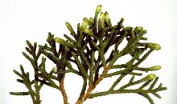  more photos...

Notes on taxonomy and nomenclature
Based on the revision of archival specimens and newly collected samples in the type locality in Japan (Honshu), a new genus Byakushincecis has been established. Aschistonyx eppoi Inouye has been reassigned to this new genus as it did not match the morphological characteristics of the genus Aschistonyx, under which it was originally described (Yukawa et al., 2024). Presently, Aschistonyx is a monotypic genus accommodating only one species Aschistonyx carpinicolus Rübsaamen, 1917 (Yukawa et al., 2024). Byakushincecis eppoi differs from A. carpinicolus in certain morphological characteristics. B. eppoi has different antennae (in males, middle circumfilum not shorter than the two others) and middle leg structures (lobe of spines is little longer than claw on the final leg segment), a narrower ventral plate, a shorter ovipositor and cerci compared to A. carpinicolus. Detailed species diagnosis is provided in Yukawa et al. (2024). In Japan, intraspecific genetic diversity of Byakushincecis eppoi in DNA barcoding fragments is less than 0.5% based on the analysis of five specimens from Juniperus chinensis var. globosa and J. chinensis var. sargentii (Yukawa et al., 2024).
The species name ‘eppoi’ seems to be derived from the first name of Mr Eppo Inouye, who observed some life history aspects and collected many specimens of the gall midge in Toyohira, Sapporo, Hokkaido (Japan), which were used for the species description (Inouye, 1964).

HOSTS
The Chinese juniper Juniperus chinensis and its varieties are the only known hosts (Inouye, 1964; Yukawa, 1976; Paik et al., 2004; Yukawa et al., 2021, 2024). In the EPPO region, J. chinensis is mainly planted as an ornamental tree in gardens and used indoors as a bonsai tree, and there is no available data on the susceptibility of European species of junipers (EFSA, 2018).
Host list: Juniperus chinensis var. chinensis, Juniperus chinensis var. sargentii, Juniperus chinensis

GEOGRAPHICAL DISTRIBUTION
Byakushincecis eppoi occurs in Japan (Honshu – Okayama and Saitama Prefectures) and the Republic of Korea (Yukawa et al., 2021, 2024); and is not present in Europe (Bell et al., 2013; Björklund & Boberg, 2021).
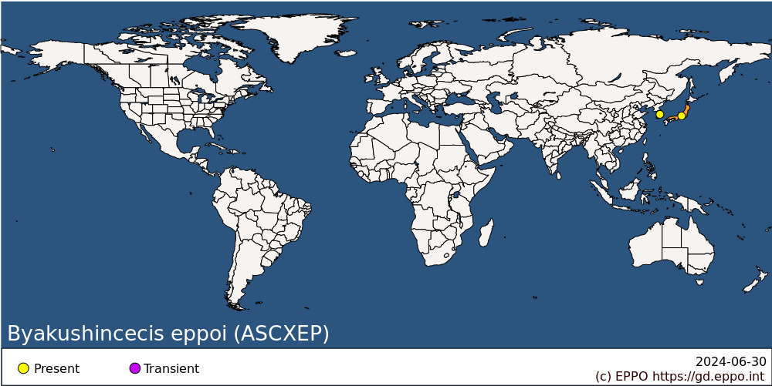
Asia: Japan (Honshu), Korea, Republic

BIOLOGY
Byakushincecis eppoi is a univoltine species. In Japan, the adults emerge from the ground at the end of May – beginning of June and lay eggs on the apical buds of juniper (Yukawa et al., 2024). The larvae develop within the buds and induce small quadrangular pyramid-like galls (Inouye, 1964;). They stay in the galls until the following April or beginning of May (Inouye, 1964). After leaving the galls, the larvae drop to the ground for pupation (Inouye, 1964; Yukawa et al., 2024). Overall, the species biology remains poorly studied.

DETECTION AND IDENTIFICATION

Symptoms
Small quadrangular pyramid-shaped swellings (galls) appear on the apical buds of juvenile shoots, which are particularly prominent in bonsai junipers (Inouye, 1964; Yukawa et al., 2024). The occurrence of galls on the apical buds in spring is the first sign of infestation (Inouye, 1964; Baker, 1995). This is followed by desiccation and browning of the twigs the following spring – early summer, after adult emergence (Inouye, 1964; Yukawa et al., 2024).

Morphology
Morphological characteristics of larvae, pupae and adults are given in Inouye (1964) and Yukawa et al. (2024).
Eggs
No information available.
Larva
The larva is elliptical, elongated (about 2.6 mm) and flat, reddish-yellow when fully grown, legless, with a well-developed but weakly chitinized head (Inouye, 1964). The mature larva has 8 papillae on the last body segment: 6 with a short conical protuberance and 2 with a prominent, pigmented conical protuberance (Yukawa et al., 2024).
Pupa
The pupa is cylindrical, with a pair of relatively long (about 130 μm) cephalic setae, a pair of lower facial papillae and two pairs of lateral facial papillae, each with a minute seta; and a long (about 220 μm) prothoracic spiracle (Yukawa et al., 2024). Head and thorax are yellow-brown (Inouye, 1964).
Adult
The adult is yellow-brown, with long legs and antennae and a pair of wings. It resembles a mosquito and is about 1.8 mm long in males (including male genitalia) and 1.8 mm (including ovipositor) in females (Inouye, 1964). The female has a short (approximately 0.16 mm long) ovipositor (Inouye, 1964; Yukawa et al., 2024).

Detection and inspection methods
So far, only visual inspection has been used to detect the damage caused by the larvae of B. eppoi. No traps, nor semiochemical attractants have been developed (Bell et al., 2013; Yukawa et al., 2024).

PATHWAYS FOR MOVEMENT
Adults of B. eppoi can spread naturally by flying over short distances. The main pathways of entry and spread are associated with plants for planting (EFSA, 2018). The pest can be transported over longer distances mainly with Chinese juniper plants, in particular bonsais (Baker, 1995). In Europe, several interceptions of J. chinensis bonsai plants originating from Japan have been made due to the presence of B. eppoi. For example, multiple infested consignments were detected in the United Kingdom during the 1970s (Bowman & Bartlett, 1978), and in 2021, two consignments were intercepted in the Netherlands (Karnkowski, 2021).
While there is a general prohibition on the import of Juniperus plants, Juniperus bonsai plants may be imported in accordance with requirements outlined in Commission Implementing Regulation (EU) 2023/1310. During the two years preceding export, Juniperus plants should have been grown in authorized nurseries, and subjected to official inspections at least six times per year to verify the absence of B. eppoi (Commission Implementing Regulation, 2023).

PEST SIGNIFICANCE

Economic impact
Severe infestation over two to three successive years results in diminished foliage density and stunted growth of the terminal shoots (Inouye, 1964). Affected plants, particularly bonsai trees, loose their commercial value (Karnkowski, 2021).

Control
No particular control measures have been established, and in Japan no specific insecticides have been registered for use against B. eppoi (Yukawa et al., 2024). Destruction of the infested plants seems to be the only control measure (Yukawa et al., 2024).

Phytosanitary risk
Phytosanitary risk is currently low as in a large part of the EPPO region (i.e. European Union), the trade of Juniperus plants for planting is strictly regulated (Commission Implementing Regulation, 2023). Several interceptions of infested bonsai trees have been documented in Europe: in the United Kingdom (Bowman & Bartlett, 1978) and the Netherlands (Karnkowski, 2021), thus showing that the insect can be moved between continents via trade. However, Juniper bonsai trees are usually kept indoors and, thus, the risk of spreading and impacting juniper trees growing outdoor is low (EFSA, 2018). Moreover, B. eppoi is not known to infest juniper species of European origin (e.g. J. communis). However, as data is generally lacking on the biology of B. eppoi, the latter cannot be fully excluded (Karnkowski, 2021). In Sweden, studies have shown that the climatic conditions prevailing in this country would not support the species establishment (Björklund & Boberg, 2021).

PHYTOSANITARY MEASURES
Strict restrictions on the movement of Juniperus plants for planting from countries where it occurs can be implemented to avoid the introduction of B. eppoi. The production of Juniperus bonsai trees within officially registered and controlled nurseries, as well as thorough and repeated inspections of plants in the country of origin prior to export are the main phytosanitary measures for preventing the entry of the pest into areas where it is absent (EFSA, 2018).

REFERENCES
Baker RHA (1995) Aschistonyx eppoi. Data Sheets on Quarantine Pests and summary pest risk assessment. Ministry of Agriculture, Fisheries and Food, Central Science Laboratory, Sand Hutton, York, PPR Point 4.3, 97/7020.
Bell H, Wakefield M, Macarthur R, Stein J, Collins D, Hart A, Roques A, Augustin S, Yart A, Péré C, Schrader G, Wendt C, Battisti A, Faccoli M, Marini L & Toffolo EP (2013) A review of the literature relevant to the monitoring of regulated plant health pests in Europe. Appendix C to the final report on: Plant health surveys for the EU territory: an analysis of data quality and methodologies and the resulting uncertainties for pest risk assessment (PERSEUS) CFP/EFSA/PLH/2010/01. https://www.ippc.int/static/media/files/publication/en/2015/09/13_EWG_ISPM6_2015_Sept_EFSA_PERSEUS_Appendix_C_to_the_Final_report.pdf
Björklund N & Boberg J (2021) Quick assessments of the potential for establishment in Sweden for a selection of quarantine pests. SLU Risk Assessment of Plant Pests. Sweden, 79 pp.
Bowman CE & Bartlett PV (1978) Pentamerismus oregonensis McGregor (Acari: Tenuipalpidae) infesting imported Juniperus chinensis L. in England. Plant Pathology 27(4), 200-201.
Commission Implementing Decision (EU) 2023/1310 of 27 June 2023. Official Journal of the European Union. 5 pp.
EFSA PLH Panel (EFSA Panel on Plant Health) Jeger M, Bragard C, Caffier D, Candresse T, Chatzivassiliou E, Dehnen-Schmutz K, Gilioli G, Jaques Miret JA, MacLeod A, Navajas Navarro M, Niere B, Parnell S, Potting R, Rafoss T, Rossi V, Urek G, Van Bruggen A, Van der Werf W, West J, Winter S, Kertesz V & Gregoire J-C (2018) Scientific Opinion on the pest categorisation of Aschistonyx eppoi. EFSA Journal 16(2), 5186, 17 pp. https://doi.org/10.2903/j.efsa.2018.5186
Inouye M (1964) Gall midges (Itonidae) attacking coniferous trees. Bulletin of the Forest Experimental Station, Meguro, Tokyo 164, 1-39 [In Japanese and English].
Karnkowski W (2021) Ashistonyx eppoi [sic]. Szkodnik podlegający obowiązkowi zwalczania. Państwowej Inspekcji Ochrony Roślin i Nasiennictwa (PIORiN) [Ashistonyx eppoi. A pest subject to mandatory control. National Plant Health and Seed Inspection Service (PIORiN)]. 1st edition, December 2021. https://piorin.gov.pl/files/userfiles/giorin/publikacje/ulotki/nowe_zagrozenia/ashistonyx_eppoi.pdf [in Polish].
Paik JC, Yukawa J, Uechi N, Sato S & Ganaha T (2004) Gall-inducing species of the family Cecidomyiidae (Diptera) recorded from the Korean Peninsula and surrounding islands, in comparison with the gall-midge fauna of Japan. Esakia 44, 57-66.
Yukawa J (1976) Check list of midge galls of Japan, with descriptions of newly recorded galls. II. Plants other than Choripetalae, 89-99.
Yukawa J, Tokuda M & Kim W (2021) Island Biogeography. In Yukawa J & Tokuda M (eds) Biology of Gall Midges Evolution, Ecology, and Biological Interactions, Springer Nature Singapore Pte Ltd., 296 pp.
Yukawa J, Tokuda M, Watanabe M, Inoue E, Uechi N & Yano F (2024) Redescriptions of three Japanese conifer‑infesting gall midges (Diptera: Cecidomyiidae) described by M. Inouye, with description of a new genus for Aschistonyx eppoi. Applied Entomology and Zoology 59, 79-89. https://doi.org/10.1007/s13355-023-00855-4

ACKNOWLEDGEMENTS
This datasheet was prepared in 2024 by Dr. Natalia Kirichenko (Sukachev Institute of Forest of the Siberian Branch of the Russian Academy of Sciences, Federal Research Center ‘Krasnoyarsk Science Center SB RAS’ and All-Russian Plant Quarantine Center, Krasnoyarsk branch, Krasnoyarsk, Russia). Her valuable contribution is gratefully acknowledged.

How to cite this datasheet?
EPPO (2024) Byakushincecis eppoi. EPPO datasheets on pests recommended for regulation. Available online. https://gd.eppo.int

Datasheet history
This datasheet was first published online in 2024. It is maintained in an electronic format in the EPPO Global Database. The sections on 'Identity', ‘Hosts’, and 'Geographical distribution' are automatically updated from the database. For other sections, the date of last revision is indicated on the right.

