EPPO Datasheet: Apriona germari
Last updated: 2019-06-27

IDENTITY
Preferred name: Apriona germari  Authority: (Hope)  Taxonomic position: Animalia: Arthropoda: Hexapoda: Insecta: Coleoptera: Cerambycidae  Other scientific names: Apriona cribata Thompson, Apriona germarii (Hope), Lamia germari Hope  Common names in English: brown mulberry longhorn beetle, jackfruit longhorn beetle, longhorn stem borer, mulberry longicorn beetle  view more common names online...  EPPO Categorization: A1 list  EU Categorization: Quarantine pest ((EU) 2019/2072 Annex II A)  view more categorizations online...  EPPO Code: APRIGE | 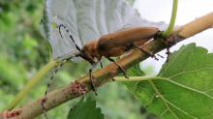  more photos...

HOSTS
The main hosts of A. germari include plants from nineteen families and thirty-six genera of plants such as Salicaceae, Moraceae, Ulmaceae and Rosaceae (Wang Yongjun et al., 1986). The following hosts are the most reported in the literature: mulberry (Morus spp.), poplar (Populus spp.), willow (Salix spp.), apple (Malus spp.), fig (Ficus carica), paper mulberry (Broussonetia papyrifera), jackfruit (Artocarpus heterophyllus) and pagoda tree (Sophora japonica). It should also be noted that the host range has two elements: the species on which larvae can develop to maturity and the species on which adults carry out their maturation feeding. Mulberry, paper mulberry and wolfberry (Lycium barbarum) are considered the main trees for maturation feeding of A. germari.
Host list: Artocarpus chama, Artocarpus heterophyllus, Artocarpus integer, Bombax ceiba, Broussonetia kazinoki, Broussonetia papyrifera, Cajanus cajan, Cajanus, Camellia oleifera, Carya illinoinensis, Celtis sinensis, Cinnamomum camphora, Citrus x aurantium var. unshiu, Citrus x aurantium, Citrus, Crataegus phaenopyrum, Cunninghamia lanceolata, Dalbergia, Diospyros kaki, Eriobotrya japonica, Ficus carica, Ficus hispida, Ficus retusa, Firmiana simplex, Juglans mandshurica, Juglans regia, Juglans, Lagerstroemia indica, Malus asiatica, Malus baccata, Malus domestica, Malus, Melia azedarach, Morus alba, Morus indica, Morus macroura, Morus, Paulownia, Pinus massoniana, Pinus yunnanensis, Platycarya strobilacea, Populus alba, Populus maximowiczii, Populus nigra var. italica, Populus tomentosa, Populus x canadensis, Populus, Prunus pseudocerasus, Pterocarya stenoptera, Punica granatum, Pyrus pyrifolia var. culta, Pyrus, Quercus acuta, Quercus, Robinia pseudoacacia, Rubus, Salix babylonica, Salix gracilistyla, Salix tetrasperma, Salix, Schima superba, Styphnolobium japonicum, Triadica sebifera, Ulmus pumila, Ulmus, Vernicia fordii

GEOGRAPHICAL DISTRIBUTION
Note: although Japan is mentioned in several publications on A. germari, it seems that this pest is not present in that country, but that there may be confusion with A. japonica.
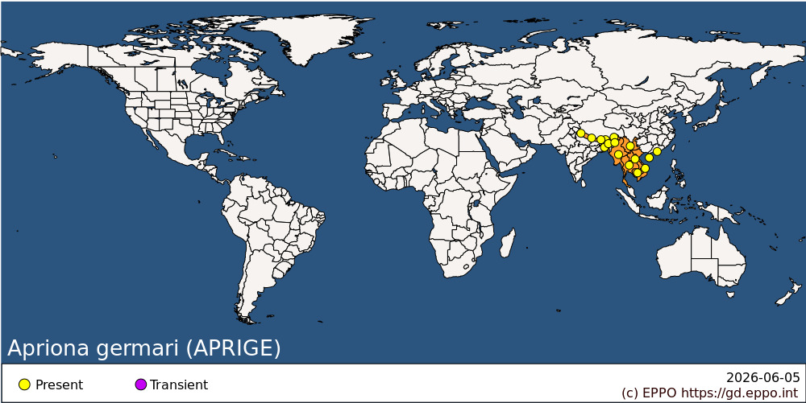
Asia: Bangladesh, Bhutan, Cambodia, China (Aomen (Macau), Hainan, Yunnan), India (Arunachal Pradesh, Meghalaya, Nagaland, Sikkim, Uttarakhand), Lao People's Democratic Republic, Myanmar, Nepal, Thailand, Vietnam

BIOLOGY
In China, the length of the lifecycle varies with climate and latitude. The further north A. germari is found, the longer it takes for a generation to develop. It is considered that a single generation takes 2–3 years to develop. Adults emerge between July and October. Females mate and lay eggs 10–15 days after emergence. Eggs are laid under the bark, in oviposition slits chewed out by the female. Larvae feed first in the sapwood and then bore into the heartwood, with small frass expulsion holes made through the bark. Several larvae may be present in the same tree. The overwintering stage is the egg or larva. The pupal stage of A. germari occurs between the middle of June and the middle of August.

DETECTION AND IDENTIFICATION
Symptoms
The adults of A. germari eat tender tree bark for maturation feeding and leave irregular scars on the tree. This usually leads to serious damage to twigs (Shimei & Rongwu, 1992).
Larvae of A. germari are the most damaging lifestage for the hosts. Resin bleeds can be observed from oviposition holes and larval tunnels in the bark. Compared with other genera, larva of A. germari are easier to detect as while boring down along the heartwood of trunk, they have to bore transverse tunnels for frass ejection leaving a row of frass expulsion holes outside the trunk. Usually, these round holes are on the same side of the trunk and both the diameters of holes and the distances between two adjacent holes gradually increases from the top to the bottom of the tree. Frass accumulates at the base of the tree.
Morphology
Eggs
About 5–7 mm long, oval, yellow white, slightly curved with a narrow front-end.
Larva
The larva is a legless grub up to 76 mm long when fully grown. It is creamy white in colour, with a chitinized brown mark on the prothorax, its width can reach 13 mm.
Pupa
Fusiform, yellow or yellow-white and 50 mm long. Antennae extend backward and curving at the end and its wings reach the third abdominal segment.
Adult
Typically cerambycid in shape, 26–51 mm in length, 8–16 mm in width. It is generally black and completely covered with an orangy-brown to greenish-yellow pubescence. Its centre point, lateral margin and edge of elytrum usually have a grey narrow brim. The antenna of female is slightly longer than the body, while the male’s antenna length is 2 or 3 segments beyond the body. The base of elytra is densely covered by black shiny nodular particles, which occupy one-fourth to one-third section; the inner and outer end-angle at the end of elytra shows a thorn-like protuberance.

PATHWAYS FOR MOVEMENT
There is not much data on the capacity for natural spread of A. germari. A survey carried out in Hebei Province suggested that 400 m was a safe distance from a source site of A. germari (Fengxin et al., 1997). However, another field survey accompanied with bait revealed that adults of A. germari can fly as far as 2500 m for food, although most individuals were caught between 250 and 550 m (Ruitong et al., 1998).
This insect can be transported with plants and wood products (including wood, wood packaging, wood chips, firewood) containing bark, moving in international trade. It is regularly intercepted in Europe on wood packaging material from Asia.

PEST SIGNIFICANCE
Economic impact
The main damage associated with Apriona spp. is caused by the larvae, which bore into the wood soon after hatching, creating long tunnels. This affects the growth of the trees and decreases the quantity and quality of the timber and longevity of the trees (Shui et al., 2009; Li, 1996) and this causes weakness, which increases the chances of wind break. Trees may die and stems/trunks might be broken. The timber becomes unsuitable for commercial use and entry of fungi and pathogens in the galleries cause discoloration of the wood.
In the area of its present distribution in China, A. germari is considered as a serious threat to forest, especially to poplar plantation. In particular, the occurrence of A. germari in poplar plantations in the middle and lower reaches of Changjiang River caused serious damage to agriculture and forestry (Ruitong et al., 1994). In addition, A. germari is also a threat to fruit production, especially to fig in southern Jiangshu Province (Shaolin et al., 1997). According to Shuping et al. (1999), in China the susceptibility sequence of host trees of A. germari are as follow: (1) Moraceae; (2) Salicaceae; (3) Ulmaceae; (4) The main planted fruit tree in North China; and (5) Some other tree species planted for afforestation. In addition to various species of Moraceae, Populus tomentosa, Malus pumila, Malus spectabilis and Malus asiatica are among the most susceptible tree species.
A. germari can attack healthy trees as well as trees under stress.
Control
Control measures include chemical control (including sprays or microcapsules targeting the adults or eggs and young larvae, and injections methods targeting older larvae in trunks and branches), physical control (removing host trees such as mulberry or paper mulberry on which maturation feeding could occur, or manually catching and killing adults), and biological control (injection of Beauvaria bassiana into larval holes, use of parasitic nematodes such as Steinernema pravassos and Heterorhabditis spp.). Cultural practices such as sanitation felling (i.e. destruction of damaged and infested plants, or pruning), or use of trap trees, as well as methods to maintain tree vigour help reduce damage.
Natural enemies include the parasitic wasps Aprostocetus prolixus on eggs and Dastarcus helophoroides on larvae and pupae, as well as Iphiaulax imposter and Eleonoria heivan, Aprostocetus fukutai, Parecerchysius ceresii and the woodpecker Dendrocopos major.
Phytosanitary risk
A. germari is present in an area with an extensive range of different climatic conditions. In areas where A. germari could establish, the pest would attack poplars, apple trees, willows and other crops and plants in the natural environment, commercial orchards, gardens, plantations and urban areas. It is expected that the potential damage would be high in the southern part of the EPPO region where the pest is more likely to establish outdoors, especially if it established in the wild on hosts that occurred extensively with or without management (e.g. poplar). Uncertainty on impact is medium to high as it is unclear how host preferences influence the development of populations, and whether specific hosts are needed in the life cycle of the pest for adult maturation (such as mulberry or paper mulberry), and the role of current management measures is not clear.
Environmental impact could be major if the pest reaches forests and other environments where poplar, willow, chestnut, Crataegus, Robinia etc. are present. However, there is uncertainty as to the extent to which species belonging to host genera that are present in the PRA area, but not in the area of origin, might be attacked.
The number of interceptions of A. germari in wood packaging material despite the implementation of ISPM 15, and the introduction of other wood borers from the same area of origin (e.g. Anoplophora glabripennis) into Europe show that there are pathways to disseminate this pest outside its area of origin.

PHYTOSANITARY MEASURES
Experience with other cerambycid beetles in the EPPO region showed that their eradication once introduced is very difficult. Therefore priority should be given to prevent their entry.
Suggested phytosanitary measures for commodities of host plants include origin from a pest-free area, or a pest-free site under physical protection or treatment (heat or irradiation for wood, and chipped to a size smaller than 3 cm for wood chips). Wood packaging material should be treated according to ISPM 15.

REFERENCES
EPPO (2013) Pest risk analysis for Apriona germari, A. japonica, A. cinerea. EPPO, Paris. http://www.eppo.int/QUARANTINE/ Pest_Risk_Analysis/PRA_intro.htm [accessed on 1 June 2013]
Fengxin M, Dazhuang H & Junjie Y (1997) [Occurrence characteristics and control countermeasures of Apriona germari in Xiling of Yixian County]. Hebei Journal of Forestry and Orchard Research 12, 83–86.
Li K (1996) Poplar stem-boring pests and their control. Journal of Northeast Forestry University 7(1), 51.
Ruitong G, Chuanyin L & Yongnong L (1994) [A preliminary study on the causes and use of preference of Apriona germari adults supplementary nutrition for mulberry and papermulberry]. Scientia Silvae Sinicae 30, 376–380.
Ruitong G, Guohong L & Guangwu L (1998) [Research and application on bait of Apriona germari]. Forest Science and Technology 30, 376–380.
Shaolin Q, Jinsheng Y & Lin M (1997) [The occurrence and damage of mulberry longicorn in Sunan hilly area and its controlling strategies]. China Plant Protection 17, 28–29.
Shimei Z & Rongwu S (1992) Apriona germari. In: [Chinese Forest Insects] (2nd edn) (Ed. Gangrou X), pp. 461–463. China Forestry Press, Beijing (CN).
Shuping Z, Dazhuang H & Junjie L (1999) [The sequence choice of the main tree species to Apriona germari in northern part of China]. Journal of Northeast Forestry University 27, 17–22.
Shui SY, Wen JB, Chen M, Hu XL, Liu F & Li J (2009) Chemical control of Apriona germari (Hope) larvae with zinc phosphide sticks. Forestry Studies in China 11, 9–13.
Yongjun W, Jilin Z & Danren Q (1986) [A plot study of the relationship between the occurence of A. germari and its extranutrition]. Jiangshu Forestry Technology 1, 32–34 (in Chinese).
Yoon HJ, Park IG, Mah YI, Lee SB & Yang SY (1997) Ecological characteristics of mulberry longicorn beetle, Apriona germari Hope, at the hibernation stage in mulberry fields. Korean Journal of Applied Entomology 36, 67–72.

ACKNOWLEDGEMENTS
This Datasheet was originally drafted by Y. Luo, Beijing Forestry University, Beijing, China. It was further elaborated based on the results of the Pest Risk Analysis conducted by an EPPO expert working group in December 2011 (EPPO, 2013).

How to cite this datasheet?
EPPO (2026) Apriona germari. EPPO datasheets on pests recommended for regulation. Available online. https://gd.eppo.int

Datasheet history
This datasheet was first published in the EPPO Bulletin in 2014 and is now maintained in an electronic format in the EPPO Global Database. The sections on 'Identity', ‘Hosts’, and 'Geographical distribution' are automatically updated from the database. For other sections, the date of last revision is indicated on the right.
EPPO (2014) Apriona germari. Datasheets on pests recommended for regulation. EPPO Bulletin 44(2), 155-158. https://doi.org/10.1111/epp.12127

