EPPO Datasheet: Anthonomus signatus
Last updated: 2024-02-28

IDENTITY
Preferred name: Anthonomus signatus
Authority: Say
Taxonomic position: Animalia: Arthropoda: Hexapoda: Insecta: Coleoptera: Curculionidae: Curculioninae
Other scientific names: Anthonomus pallidus Dietz, Anthonomus scutellatus Gyllenhal
Common names in English: strawberry bud weevil, strawberry clipper, strawberry weevil
view more common names online...
EPPO Categorization: A1 list
EU Categorization: A1 Quarantine pest (Annex II A)
view more categorizations online...
EPPO Code: ANTHSI

Notes on taxonomy and nomenclature
In the EPPO region, Anthonomus rubi (Herbst) is very similar in appearance and habits to A. signatus, and another similar species, A. bisignifer Schenkling, is recorded from Japan (EPPO, 2024). The two 'exotic' species have thus to be distinguished from the commonplace and widespread European A. rubi.

HOSTS
Strawberries are the principal host of A. signatus, but Rubus spp. are also noted as minor hosts: blackberries, raspberries, , R. occidentalis, as well as Vaccinium spp. These hosts are widely grown in the EPPO region.
The pest has been recorded, presumably incidentally, on other hosts (Headlee, 1918; Baerg, 1923).
Host list: Cercis canadensis, Fragaria vesca, Fragaria virginiana, Fragaria x ananassa, Potentilla canadensis, Rubus fruticosus, Rubus idaeus, Rubus occidentalis, Rubus sp., Vaccinium sp.

GEOGRAPHICAL DISTRIBUTION
Anthonomus signatus is native and restricted to North America. In the USA, it is found in all States east of the Mississippi River, and some States West of the Mississippi and East of the Rockies. In Canada, it is found in all provinces except Yukon, the North West Territories and Nunavut.
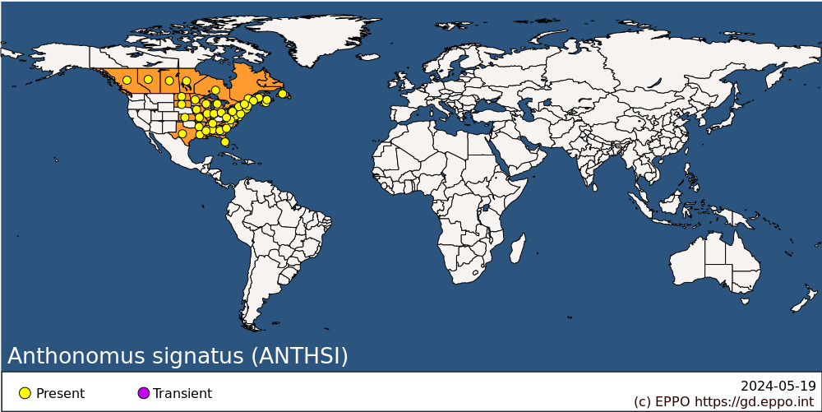
North America: Canada (Alberta, British Columbia, Manitoba, New Brunswick, Newfoundland, Nova Scotia, Ontario, Prince Edward Island, Québec, Saskatchewan), United States of America (Alabama, Arkansas, Connecticut, Delaware, District of Columbia, Florida, Georgia, Illinois, Indiana, Iowa, Kansas, Louisiana, Maine, Maryland, Massachusetts, Michigan, Minnesota, Mississippi, Missouri, New Hampshire, New Jersey, New York, North Carolina, North Dakota, Ohio, Pennsylvania, South Carolina, South Dakota, Tennessee, Texas, Vermont, Virginia, West Virginia, Wisconsin)

BIOLOGY
A. signatus overwinters as an adult around the base of strawberry plants, and in litter and moss in adjacent woodlands and hedgerows. The weevils emerge in spring and feed on leaves of strawberry or Rubus, and most extensively on the flower buds. The females lay their eggs in holes pierced in staminate buds. After oviposition, females girdle the pedicel below the bud. The stem wilts, the bud droops and may later fall off. The egg takes 6-14 days to hatch and the larvae then feed for 3-4 weeks in the severed bud hanging on the plant or on the ground. Even when decaying, the severed bud still provides enough food for the larva, and it is within this bud that they then pupate. After 5-8 days, the adult emerges and feeds for some weeks on flowers before moving into diapausing sites in late July and August. The adults are sluggish on cool, cloudy days but fly readily in bright warm conditions. They can be seen mating throughout the oviposition period (Baerg, 1923). Sampling adults with a vacuum aspirator in insecticide-free plots showed that adults peaked in late-May in strawberry and raspberry cultivated in Quebec, Canada (Rivard et al., 1979). A second peak of adults was determined in both plots in mid-August.

DETECTION AND IDENTIFICATION

Symptoms
Partially severed buds can be seen hanging from the plants, and severed buds lying on the ground.

Morphology
Morphometric data of all stages are presented in Mailloux and Bostanian (1993).
Eggs
About 0.5 mm, glassy-white, laid among anthers in the bud.
Larva
Glassy-white becoming greyish in the later stages. Descriptions, illustrations and keys for the larva are provided by Ahmad & Burke (1972). There are three larval instars. They have an average head capsule width of 0.266 (L1), 0.375 (L2) and 0.510 (L3) mm (Mailloux and Bostanian, 1993).
Pupa
Yellowish-white, about 2-3 mm x 1-2 mm, formed in the remains of the bud. Descriptions, illustrations and keys for the pupa are provided by Burke (1968).
Adult
About 2.5 mm long. Usually reddish-brown to black with a large dark spot on each elytron. However, the colour is variable and the spots may be absent. Adult females and males can be differentiated by observing the pygidium (Fig. 3 in Mailloux and Bostanian, 1993). Overwintered and summer adults have a 1:1 sex-ratio. Newly emerged individuals (teneral) can be distinguished from older ones by their callow integument (Mailloux and Bostanian, 1993).

Detection and inspection methods
Several monitoring methods were used to assess strawberry clipper weevil populations. Mailloux and Bostanian (1993) collected fallen buds and monitored emerging adults under Berlese funnels. Adults were sampled by beating strawberry plants with a wooden board over a cloth net placed underneath the foliage. Local movements of adults have been studied by positioning sticky traps (Mailloux and Bostanian, 1993). The abundance of adults has been determined by sweep-netting, container tapping over flower clusters, and vacuum aspirators (Bostanian and Mailloux, 1999). Damage is assessed by determining the number of buds clipped per unit of row (e.g. m). A predictive model to determine adult abundance and build-up based on day-degree accumulation has been developed by Bostanian et al. (1999).

PATHWAYS FOR MOVEMENT
Adults can fly over small distances. International movement is most likely to occur on planting material of strawberry and Rubus spp. Severed buds with larvae, or adults, might accidentally accompany consignments of fresh fruit.

PEST SIGNIFICANCE

Economic impact
In southern New Jersey (US), at the beginning of the century (Headlee, 1918), A. signatus completely destroyed the strawberry crop over considerable areas and greatly reduced it in others. Reductions of 75% were not uncommon. However, losses are less obvious with vigorously growing cultivars producing 40 or more buds per plant (Gorham, 1936). In New York State, strawberry yield reductions ranged from 50 to 100% and early season cultivars were generally more susceptible than late cultivars (Spangler et al., 1988). In field experiments conducted in New York State with June-bearing cultivars, no relationship was found between the naturally clipped buds per m and subsequent yield (English-Loeb et al., 1999). Only a small proportion (7%) of primary flower buds (that produce the bigger fruit) were attacked, and most attacks were on secondary flowers (Kovach et al., 1999).
An action threshold of two clipped buds per m of row has commonly been used by pest managers. However Pritts et al. (1999) considered that this threshold could be raised because when simulating clipper weevil damage in matted row plantings of 12 strawberry cultivars, yield at harvest (in grams/m row) was similar to the yield obtained in non-infested rows. These results suggested that a compensation mechanism following flower cut is taking place within the plants. McPhie and Burrack (2017) also concluded that in strawberries grown under annual plasticulture systems, strawberry plants compensate for clipped buds up to a certain point.

Control
With the appearance of DDT and dieldrin on the market, the pest came under good control. However, withdrawal of these pesticides has led A. signatus to become again one of the most important pests of strawberries in Michigan (US) (Clarke & Howitt, 1975). As of 2023, the Southern Region Strawberry pest management recommendations (Eastern USA) listed three insecticides that are targeted against adults: bifenthrin, fenpropathrin, and carbaryl (Pfeiffer, 2023). Field experiments conducted in New York State suggest that A. signatus can be managed effectively by treating peripheral rows (< 12 m from the border) of fields rather than entire fields (Kovach et al., 1999). Also, because damage to large, primary buds is limited to a small proportion (7%) of primary flowers that produce the largest fruit, thresholds could be raised.

Phytosanitary risk
In the EPPO region, A. signatus is likely to be at least as important a pest as A. rubi (see Identity). Temperature development curves (Clarke & Howitt, 1975) show its base temperature to be below 10°C, which is typical of Northern European species, and the general pattern of its geographical distribution suggests that it could survive perfectly well in most of Europe. In the EPPO region it is potentially dangerous to strawberries and, in northern countries especially, also to Rubus spp.

PHYTOSANITARY MEASURES
In general, phytosanitary requirements for soil cover the risk of A. signatus presence in soil. It can be recommended that, for plants for planting (of Fragaria, Rosa, Rubus and Vaccinium) from countries where A. signatus occurs, all importing countries should require that the consignment must have been grown in an area free from this pest and the plants they derive from must be found to be free from A. signatus during the growing season.

REFERENCES
Ahmad M & Burke HR (1972) Larvae of the weevil tribe Anthonomini (Coleoptera: Curculionidae). Miscellaneous Publications of the Entomological Society of America 8, 31-81.
Baerg WJ (1923) The strawberry weevil. Arkansas Agricultural Experiment Station Bulletin No. 185.
Bostanian NJ, Binns M, Kovach J, Racette G & Mailloux G (1999) A predictive model for strawberry bud weevil adults in strawberry fields. Environmental Entomology 28, 388-406.
Burke HR (1968) Pupae of the weevil tribe Anthonomini (Coleoptera: Curculionidae). Technical Monographs, Texas Agricultural Experiment Station 5, 1-92.
Clarke RG & Howitt AJ (1975) Development of the strawberry weevil under laboratory and field conditions. Annals of the Entomological Society of America 68, 715-718.
English-Loeb G, Pritts MP, Kovach J, Rieckenberg R & Kelly MJ (1999) Compensatory ability of strawberries for bud and flower removal: Implications for managing the strawberry bud weevil. Journal of Economic Entomology 92, 915-921.
EPPO (2024) Anthonomus bisignifer. EPPO datasheets on pests recommended for regulation. https://gd.eppo.int/taxon/ANTHBI/datasheet (accessed 2024-01-10).
Gorham RP (1936) The strawberry weevil. Multigraph, Fredericton, Canada.
Headlee WE (1918) The strawberry weevil. New Jersey Agricultural Station Bulletin No. 324.
Kovach J, Rieckenberg R, English-Loeb G & Pritts M (1999) Oviposition patterns of the strawberry bud weevil (Coleoptera: Curculionidae) at two spatial scales and implications for management. Journal of Economic Entomology 92, 1358-1363.
Mailloux G & Bostanian NJ (1993) Development of the strawberry bud weevil (Coleoptera: Curculionidae) in strawberry fields. Annals of the Entomological Society of America 86, 384-393.
McPhie D & Burrack H (2017) Effect of simulated Anthonomus signatus (Coleoptera: Curculionidae) injury on strawberries (Fragaria × ananassa) grown in Southeastern plasticulture production. Journal of Economic Entomology 110, 208-212.
Pfeiffer DG (2023) Strawberry bud weevil: Changing thresholds? Southern Region Small Fruit Consortium, (North Carolina State University – Raleigh, North Carolina). https://smallfruits.org/2023/01/strawberry-bud-weevil-changing-thresholds/
Pritts M, Kelly MG & English-Loeb G (1999) Strawberry cultivars compensate for simulated bud weevil damage in matted row plantings. HortScience 3, 109–111.
Rivard I, Mailloux G, Paradis RO & Boivin G (1979) Apparition des adultes de l’anthonome du fraisier, Anthonomus signatus Say, dans les fraisières et framboisières au Québec. Phytoprotection 60, 41-46.
Spangler S, Agnello A & Schaefers G (1988) Strawberry bud weevil (clipper), Anthonomus signatus. New York State Cornell Cooperative Extension Small Fruit Fact Sheet 102GFSSFI3, 2 p. http://hdl.handle.net/1813/43131

ACKNOWLEDGEMENTS
This datasheet was extensively revised in 2024 by Charles Vincent, formely Saint-Jean-sur-Richelieu Research and Development Centre, Agriculture and Agri-Food Canada, Saint-Jean-sur-Richelieu, QC, Canada. His valuable contribution is gratefully acknowledged.

How to cite this datasheet?
EPPO (2024) Anthonomus signatus. EPPO datasheets on pests recommended for regulation. Available online. https://gd.eppo.int

Datasheet history
This datasheet was first published in the EPPO Bulletin in 1989 and revised in the two editions of 'Quarantine Pests for Europe' in 1992 and 1997, as well as in 2024. It is now maintained in an electronic format in the EPPO Global Database. The sections on 'Identity', ‘Hosts’, and 'Geographical distribution' are automatically updated from the database. For other sections, the date of last revision is indicated on the right.
CABI/EPPO (1992/1997) Quarantine Pests for Europe (1st and 2nd edition). CABI, Wallingford (GB).
EPPO (1989) EPPO Datasheet on quarantine organisms no 164: Anthonomus signatus. EPPO Bulletin 19(4), 667-670. https://onlinelibrary.wiley.com/doi/abs/10.1111/j.1365-2338.1989.tb01157.x

