EPPO Datasheet: Squash leaf curl virus
Last updated: 2023-11-20

IDENTITY
Preferred name: Squash leaf curl virus  Taxonomic position: Viruses and viroids: Monodnaviria: Shotokuvirae: Cressdnaviricota: Repensiviricetes: Geplafuvirales: Geminiviridae: Begomovirus  Other scientific names: SLCV, SLCuV, Squash leaf curl begomovirus, Squash leaf curl bigeminivirus, Squash leaf curl geminivirus  Common names in English: curly mottle of watermelon, leaf curl of melon, leaf curl of squash, necrotic mosaic of melon  view more common names online...  EPPO Categorization: A2 list  view more categorizations online...  EPPO Code: SLCV00 | more photos...

Notes on taxonomy and nomenclature
There are uncertainties on the synonymy of Squash leaf curl virus with Watermelon curly mottle virus (WCMoV), a whitefly transmitted begomovirus initially reported on watermelon in Arizona (USA) in 1986 (Brown & Nelson, 1986, 1989) and Melon leaf curl virus (MLCV) described in melon in California (USA) in 1985, (CABI, 2023). ICTV downgraded Watermelon curly mottle virus and Melon leaf curl virus from species to tentative species (ICTV, 2023). WCMoV and MLCV are not covered by this datasheet.
This datasheet does not cover Squash leaf curl Philippines virus and Squash leaf curl China virus which are different species (ICTV, 2023).

HOSTS
The original strain of the virus (SLCV-CA) was reported in California (USA) damaging crops of Cucurbita maxima and other cucurbits. The host range of SLCV includes all major crops of the family Cucurbitaceae including Cucumis sativus (cucumbers), Cucumis melo (melons), Citrullus lanatus (watermelons). The virus has also been reported infecting three Solanaceae crops (tomato, pepper and eggplant) and cotton. SLCV has also been reported from a few wild Cucurbita spp., native Cactaceae and weeds from various families (Anfoka et al., 2017; Fontenele et al., 2021).
Host list: Capsicum annuum, Chenopodiastrum murale, Citrullus lanatus, Convolvulus sp., Cucumis melo, Cucumis sativus, Cucurbita maxima, Cucurbita moschata, Cucurbita pepo, Cylindropuntia whipplei, Ecballium elaterium, Ferocactus acanthodes, Gossypium, Malva neglecta, Malva nicaeensis, Malva parviflora, Opuntia atrispina, Opuntia basilaris, Opuntia caracassana, Opuntia robusta, Opuntia, Pereskiopsis kellermanii, Phaseolus vulgaris, Physalis ixocarpa, Proboscidea louisianica, Prosopis farcta, Raphanus sativus, Sinapis arvensis, Solanum lycopersicum, Solanum melongena

GEOGRAPHICAL DISTRIBUTION
Squash leaf curl virus was initially identified in the USA in the 1970s and in 2002 the virus was reported for the first time outside the New World in Israel, and then spread to other countries in the Near East (Lapidot et al., 2014).
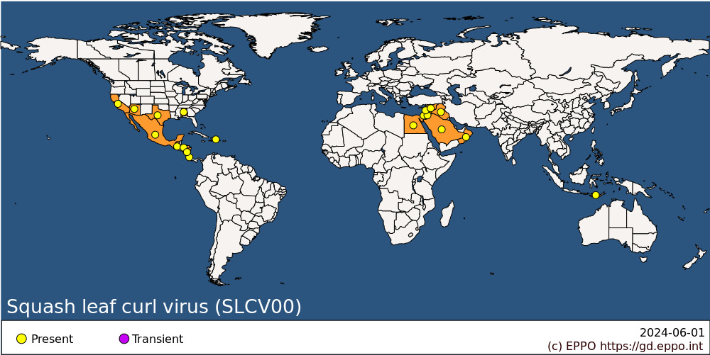
EPPO Region: Israel, Jordan
Africa: Egypt
Asia: Indonesia (Nusa Tenggara), Iraq, Israel, Jordan, Lebanon, Oman, Saudi Arabia, Syria
North America: Mexico, United States of America (Alabama, Arizona, California, Texas)
Central America and Caribbean: Costa Rica, Dominican Republic, Guatemala, Honduras, Nicaragua

BIOLOGY
SLCV is transmitted in a persistent manner by Bemisia tabaci, especially MEAM1 species (Middle East-Asia Minor, formerly known as biotype B). Viruliferous whiteflies can retain the virus for 26 days (Cohen et al., 1983). It is not transmitted by mechanical inoculation.
There are no reports of seed transmission.

DETECTION AND IDENTIFICATION

Symptoms
SLCV causes severe leaf curling thickened leaf vein-banding and mild chlorosis and leaf malformation. Fruits of infected plants are usually unmarketable.

Morphology
SLCV has geminate particles, 22 x 38 nm in size (Cohen et al., 1983). The virus is associated with maturing phloem sieve tube elements (Hoefert, 1987).

Detection and inspection methods
ELISA is a simple and reliable method used to detect SLCV (Farag et al., 2011; McCreight & Kishaba, 1991). The virus can also be detected by PCR in DNA obtained from infected plants. An EPPO Diagnostic Protocol for Begomoviruses covers detection and/or identification of SLCV (EPPO Standard PM 7/152, EPPO 2022).

PATHWAYS FOR MOVEMENT
SLCV moves only in its vector B. tabaci, which can spread it between fields and glasshouses in infested areas. In international trade, it is very unlikely to be carried by plants of its main cultivated hosts, since these are short-lived vegetable crops not normally moved except as seedlings. Young seedlings for transplanting might constitute a pathway for spread within the EPPO region. The vegetables as such are not likely to carry B. tabaci. So, the main risk of movement is in B. tabaci on alternative host plants (e.g., ornamentals), given the fact that the vector moves readily from one host to another, and that the virus can persist in the vector for several weeks after acquisition. Seed is not a pathway as no seed transmission has been reported for SCLV.

PEST SIGNIFICANCE

Economic impact
SLCV has caused severe losses of squashes, melons and related cucurbits in Arizona, California and Texas (USA) (Duffus & Flock, 1982; Isakeit et al., 1994; Kuo et al., 2007; Nameth et al., 1985) as well as in Mexico (Vargas-Salinas et al., 2020). In a study conducted in Israel, Sufrin-Ringwald & Lapidot showed that dual infection of melon plants with SLCV and Watermelon chlorotic stunt virus (WmCSV) caused yield reduction of 54% (Sufrin-Ringwald & Lapidot, 2010). In Egypt, Idris et al. (2006) reported that SLCV caused severe symptoms in pumpkin crops (Cucurbita pepo). The virus was reported to cause 23% yield reduction in beans (Phaseolus vulgaris) when plants were infected at early growth stages by SLCV (Farrag et al., 2014).

Control
Together with the rational use of systemic insecticides to control the vector, planting SLCV-resistant plants is the most effective way to reduce disease incidence. However, cucurbit hybrids resistant to the virus are still not available, therefore, cultural practices that can reduce B. tabaci population should be followed by farmers to reduce yield losses caused by SLCV. These practices include removing overwintering crops early in the season prior to the emergence of adult whiteflies, destroying weeds that may act as alternative hosts for B. tabaci, covering the soil with a mulch of sawdust, fresh wheat straw or yellow polyethylene sheets and growing plants under physical barriers, such as low mesh tunnels and shade-cloth.

Phytosanitary risk
SLCV presents a threat to the cultivation of cucurbits (especially courgette, melon, squash and watermelon), in the southern part of the EPPO region as well as under glass in the northern part, wherever B. tabaci occurs. It has established in some countries in the Near East and may further established in other EPPO countries.

PHYTOSANITARY MEASURES
Host plants for planting should only be imported from pest-free areas for the virus. They may also come from areas where the virus occurs if they are produced in pest-free sites of production e.g. under isolation or where measures are implemented to avoid the presence of B. tabaci (e.g. green/screenhouses, trapping) and no symptoms of the virus are observed during the cycle of vegetation. Surveillance (visual inspection followed by laboratory testing) contributes to early detection of SLCV infected plants and assessment of vectors for targeted insecticide application.

REFERENCES
Anfoka G, Altaleb M, Haj Ahmad F & Abu Obaida M (2017) Charlock mustard (Sinapis arvensis): a weed reservoir for begomoviruses and associated betasatellite in Jordan. Canadian Journal of Plant Pathology 39, 325-333.
Brown JK & Nelson MR (1989) Characterization of watermelon curly mottle virus, a geminivirus distinct from squash leaf curl virus. Annals of Applied Biology 115, 243-252.
Brown JK & Nelson MR (1986) Whitefly-borne viruses of melons and lettuce in Arizona. Phytopathology 76, 236-239.
CABI (2023) Datasheet on Squash leaf curl virus (leaf curl of squash). https://doi.org/10.1079/cabicompendium.1503
Cohen S, Duffus JE, Larsen RC, Liu HY & Flock RA (1983) Purification, serology, and vector relationships of squash leaf curl virus, a whitefly-transmitted geminivirus. Phytopathology 73, 1669-1673.
Duffus JE & Flock RA (1982) Whitefly-transmitted disease complex of the desert southwest. California Agriculture 36, 4-6.
EPPO (2022) EPPO Standard on Diagnostics PM 7/152 (1) Begomoviruses. EPPO Bulletin 52, 643–664 https://doi.org/10.1111/epp.12887
Farrag AA, El-Attar AK, El-Banna OM, Ibrahim AI, Mazyad HM (2014) Squash leaf curl virus (SLCV) incidence and severity on Phaseolus vulgaris in Egypt. Egyptian Journal of Virology 11(2), 112-123.
Farag AG, Mohamed EF, Osman TA, Ahmed EA (2011) Detection and molecular characterization of squash leaf curl begomoviruses (SqLCV) in Egypt. Arab journal of biotechnology 14(2), 199-212.
Fontenele RS, Bhaskara A, Cobb IN, Majure LC, Salywon AM, Avalos-Calleros JA, Argüello-Astorga GR, Schmidlin K, Roumagnac P, Ribeiro SG, Kraberger S, Martin D P, Lefeuvre P & Varsani A (2021) Identification of the Begomoviruses squash leaf curl virus and watermelon chlorotic stunt virus in various plant samples in North America. Viruses 13, 810; https://doi.org/10.3390/v13050810
Hoefert LL (1987) Association of squash leaf curl virus with nuclei of squash vascular cells. Phytopathology 77, 1596-1600.
Idris AM, Abed-Salam A, Brown JK (2006) Introduction of the New World squash leaf curl virus to squash (Cucurbita pepo) in Egypt: A potential threat to important food crops. Plant Disease 90, 1262.
Isakeit T, Robertson NL, Brown JK, Gilbertson RL (1994) First report of squash leaf curl virus on watermelon in Texas. Plant Disease 78(10), 1010.
ICTV (2023) Current ICTV Taxonomy Release. https://ictv.global/taxonomy
Kuo YW, Rojas MR, Gilbertson RL, Wintermantel WM (2007) First report of Cucurbit yellow stunting disorder virus in California and Arizona, in association with Cucurbit leaf crumple virus and Squash leaf curl virus. Plant Disease 91(3), 330. https://doi.org/10.1094/PDIS-91-3-0330B
Lapidot M, Gelbart D, Gal-On A, Sela N, Anfoka G, Haj Ahmad F, Abou-Jawda Y, Sobh H, Mazyad H, Aboul-Ata A, El-Attar AK, Ali-Shtayeh MS, Jamous RM, Polston JE & Duffy S (2014) Frequent migration of introduced cucurbit-infecting begomoviruses among Middle Eastern countries. Virology Journal 11, 181. https://doi.org/10.1186/1743-422X-11-181
McCreight JD, Kishaba AN (1991) Reaction of cucurbit species to squash leaf curl virus and sweetpotato whitefly. Journal of the American Society for Horticultural Science 116(1), 137-141.
Nameth ST, Laemmlen FF & Dodds JA (1985) Viruses cause heavy melon losses in desert valleys. California Agriculture 39, 28-29.
Sufrin-Ringwald & Lapidot (2010) Characterization of a synergistic interaction between two cucurbit-infecting Begomoviruses: Squash leaf curl virus and Watermelon chlorotic stunt virus. Phytopathology 101, 281-289.
Vargas-Salinas M, Medina-Hernández D, Aranda-López O, Hernández-Barrera R, Holguín-Peña RJ (2020) Occurrence and geographic distribution of squash leaf curl virus in the Baja California Peninsula, Mexico. Canadian Journal of Plant Pathology 42(1), 107-115. https://doi.org/10.1080/07060661.2019.1631215

ACKNOWLEDGEMENTS
This datasheet was extensively revised in 2023 by Ghandi Anfoka, Al-Balqa Applied University. His valuable contribution is gratefully acknowledged.

How to cite this datasheet?
EPPO (2024) Squash leaf curl virus. EPPO datasheets on pests recommended for regulation. Available online. https://gd.eppo.int

Datasheet history
This datasheet was first published in 1997 in the second edition of 'Quarantine Pests for Europe', and revised in 2023. It is now maintained in an electronic format in the EPPO Global Database. The sections on 'Identity', ‘Hosts’, and 'Geographical distribution' are automatically updated from the database. For other sections, the date of last revision is indicated on the right.
CABI/EPPO (1997) Quarantine Pests for Europe (2nd edition). CABI, Wallingford (GB).

