EPPO Datasheet: Saperda candida
Last updated: 2022-01-19

IDENTITY
Preferred name: Saperda candida  Authority: Fabricius  Taxonomic position: Animalia: Arthropoda: Hexapoda: Insecta: Coleoptera: Cerambycidae  Other scientific names: Saperda bipunctata Hopping, Saperda bivittata Say  Common names in English: Saskatoon borer, round-headed apple-tree borer  view more common names online...  EPPO Categorization: A1 list  EU Categorization: A1 Quarantine pest (Annex II A)  view more categorizations online...  EPPO Code: SAPECN | 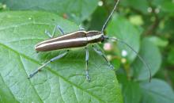  more photos...

Notes on taxonomy and nomenclature
There are no valid subspecies for this distinctive insect. The names bipunctata Hopping and bivittata Say are junior synonyms of candida Fabricius (Linsley & Chemsak, 1995).

HOSTS
Larvae feed nearly exclusively on woody hosts within the family Rosaceae (Linsley & Chemsak, 1995; 1997). In North America Cydonia, Malus and Pyrus are the most important cultivated hosts, while Amelanchier and Crataegus are the most common native wild hosts (Felt & Joutel, 1904). Aronia, Cotoneaster, Prunus and Sorbus are also reported as hosts while Pyracantha is possibly a host but this needs confirmation. Relatively recent studies (Vlasak & Vlasakova, 2002) report the rearing of adults from Betula.
Host list: Amelanchier alnifolia, Amelanchier canadensis, Amelanchier laevis, Aronia arbutifolia, Betula sp., Borkhausenia intermedia, Cotoneaster sp., Crataegus, Cydonia oblonga, Malus coronaria, Malus domestica, Prunus avium, Prunus domestica, Prunus persica, Pyrus communis, Sorbus americana

GEOGRAPHICAL DISTRIBUTION
The native range of this beetle is throughout the eastern United States as far west as Texas and the Dakotas (Linsley & Chemsak, 1995), and in southeastern Canada from Nova Scotia west to central Alberta (Bousquet et al., 2013; Bousquet et al., 2017). In 2008 it was detected in Germany on the island of Fehmarn (Nolte & Krieger, 2008), where eradication measures are being applied.
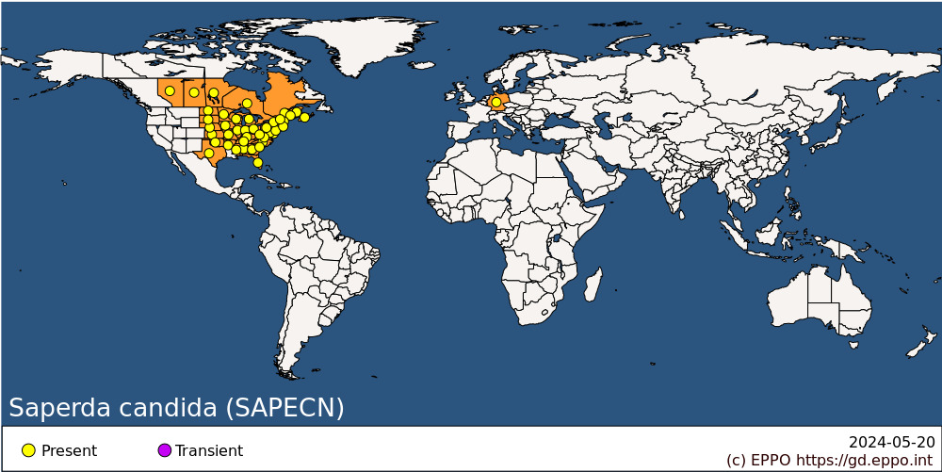
EPPO Region: Germany
North America: Canada (Alberta, Manitoba, New Brunswick, Nova Scotia, Ontario, Québec, Saskatchewan), United States of America (Alabama, Arkansas, Connecticut, Delaware, Florida, Georgia, Illinois, Indiana, Iowa, Kansas, Kentucky, Maine, Maryland, Massachusetts, Michigan, Minnesota, Mississippi, Missouri, Nebraska, New Hampshire, New Jersey, New York, North Carolina, North Dakota, Ohio, Oklahoma, Pennsylvania, Rhode Island, South Carolina, South Dakota, Tennessee, Texas, Vermont, Virginia, West Virginia, Wisconsin)

BIOLOGY
Adult beetles are typically active from May to September, emerging from early April in the southern part of their range to as late as June in the north. Adults begin maturation feeding on host foliage and the bark of small twigs with mating taking place after about 10 days. Females commence ovipositing soon thereafter. Eggs are laid singly in a longitudinal slit (6 – 18 mm in length) chewed into the base of the host trunk within 25 cm of the ground. One to 6 eggs can be laid on the same tree and a single female may lay up to 15 to 30 eggs over a period of 75 days. Multiple females will oviposit on the same trunk. Eggs hatch after 15 to 22 days and the newly hatched larva begins feeding downwards in the sapwood just under the bark making a sinuous gallery, eventually creating an oval chamber where the first winter is passed. Feeding in the sapwood resumes the following spring with characteristic accumulations of red frass on the ground after being ejected from the galleries. By late summer the larva is about half grown and still feeding in the sapwood where it will spend the second winter. Feeding is completed the following summer at which time the larva bores into the heartwood to create a pupation chamber filled with frass and long wood fibres. The third winter is passed in this chamber as a quiescent final instar larva. Pupation commences the next spring and lasts about 3 weeks. The teneral adult remains in the pupal chamber for about 2 weeks before chewing its way through the bark and emerging as a fully sclerotized adult. The life cycle can be reduced to two years in the south, or extend up to four years in the north (Felt & Joutel, 1904; Hess, 1940; Solomon, 1995).

DETECTION AND IDENTIFICATION

Symptoms
Girdling damage and weakness at the base of the host trunk is symptomatic of attack, as is the accumulation of frass and wood fibres on the ground after being ejected from feeding galleries (Solomon, 1995).

Morphology
Eggs are elongate and flattened, about 8 mm in length and 1/3 that in width at mid-point, pale rusty-brown in colour and lacking any noticeable sculpture (Felt & Joutel, 1904).
Larvae are elongate with a brownish oblong head and a cylindrical white to yellowish-white body sparsely clothed with coarse castaneous setae, and lacking legs or terminal appendages. The pronotum is heavily chitinized anteriorly with coarse recurved asperities posteriorly (Craighead, 1923). Maximum length up to 38 mm (Solomon, 1995).
Pupa similar to larva but with a few small chitinous points on the head and body and with coarse setae grouped on the pronotum, mesonotum, in a V-shaped group on the metanotum, and as dense transverse rows across the abdominal terga (Craighead, 1923).
Adults are 10 to 25 mm in length, with antennae slightly longer than the length of the body. Dorsally light brown to black with two distinct longitudinal white stripes extending from the head down the length of the body to the apex of the elytra (Evans, 2014). The white stripes are sometimes interrupted on the elytra near the middle. The antennae and legs are covered with greyish pubescence while the underside of the body is clothed with white pubescence.

Detection and inspection methods
The fact that the larvae feed internally on the lower stems and trunks of host material makes detection difficult. Careful inspection of stems near ground level can reveal longitudinal oviposition scars on the bark. The presence of brown to dark brown sap stains and areas of depressed bark as well as reddish frass ejected from cracks and holes in the bark are a sure sign of infestation by this pest. The presence of 5 to 6 mm diameter circular holes in the bark indicates successful emergence of adult beetles. Trees with trunks broken off near the ground level should be inspected for boring tunnels, frass and larvae.

PATHWAYS FOR MOVEMENT
Adults are not strong fliers and females typically oviposit close to the trees from which they have emerged. However, some beetles have been reported to fly up to several hundred metres before ovipositing (Hess, 1940). Plants for planting (with roots) of Amelanchier, Malus and other hosts, as well as round wood (including firewood) of host plants with bark are potential pathways to transport the pest.

PEST SIGNIFICANCE

Economic impact
This insect attacks healthy trees and in the late 19th century was one of the most damaging pests to young Malus trees in North America. Trees from 3 to 10 years of age are the most at risk. The presence of only a few larvae in a small stem can cause enough damage to completely girdle the trunk and result in the death of the tree. Improved pest management techniques by the mid-20th century greatly reduced the impact of this insect in commercial orchards.

Control
Wrapping the lower portion of the trunk with a protective layer of material will prevent oviposition by females. Larvae can be mechanically killed by inserting a hooked wire into their galleries through a window cut into the bark. This works best for young larvae that are tunnelling in the sapwood near the bark surface but is less effective for older larvae that have galleries extending into the heartwood. Chemical options may be available.

Phytosanitary risk
Fruit tree species such as Malus, Prunus and Pyrus are grown widely across the EPPO region in climatic zones that are similar to zones in North America where S. candida is present. Other hosts such as Amelanchier, Cotoneaster, Crataegus and Sorbus are widely planted in the EPPO region as ornamentals in parks and gardens and also occur in the wild which could support populations of this insect. With suitable host material and climate, S. candida poses a very real risk of establishing and spreading within the EPPO region.

PHYTOSANITARY MEASURES
Preventing the introduction or movement of infested host material, in particular live plants for planting is the best measure to protect the EPPO region from this pest. Suggested phytosanitary measures are specified in the EPPO PRA (EPPO, 2021). Countries may require that plants for planting have been produced in pest-free areas, or in pest-free places of production surrounded by a buffer zone, or in insect proof facilities. Round wood with bark of host plants may be treated (heat treatment, fumigation, irradiation), debarked, or stored for 1 year in the country of origin before being exported and visually inspected.

REFERENCES
Bousquet Y, Bouchard P, Davies AE & Sikes DS (2013) Checklist of beetles (Coleoptera) of Canada and Alaska (revised second edition). Pensoft Series Faunistica No. 109, Sofia, Bulgaria, 402 pp.
Bousquet Y, Laplante S, Hammond HEJ & Langor DW (2017) Cerambycidae (Coleoptera) of Canada and Alaska: identification guide with nomenclatural, taxonomic, distributional, host-plant, and ecological data. Nakladatelství Jan Farkač, Prague, Czech Republic, 300 pp.
Craighead FC (1923) North American Cerambycid larvae – a classification and the biology of North American cerambycid larvae. Canada Department of Agriculture, Technical Bulletin 27 (n.s.). Ottawa, Canada, 239 pp.
EPPO (2021) Report of a Pest Risk Analysis for Saperda candida, 6 pp. Available online: https://gd.eppo.int/taxon/SAPECN/documents
Evans AV (2014) Beetles of Eastern North America. Princeton University Press, Princeton, NJ, USA, 560 pp.
Felt EP & Joutel LH (1904) Monograph of the genus Saperda. Bulletin 74, New York State Museum. University of the State of New York, Albany, NY, USA, 86 pp.
Hess AD (1940) The biology and control of the round-headed apple-tree borer, Saperda candida Fabricius. Bulletin 688, New York State Agricultural Experiment Station, Ithaca, NY, USA, 93 pp.
Linsley EG & Chemsak JA (1995) The Cerambycidae of North America, Part VII, No. 2: Taxonomy and classification of the subfamily Lamiinae, Tribes Acanthocinini through Hemilophini. University of California Publications in Entomology 114, 1-292.
Linsley EG & Chemsak JA (1997) The Cerambycidae of North America, Part VIII: Bibliography, index, and host plant index. University of California Publications in Entomology 117, 1-534.
Nolte O & Krieger D (2008) [Detection of Saperda candida Fabricius 1787 on Fehmarn - another colonizing introduced beetle species in Central Europe]. DGaaE Nachrichten 22(3), 133-136 (in German).
Solomon JD (1995) Guide to insect borers in North American broadleaf trees and shrubs. Agriculture Handbook 706. United States Department of Agriculture, Forest Service, Washington DC, USA, 735 pp.
Vlasak J & Vlasakova K (2002) Records of Cerambycidae (Coleoptera) in Massachusetts with notes on larval hosts. The Coleopterists Bulletin 56, 203-219.

ACKNOWLEDGEMENTS
This datasheet was prepared in 2022 by Bruce D. Gill. His valuable contribution is gratefully acknowledged.

How to cite this datasheet?
EPPO (2024) Saperda candida. EPPO datasheets on pests recommended for regulation. Available online. https://gd.eppo.int

Datasheet history
This datasheet was first published online in 2022. It is maintained in an electronic format in the EPPO Global Database. The sections on 'Identity', ‘Hosts’, and 'Geographical distribution' are automatically updated from the database. For other sections, the date of last revision is indicated on the right.

