EPPO Datasheet: Pissodes yunnanensis
Last updated: 2021-11-04

IDENTITY
Preferred name: Pissodes yunnanensis  Authority: Langor & Zhang  Taxonomic position: Animalia: Arthropoda: Hexapoda: Insecta: Coleoptera: Curculionidae: Molytinae  Common names in English: Yunnan pine weevil  view more common names online...  EU Categorization: A1 Quarantine pest (Annex II A)  view more categorizations online...  EPPO Code: PISOYU | 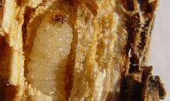  more photos...

Notes on taxonomy and nomenclature
This species was described in 1999 (Langor et al., 1999) and there have been no subsequent taxonomic or nomenclatural changes.

HOSTS
Pinus yunnanensis (Yunnan pine) is the only known host of Pissodes yunnanensis. It almost exclusively infests trees less than 20 years old but prefers trees 8-10 years old (Zhang et al., 2004). Although Pissodes yunnanensis is also reported from Pinus densa at one location (Xueshan, Yulong County) in North-Western Yunnan Province (China), evidence has been published by some local experts that suggests that this tree species is conspecific with Pinus yunnanensis (Hong et al., 2000).
Host list: Pinus yunnanensis

GEOGRAPHICAL DISTRIBUTION
Pissodes yunnanensis is currently known only from Guizhou, Sichuan, and Yunnan provinces in the People’s Republic of China (Zhang et al., 2007). It occurs between 1100-2800 m in elevation (Langor et al., 1999; Zhang et al., 2004).
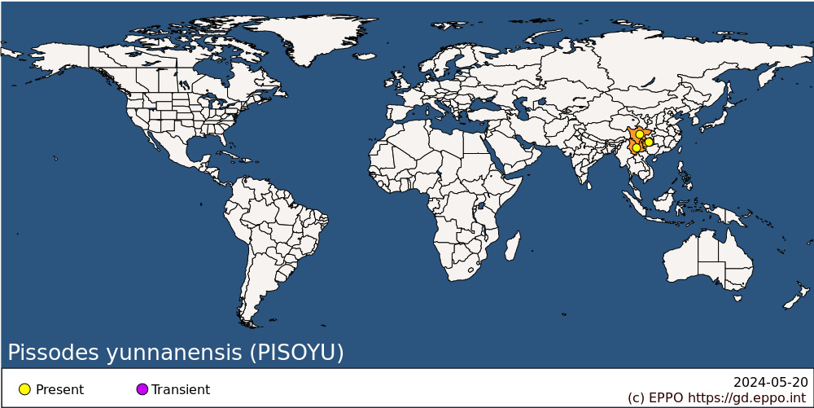
Asia: China (Guizhou, Sichuan, Yunnan)

BIOLOGY
A detailed account of the biology of Pissodes yunnanensis is provided by Zhang et al. (2004). This species completes one generation per year in the Lashi Forest (altitude 2400-2800 m) in Yunnan Province, but development spans two calendar years. Adults emerge from their pupal chambers (chip cocoons) under the bark by chewing a hole 4-5 mm in diameter through the bark. Emerged adults are capable of flight and feed on healthy shoots of the same tree or nearby trees for about one month as they become sexually mature. Mating occurs on the bark surface. Eggs are deposited from late June to mid-July. Females chew a small hole into the bark, lay 1-4 eggs per hole, and cap the hole with a dark brown excrement cap. Under controlled conditions, in the laboratory females each laid 70-92 eggs (average: 82). Eggs hatch in 7-20 days, depending on temperature. Temperatures above 25 °C are detrimental to egg survival. Larvae appear by mid-July and there are four larval instars. First and second instars feed in the inner phloem and construct meandering galleries filled with frass. Third instar larvae leave the phloem and enter the sapwood (and sometimes pith) where development is completed. Third instar larvae (and a few second instars) overwinter from November to February in the sapwood or pith and their development resumes the following spring when temperatures increase sufficiently. Pupation occurs between late March and late May in the outer sapwood or pith. Before pupation, the mature larva excavates a pupation chamber at the end of its feeding gallery and lines it with elongated wood chips stripped from the phloem and sapwood by the larva. These so-called chip cocoons are 7-9 mm long and 3-4 mm wide and are typical of most species of Pissodes. The pupation period lasts 2-4 weeks depending on temperature. Callow adults remain in chip cocoons for several days while they harden, emerging in mid-April to mid-July (peak: mid-May). The species has no diapause. There is evidence that some adults can live longer than a year. Parasitism is the major source of mortality, totalling 2-25% among large larvae and 5-10% among pupae. About 10 species of parasitoids attack P. yunnanensis.

DETECTION AND IDENTIFICATION

Symptoms
Adults of Pissodes yunnanensis attack trees that are <20 years old, especially those 8-10 years old (Zhang et al., 2004). Larvae feed in the phloem, sapwood and sometimes pith of branches, leaders, and stems (Zhang et al., 2004). The first signs of a tree attacked by adult weevils in the spring (March-April) are resin droplets that exude from puncture wounds caused by adults feeding on current and one-year-old shoots. Resin droplets are visible from a distance of several metres as they glisten in the sun. Upon close inspection of shoots undergoing attack, feeding wounds (0.5 mm wide and 1.0-.2.5 mm deep) made by adults, usually at the base of needle fascicles, will be visible. Each feeding wound results in death to an area of cambium 1.5-2.5 mm in diameter under the bark, and damaged cambium tissues turn from green to brown. These puncture wounds and associated cambium discolouration are indicators of P. yunnanensis infestation. Foliage on leaders and lateral branches turn yellow in late April or early May of the year following attack, and orange or red by late May, and newly killed leaders and lateral branches retained their red colour for more than one year. The presence of chip cocoons under the bark is also evidence that Pissodes are present, and chip cocoons may persist for many years after they are vacated.

Morphology
Eggs
Eggs are yellowish-white, oval, and about 0.43 mm long and 0.27 mm wide (Zhang et al., 2004).
Larva
Newly hatched larvae are translucent, yellowish-white, and about 0.60 mm long. Larvae become opaque and milky-white as they mature. Mature larvae are crescent-shaped with light brown heads (Zhang et al., 2004). Fourth-instar larvae are 6.0-11.0 mm long. A detailed description of mature larvae of this species is provided by Williams and Langor (2011).
Pupa
Pupae are at first ivory-white, changing to dark brown as they mature, and are 4.0-9.0 mm long and 1.5-4.0 mm wide. The eyes and elytra are the first structures to turn brown (Zhang et al., 2004).
Adult
Adult morphology is described in detail by Langor et al. (1999). The robust adult has a long curved snout. It is mostly brown and moderately clothed with whitish, scale-like setae on the dorsum and venter. The whitish scales on the elytra form a diffuse, antedeclivital, transverse fascia (patch), and the cuticle under and immediately surrounding the fascia is darker than that on the rest of the elytra. The elytra lack a posthumeral fascia, but have shallowly to moderately deep, well-separated, round to oval punctures. Males are 4.2-7.2 mm long and 1.8-2.8 mm wide at the elytra, and females are slightly larger at 5.3-7.6 mm long and 2.1-2.9 mm wide.

Detection and inspection methods
This species almost exclusively attacks young trees < 20 years old. Young P. yunnanensis saplings with copious resin droplets on the current and previous year’s growth should be investigated for signs of weevil attack such as feeding and oviposition punctures and presence of adults on the bark. Drooping of recent growth and eventual discoloration of needles is also a sign of infestation. Removal of bark on previous and current year’s leader growth on infested trees will reveal larval galleries in the phloem, sapwood and pith, chip cocoons, pupae, callow adults and/or round adult emergence holes in the bark. There are no native species of Pissodes in the EPPO region that specifically target the terminal leaders of pines so detection of young pines (or spruce) with such damage and clear evidence of the presence of Pissodes is likely to signal the presence of one of four non-native terminal-infesting Pissodes, one of which is P. yunnanensis (others are P. nitidus, P. strobi, and P. terminalis). Specimens of Pissodes yunnanensis can be identified using Langor et al. (1999) for adult diagnosis or Williams and Langor (2011) for identification of mature larvae. DNA barcodes can be used to confirm identity of this species (Zhang et al., 2007; GenBank: https://www.ncbi.nlm.nih.gov/nuccore/?term=pissodes+yunnanensis).

PATHWAYS FOR MOVEMENT
Adults are capable of flight although the range is unknown. It is also possible that human transplant of infested saplings or movement of infested foliage could help dispersal of this species within the region. As this species is almost exclusively limited to saplings < 20 years old and is found on recent foliage, long distance transport via lumber or dunnage seems highly improbable.

PEST SIGNIFICANCE

Economic impact
Pissodes yunnanensis in the past has been a serious pest of young P. yunnanensis, causing stem deformities and mortality (Xu et al., 2002). With the greatly increased plantations of P. yunnanensis in the late 20th and early 21st centuries, weevil damage increased considerably. In Yunnan Province, the extent of young P. yunnanensis plantations infested by weevils increased from 670 ha in 1998 to 2600 ha in 2002 near Lijiang, and from 200 ha in 1994 to 351 ha in 1995 near Kunming (Zhang et al., 1999; Li et al. 2001). However, by 2004, P. yunnanensis was no longer being commercially harvested and rather was protected and propagated for soil protection (Zhang et al., 2004). Currently, plantations of P. yunnanensis of susceptible age (< 20 years) are much less common and consequently weevil damage is no longer as serious as it once was.

Control
There has been little work on the control of this species. As with other terminal-infesting species of Pissodes in North America, infested shoots may be pruned and destroyed by chipping, burning, or burying. To prevent introduction of this weevil to other regions, importation of young trees and foliage should continue to be closely regulated.

Phytosanitary risk
Although recorded as infesting only Pinus yunnanensis it is possible that this weevil species could breed in and cause significant damage to other pine species in the EPPO region should it be introduced there. The risk of inadvertent introduction of Pissodes yunnanensis to the EPPO region currently seems low for three reasons: sources of weevils in South-Western China have been reduced in recent years due to the ban on harvesting of P. yunnanensis there; transport of logs and dunnage (the most common pathways for inadvertent spread of bark- and wood-boring insects) are unlikely pathways for this species because of its preference for saplings rather than for larger trees that are the typical sources such materials and because harvesting of P. yunnanensis is now banned; and it would require the transportation of infested saplings or foliage samples to allow spread of this species, and movement of these materials is subject to high levels of regulation. Although any insect may be transported as a ‘hitch-hiker’, it seems unlikely this could occur for P. yunnanensis.

PHYTOSANITARY MEASURES
Adherence to International Standards for Phytosanitary Measures No. 15 for solid wood packing material (IPPC, 2019) will greatly decrease the risk of introduction of bark- and wood-boring insects, including Pissodes yunnanensis. Any young trees or tree parts of P. yunnanensis introduced into the EPPO region should be quarantined until it is thoroughly checked for signs and symptoms of non-native species, including P. yunnanensis.

REFERENCES
Hong Y, Song G, Fu HR & Qiao JH (2000) A preliminary study on genetic variation and relationships of Pinus yunnanensis and its closely related species. Acta Botanica Sinica 42, 102-110 [In Mandarin].
IPPC (2019) ISPM 15. Regulation of wood packaging material in international trade. FAO, Rome, 24 pp. https://www.ippc.int/en/publications/640/
Langor DW, Situ, YX & Zhang, R (1999) Two new species of Pissodes (Coleoptera: Curculionidae) from China. The Canadian Entomologist 131, 593-603.
Li Y, Zhang Y, Yang F, Zhou J & Chen S (2001) Damage by Pissodes sp. in Kunming City. Yunnan Forest Science Technology [Yunnan Lin Ye Ke Ji] 4, 53–5 [In Mandarin].
Williams DJ & Langor DW (2011) Description of mature larvae of Pissodes yunnanensis Langor and Zhang and Pissodes punctatus Langor and Zhang (Coleoptera: Curculionidae) from China. The Coleopterists Bulletin 65, 157-166.
Xu C, Zhang H, Zhang Z, Huang S & Ye H (2002) Damage of Pissodes yunnanensis to the young trees of Pinus yunnanensis. Forest Pests and Diseases of China [Zhong Guo Sen Lin Bing Chong] 21(3), 45 [In Mandarin].
Zhang H, Langor DW, Ye H, Li Z & Laffin RD (2007) Genetic divergence among populations of Pissodes yunnanensis (Coleoptera: Curculionidae) in southwestern China. The Canadian Entomologist 139, 308-318.
Zhang Y, Li Y, Yang F, Li P & Li K (1999) A study of bionomics and control on Pissodes sp. Journal of Southwest Forest College [Xinan Lin Xue Yuan Xuebao] 19, 118–21 [In Mandarin].
Zhang H, Ye H, Haack RA & Langor DW (2004) Biology of Pissodes yunnanensis (Coleoptera: Curculionidae), a pest of Yunnan pine in southwestern China. The Canadian Entomologist 136, 719-726.
CABI and EFSA resources used when preparing this datasheet
CABI Datasheet on Pissodes yunnanensis. Available at: https://www.cabi.org/isc/datasheet/41494 [Accessed 15 June 2021]
EFSA Pest survey card on Pissodes cibriani, P. fasciatus, P. nemorensis, P. nitidus, P. punctatus, P. strobi, P. terminalis, P. yunnanensis and P. zitacuarense. Available at: https://efsa.onlinelibrary.wiley.com/doi/epdf/10.2903/sp.efsa.2020.EN-1910 [Accessed 15 June 2021]

ACKNOWLEDGEMENTS
This datasheet was prepared in 2021 by David W. Langor (Natural Resources Canada, Canadian Forest Service) and Stephen D. Langor. A brief update of the current status of Pissodes yunnanensis in Yunnan Province was provided to D. Langor by Hongrui Zhang in July 2021. Their valuable contributions are gratefully acknowledged.

How to cite this datasheet?
EPPO (2024) Pissodes yunnanensis. EPPO datasheets on pests recommended for regulation. Available online. https://gd.eppo.int

Datasheet history
This datasheet was first published online in 2021. It is maintained in an electronic format in the EPPO Global Database. The sections on 'Identity', ‘Hosts’, and 'Geographical distribution' are automatically updated from the database. For other sections, the date of last revision is indicated on the right.

