EPPO Datasheet: Phyllosticta solitaria
Last updated: 2023-10-26

IDENTITY
Preferred name: Phyllosticta solitaria
Authority: Ellis & Everhart
Taxonomic position: Fungi: Ascomycota: Pezizomycotina: Dothideomycetes: Botryosphaeriales: Phyllostictaceae
Common names in English: blotch of apple, fruit blotch of pome fruits, leaf spot of pome fruits, twig cancer of pome fruits
view more common names online...
EPPO Categorization: A1 list
EU Categorization: A1 Quarantine pest (Annex II A)
view more categorizations online...
EPPO Code: PHYSSL

HOSTS
Apples are the principal host, including cultivated forms and the wild Malus coronaria, on which the pathogen was first described. P. solitaria has also been reported on Crataegus spp. and Pyrus spp. (Wikee et al., 2011). Apples would be the main host throughout the EPPO region.
Host list: Crataegus, Malus coronaria, Malus domestica, Malus, Pyrus

GEOGRAPHICAL DISTRIBUTION
P. solitaria is probably native to the eastern part of North America (Guba, 1925) and occurs in several states in the USA (Farr et al. , 1989). Historic records on the spread of this fungus are limited to its appearance in Canada (Ginns, 1986) and an isolated report in Denmark (Johansen, 1948). More recently, Wikee et al. (2011) suggested a much wider distribution for P. solitaria including China, India, South Africa, Zimbabwe, Brazil, and Greece, however, no further evidence or references for the occurrence of P. solitaria in these countries were provided.
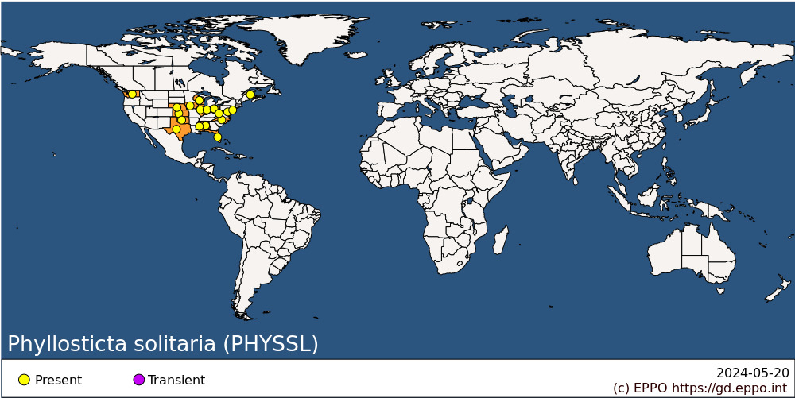
North America: Canada (New Brunswick), United States of America (Alabama, Florida, Illinois, Indiana, Iowa, Kansas, Maryland, Mississippi, Nebraska, New Jersey, North Carolina, Ohio, Oklahoma, Texas, Washington, West Virginia, Wisconsin)

BIOLOGY
Primary infection occurs about 2-4 weeks after blossom fall; overwintering cankers are probably the exclusive source of primary inoculum (Anderson, 1956; Guba, 1925; Sheldon, 1907). Canker enlargement may occur in winter in Illinois (USA) during prolonged warm, moist periods, but it usually begins in the spring, and is accompanied by the formation of true pycnidia. The rainsplash-dispersed pycnidiospores infect the current year’s growth, with new cankers appearing in August (Guba, 1925). Lesions also occur on the leaves and fruit. Infections arising after July-August bear only pycnosclerotia, which either remain sterile or give rise to pycnidiospores the following spring (Anderson, 1956; Guba, 1925).
Primary lesions on fruit and foliage are important inoculum sources for summer infections. On fruit, pycnidia, which have already functioned in the season, fill up and become typical pycnosclerotia in the autumn, and they overwinter in this form. Overwintering pycnosclerotia on mummified fruit and fallen leaves give rise to pycnidiospores in the spring, but their role as inoculum is probably negligible; many overwintering pycnosclerotia become sterile. Fungal mycelium can overwinter indefinitely in twig cankers of some cultivars while, in others, natural excision occurs within 3-4 years; spores will be produced each spring from these cankers. The ascigerous stage has not been found, but probably occurs in the spring as one of the final stages of the pycnosclerotium (Anderson, 1925; Guba, 1925).
Disease incidence and severity are directly correlated with rainfall; in years with frequent rain, 50% or more of the fruits in many orchards may be affected. There are varying reports on effects of temperature on the fungus (Gardner et al., 1923; Guba, 1924; Burgert, 1934) and the temperature requirements observed do not explain the distribution of P. solitaria in nature. The pathogen is able to survive long periods (at least 9 months) of cold storage at 1-2°C (McClintock, 1930). The minimum temperature at which spore germination will occur in culture is around 5-10°C, the maximum 30-39°C, and the optimum for growth and spore germination 21-27°C (Guba, 1925). Light has no effect on cultures of the fungus.
For more information, see Gardner et al. (1923), Guba (1925), Roberts & Pierce (1926), Rolfs (1942).

DETECTION AND IDENTIFICATION

Symptoms
On apple leaves
Tiny white spots, 1.5-3 mm in diameter, first appear between or on the veins and petioles. The spots enlarge, up to 6 mm, and become elliptical, sunken, tan or yellowish-beige lesions with a black spot (pycnidium) forming in the centre. This infection is of little consequence in itself, but infection at the petiole base may cause defoliation by midsummer. Leaves often remain uninfected (Anderson, 1956; Guba, 1925).
On apple twigs, watersprouts and fruit spurs
Roughly circular, dark, raised spots studded with tiny projecting pycnidia develop. These infections may either be the result of a direct spore infection or may arise from the fungus passing from the petiole of the leaf to the wood. Slightly sunken, brown to black cankers develop. In the second year, the central part of the canker is surrounded by a dark border which indicates the extent of the fungus. Pycnidia form in the border area. In the third season, an additional boundary zone forms. As cankers enlarge, they may coalesce and so girdle the twigs. The fungus does not penetrate the wood deeply and lesions may be separated by a callus layer (Gardner, 1923). Dead tissues subsequently slough off (Anderson, 1956; Guba, 1925).
On apple fruit
The earliest symptom, which may often go unnoticed, consists of isolated, dark-coloured, semi-hemispherical, raised or blister-like areas, 3 mm in diameter, on the young fruits in late May and early June. These lesions gradually enlarge and develop fringed but distinct margins, with a star-like appearance. The fruit may crack and so provide entry sites for secondary rot fungi. On yellow-skinned cultivars, the spots frequently have a reddish margin.
For more information, see Gardner et al. (1923), Guba (1924), Roberts & Pierce (1926), Rolfs (1942).

Morphology
The ascigerous stage of P. solitaria is not known, but fructifications on fallen leaves in spring, resembling unripe ascomata, have been observed by Guba (1925). No spermatial state is known (Van der Aa, 1973).
Pycnidia are variable in size and shape according to the organs affected. On leaf spots, pycnidia are minute, thin-walled, globose or subglobose, 60-95 µm, with a rostrate ostiole 9-12 x 7-12 µm. On petioles, pycnidia are larger, 62-119 µm, with an ostiole 12-14 x 9-12 µm. On fruits, pycnidia are depressed, elliptical, thick-walled, 57-95 x 107-166 µm, the stoma being 12-23 µm, the side walls 14-16 µm thick and the basal wall about 4.75 µm thick. On bark, there are two types of fruiting body: pycnidia and pycnosclerotia; the former are similar to those on fruit, but develop a distinct ostiole and have walls of limited thickness (Guba, 1925).
Conidia are ovoid or broadly elliptic, seldom subglobose, pyriform when young, with a truncate base, broadly rounded and indistinctly indented apically, unicellular, hyaline, smooth walled; 7-11 x 5-8.5 µm, surrounded by a thick slime layer, containing a mixture of numerous, fine and coarse guttules, with 5-15 distinct apical appendages usually 7-9 µm long (Van der Aa, 1973).
Pycnosclerotia are pycnidia containing a pseudoparenchyma of large cells. They are globose or subglobose, 115-274 x 107-238 µm; ostiole 23-59 µm thick. Pycnosclerotial spores bear a long, narrow, gelatinous, hyaline appendage, considerably broadened at the base to cover about half the spore (Guba, 1924; Van der Aa, 1973).

Detection and inspection methods
The description by Guba (1925) and Van der Aa (1973) can be used for morphological identification, as long as the sample comes from one of the listed host species, this should lead to a reliable identification. P. solitaria can also be distinguished from other species in the Phyllostictaceae based on multilocus sequence analyses (Wikee et al., 2011).

PATHWAYS FOR MOVEMENT
P. solitaria is locally dispersed by its rain-splashed conidia. International movement is only likely on seedlings or planting material with cankers. The ability of the fungus to withstand long periods of cold storage should be noted (McClintock, 1930).

PEST SIGNIFICANCE

Economic impact
P. solitaria causes a serious blotching of apples which reduces fruit quality. Losses were reported in the past to vary between 5 and 10%, damage being greatest in the middle states of the USA. In Illinois, in 1924, annual losses of approximately 6000 tonnes were recorded, blotch being second only to scab (Venturia inaequalis) in seriousness; in unsprayed orchards, all trees and up to 90% of the fruit were affected (Anderson, 1956). In 1925, apple blotch had not caused appreciable damage north of the 42nd parallel. Since there are no recent publications on this pathogen, it is clear that its economic importance has declined, probably in connection with regular fungicide treatment of orchards against more important diseases. A fairly recent description of the disease characterized its occurrence as rare in commercial apple orchards (Yoder & Sutton, 2013).

Control
The disease can be avoided by planting disease-free nursery material as well as by using resistant cultivars (Yoder & Sutton, 2013). The removal of cankers in nursery stock and young trees planted outdoors has proven to be effective (Anderson, 1956). Chemical control using lime sulphur, Bordeaux mixture and fungicides (ferbam, zineb, thiram or captan) were reported to give satisfactory control (Gardner, 1923; Talbert, 1924; Roberts & Pierce, 1926; Strubble & Morrison, 1961).

Phytosanitary risk
P. solitaria evidently presents a certain risk for apple orchards in the EPPO region, where no very similar pathogen occurs. It may also present a risk to its other wild and cultivated hosts (Crataegus, Malus, Pyrus). It should, however, be noted that its importance in North America has considerably declined and that it is now rare there. It is also presumably easily controlled by modern fungicide treatments.

PHYTOSANITARY MEASURES
It can be recommended that plants for planting of Crataegus, Malus and Pyrus (except seeds and tissue cultures) from countries where P. solitaria occurs should have been subject to a growing-season inspection at the place of production and found free from symptoms of P. solitaria.

REFERENCES
Anderson HW (1956) Diseases of fruit crops, 501 pp. McGraw-Hill, New York, USA.
Burgert IA (1934) Some factors influencing germination of the spores of Phyllosticta solitaria. Phytopathology 24, 384-396.
Farr DF, Bills GF, Chamuris GP & Rossman AY (1989) Fungi on plants and plant products in the United States, APS Press, St Paul, USA, 1252 pp.
Gardner MW (1923) Origin and control of apple blotch cankers. Journal of Agricultural Research 25, 403-418.
Gardner MW, Greene L & Baker CE (1923) Apple blotch. Bulletin of Purdue University Agricultural Experiment Station No. 267.
Ginns JH (1986) Compendium of plant disease and decay fungi in Canada, 1960-1980, 416 pp. Research Branch, Agriculture Canada Publication No. 1813
Guba EF (1924) Phyllosticta leaf spot, fruit spot and canker of the apple; its etiology and control. Phytopathology 14, 234-237.
Guba EF (1925) Phyllosticta leaf spot, fruit blotch, and canker of the apple: its etiology and control. University of Illinois, Agricultural Experiment Station, Bulletin no. 256, 481-554.
Johansen G (1948) Fungal infections of particular interest. Maanedlig Oversigt over Sygdommer i Kulturplanter No. 300, pp. 102-104.
McClintock JA (1930) The longevity of Phyllosticta solitaria on apple seedlings held in cold storage. Phytopathology 20, 841-843.
Roberts JW & Pierce L (1926) Apple blotch. Farmer's Bulletin, US Department of Agriculture No. 1479, pp. 1-11.
Rolfs FM (1942) Apple blotch. Bulletin of Oklahoma Agricultural Experiment Station B261, pp. 1-15.
Sheldon JL (1907) Concerning the relationship of Phyllosticta solitaria to the fruit blotch of apples. Science 26, 183-185.
Strubble FB & Morrison LS (1961) Control of apple blotch with fungicides. Plant Disease Reporter 45, 441-443.
Talbert TB (1924) Apple blotch control in Missouri. Circular of the Mississippi Agricultural Experiment Station No. 124, pp. 1-8.
Van der Aa HA (1973) Studies in Phyllosticta. I. Studies in Mycology 5, 79-81.
Wikee S, Udayanga D, Crous PW, Chukeatirote E, McKenzie EH, Bahkali AH, Dai DQ & Hyde KD (2011) Phyllosticta—an overview of current status of species recognition. Fungal Diversity 51, 43-61.
Yoder KS & Sutton TB (2013) Blotch. In: Compendium of apple and pear diseases and pests – 2nd edition (Ed. by Sutton TB, Aldwinckle HS, Agnello AM & Walgenbach JF), American Phytopathological Society, St. Paul, Minnesota, USA, p. 36.
CABI and EFSA resources used when preparing this datasheet
CABI Datasheet on Phyllosticta solitaria. https://www.cabidigitallibrary.org/journal/cabicompendium
EFSA Pest survey card on Phyllosticta solitaria. https://doi.org/10.2903/sp.efsa.2020.EN-1863

ACKNOWLEDGEMENTS
This datasheet was extensively revised in 2023 by Sietse van der Linde, NIVIP. His valuable contribution is gratefully acknowledged.

How to cite this datasheet?
EPPO (2024) Phyllosticta solitaria. EPPO datasheets on pests recommended for regulation. Available online. https://gd.eppo.int

Datasheet history
This datasheet was first published in the EPPO Bulletin in 1978 and revised in the two editions of 'Quarantine Pests for Europe' in 1992 and 1997, as well as in 2023. It is now maintained in an electronic format in the EPPO Global Database. The sections on 'Identity', ‘Hosts’, and 'Geographical distribution' are automatically updated from the database. For other sections, the date of last revision is indicated on the right.
CABI/EPPO (1992/1997) Quarantine Pests for Europe (1st and 2nd edition). CABI, Wallingford (GB).
EPPO (1980) Data sheets on quarantine organisms No. 20, Phyllosticta solitaria. EPPO Bulletin 10(1), 3 pp. https://onlinelibrary.wiley.com/doi/epdf/10.1111/j.1365-2338.1980.tb02689.x

