EPPO Datasheet: Peach rosette phytoplasma
Last updated: 2022-02-07

IDENTITY
Preferred name: Peach rosette phytoplasma
Taxonomic position: Bacteria: Tenericutes: Mollicutes: Acholeplasmatales: Acholeplasmataceae
Common names in English: rosette of peach
view more common names online...
EPPO Categorization: A1 list
view more categorizations online...
EPPO Code: PHYP30

Notes on taxonomy and nomenclature
Work by Davis et al. (2013), employing sequence and computer-simulated RFLP analyses of 16S rDNA, has shown that peach rosette phytoplasma is to be regarded as the X-disease agent ‘Candidatus Phytoplasma pruni’, a member of the X-disease phytoplasma group or 16SrIII group, subgroup 16SrIII-A. However, peach rosette phytoplasma may represent a subgroup 16SrIII-A variant whose 16S rDNA differs by a single base substitution in a Sau3AI restriction enzyme site (Davis et al., 2013).

HOSTS
Peach (Prunus persica) is the principal host of peach rosette phytoplasma, but the disease is also important on Japanese plum (P. salicina) (KenKnight, 1976; Kirkpatrick, 1995). Other hosts of peach rosette phytoplasma are almond (P. dulcis), apricot (P. armeniaca), sweet cherry (P. avium), sour cherry (P. cerasus) and several ornamental and wild Prunus spp. (Kenknight, 1976). The wild species P. angustifolia, P. hortulana and P. munsoniana can act as natural reservoirs of the pathogen (Kenknight, 1976). The phytoplasma was also transmitted by means of the dodder Cuscuta campestris to herbaceous hosts periwinkle (Catharanthus roseus), tomato (Solanum lycopersicum) and tobacco (Nicotiana tabacum) (Kunkel, 1943; Kirkpatrick, 1995).
Host list: Prunus angustifolia, Prunus armeniaca, Prunus avium, Prunus cerasus, Prunus dulcis, Prunus hortulana, Prunus munsoniana, Prunus persica, Prunus salicina

GEOGRAPHICAL DISTRIBUTION
Peach rosette was first observed in Georgia (US) in 1881 (Smith, 1891). Subsequently the disease was reported primarily from the South-Eastern United States and as far west as Texas (KenKnight, 1976; Uyemoto & Scott, 1992; Kirkpatrick, 1995; Scott & Zimmerman, 2001; Kirkpatrick et al., 2011). A severe outbreak occurred in Arkansas in 1977 (Kim & Slack, 1978). In Southern Italy, a disorder of peach resembling peach rosette was reported in a small orchard near Salerno (Marcone et al., 1995). The etiology of this disorder was not elucidated, but two different phytoplasmas, based on RFLP analysis of PCR-amplified rDNA, were found, which were assigned to the aster yellows (AY) phytoplasma group or 16SrI group, and the 16SrIII group. Even though neither phytoplasma could be detected in diseased peach trees with the methods used (Marcone et al., 1995), both phytoplasmas were transmitted from diseased trees to Catharanthus roseus (periwinkle) via dodder (Cuscuta campestris) bridges. Before further studies could be completed, affected trees were destroyed and the disease was eradicated in Southern Italy (Ragozzino, 2011; Marcone et al., 2014).
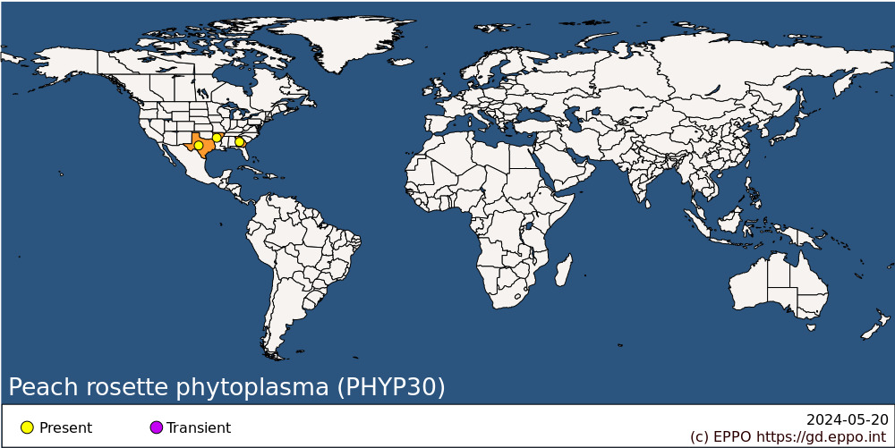
North America: United States of America (Arkansas, Georgia, Texas)

BIOLOGY
The peach rosette phytoplasma is graft- but not seed-transmissible. Although an insect vector of peach rosette phytoplasma has not been identified, natural spread into peach orchards is correlated with the close proximity to diseased wild plum (Prunus angustifolia) trees, in which the peach rosette agent has been detected by PCR (Scott & Zimmerman, 2001).

DETECTION AND IDENTIFICATION

Symptoms
Symptoms are similar in some respects to those caused by the peach rosette mosaic virus (Dias, 1975; EPPO/CABI, 1996a). On peach, a characteristic disease symptom is the production of numerous multiple axillary buds and of excessive number of shoots with shortened internodes, due to death of terminal buds. As new leaves develop, they appear normal in size and appressed into distinct dense rosettes. At the base of these rosettes, there are one or two abnormally long and straight leaves with inward rolled margins. Older leaves turn yellow and drop by early summer to leave tufts of younger leaves near the tips of otherwise bare shoots. Very few adventitious shoots develop in the interior of the tree canopy. The affected trees produce only few, small misshapen fruits that drop prematurely. Severely affected trees may succumb during the first year of symptom expression (Kunkel, 1936; McClintock et al., 1951; Kirkpatrick et al., 1975; KenKnight, 1976). On Japanese plum, leaves on infected trees develop chlorosis and often a reddish blush and rosette symptoms are less pronounced than on peach (Kirkpatrick, 1995). Affected plum trees may survive 2 to 3 years after the appearance of symptoms.

Morphology
Phytoplasma bodies have been observed by transmission electron microscopy in diseased peach and almond trees, and also in inoculated periwinkle plants (Kirkpatrick et al., 1975). The phytoplasma bodies were bounded by a unit membrane, lacked a rigid cell wall and were found to possess, in their cytoplasm, dispersed strands resembling DNA and ribosome-like particles. They were pleomorphic and varied in size from 80 to 800 nm. These bodies were not present in apparently healthy plants. Symptom remission after tetracycline hydrochloride treatment further confirmed the phytoplasmal etiology of the disease (Kirkpatrick et al., 1975).

Detection and inspection methods
Visual symptoms assessment is mainly based on the presence of rosette symptoms. Peach rosette phytoplasma can be tested for on peach seedlings (cv. Elberta or GF305) in the field, but these pathogenicity tests may take up to 4 years to allow the appearance of symptoms. The phytoplasma can also be tested for on the same indicators in the glasshouse, symptoms appearing up to 3 months after inoculation. However, for reliable diagnosis, the identity of the infecting pathogen should be determined by molecular technologies such as PCR-based methods.

PATHWAYS FOR MOVEMENT
The insect vector involved in the natural spread of peach rosette phytoplasma is unknown. The pathogen is most likely to be spread internationally in infected planting material.

PEST SIGNIFICANCE

Economic impact
Although sporadic outbreaks of the disease still occur, peach rosette is currently of minor importance (Kirkpatrick, 1995; Scott & Zimmerman, 2001; Kirkpatrick et al., 2011; Ragozzino, 2011).

Control
The disease can easily be controlled by destroying affected trees and removing wild plum growing near orchards. However, if these measures are not taken, the disease can spread epidemically, as in Arkansas (USA) in 1977 where whole orchards were affected although previously only isolated diseased trees had been seen (Kim & Slack, 1978).

Phytosanitary risk
In the EPPO region, peach, the main host, has the greatest economic importance among Prunus spp. There are probably susceptible European cultivars and, in any case, American cultivars are frequently introduced. Healthy planting material of Prunus is recommended, and nuclear stocks should be screened at regular intervals using sensitive PCR procedures. However, this pest is undoubtedly less important than peach X-disease phytoplasma (EPPO/CABI, 1996b).

PHYTOSANITARY MEASURES
It can be recommended that Prunus planting material should come from a field inspected during the growing season and, particularly for material from countries where peach rosette phytoplasma occurs, the material should be subject to an official certification scheme, with particular emphasis on preventing reinfection of healthy material by airborne vectors. The EPPO certification schemes for Prunus fruit trees (EPPO, 2001a,b), though intended to be used primarily within the EPPO region, provides a suitable model.

REFERENCES
Davis RE, Zhao Y, Dally EL, Lee I-M, Jomantiene R & Douglas SM (2013) ‘Candidatus Phytoplasma pruni’, a novel taxon associated with X-disease of stone fruits, Prunus spp.: multilocus characterization based on 16S rRNA, secY, and ribosomal protein genes. International Journal of Systematic and Evolutionary Microbiology 63, 766-776.
Dias HF (1975) Peach rosette mosaic virus. CMI/AAB Descriptions of Plant Viruses No. 150. Association of Applied Biologists, Wellesbourne, UK.
Dunez J (1981) Exotic virus and virus-like diseases of fruit trees. EPPO Bulletin 11, 251-258.
EPPO (2001a) PM 4/29 Certification scheme for cherry. EPPO Bulletin 31(4), 447-461.
EPPO (2001b) PM 4/30 Certification scheme for almond, apricot, peach and plum. EPPO Bulletin 31(4), 463-478.
EPPO/CABI (1996a) Peach rosette mosaic nepovirus. In: Quarantine pests for Europe. 2nd edition (Ed. by Smith IM, McNamara DG, Scott PR, Holderness M). CAB INTERNATIONAL, Wallingford, UK.
EPPO/CABI (1996b) Peach X-disease phytoplasma. In: Quarantine pests for Europe. 2nd edition (Ed. by Smith IM, McNamara DG, Scott PR, Holderness M). CAB INTERNATIONAL, Wallingford, UK.
Kenknight G (1976) Peach rosette. In: Diseases and non-infectious disorders of stone fruits in North America. USDA Agriculture Handbook No. 437, pp. 73-76. United States Department of Agriculture, USA.
Kim KS & Slack DA (1978) Peach rosette in Arkansas. Plant Disease Reporter 62, 310-311.
Kirkpatrick BC (1995) Peach rosette. In: Compendium of stone fruit diseases. APS Press, St Paul, USA.
Kirkpatrick HC, Lowe SK & Nyland G (1975) Peach rosette: the morphology of an associated mycoplasma-like organism and the chemotherapy of the disease. Phytopathology 65, 864-870.
Kirkpatrick BC, Pasquini G, Scott S & Foissac X (2011) Economic impact of pome and stone fruit phytoplasmas. In: Virus and Virus-Like Diseases of Pome and Stone Fruits (eds Hadidi A, Barba M, Candresse T, Jelkmann W), pp. 9-12. APS Press, St. Paul, MN, USA.
Kunkel LO (1936) Immunological studies on the three peach diseases, yellows, rosette, and little peach. Phytopathology 26, 201-219.
Kunkel LO (1943) New hosts as a key to progress in plant virus disease research. In: Virus Diseases. Ithaca, USA: Rockefeller Institute for Medical Research, 61-82.
McClintock JA, Kunkel LO & Thornberry HH (1951) Peach rosette. In: Virus Diseases and other Disorders with Viruslike Symptoms of Stone Fruits in North America. USDA Agriculture Handbook 10. Washington, USA: United States Government Printing Office, 7-10.
Marcone C, Di Serio F & Ragozzino A (1995) Peach rosette: a disease associated with mycoplasma-like organisms. Acta Horticulturae 386, 471-479.
Marcone C, Guerra LJ & Uyemoto JK (2014) Phytoplasmal diseases of peach and associated phytoplasma taxa. Journal of Plant Pathology 96 (1), 15-28.
Ragozzino A (2011) Peach rosette phytoplasma. In: Virus and Virus-Like Diseases of Pome and Stone Fruits (eds Hadidi A, Barba M, Candresse T & Jelkmann W), pp. 251-253. APS Press, St. Paul, MN, USA.
Scott SW & Zimmerman MT (2001) Peach rosette, little peach, and red suture are diseases induced by a phytoplasma closely related to western X-disease. Acta Horticulturae 550, 351-354.
Slack DA & Kim KS (1977) Peach rosette disease. Arkansas Farm Research 26, 15.
Smith EF (1891) The peach rosette. Journal of Mycology 6, 143-148.
Uyemoto JK & Scott SW (1992) Important diseases of Prunus caused by viruses and other graft-transmissible pathogens in California and South-Carolina. Plant Disease 76, 5-11.

ACKNOWLEDGEMENTS
This datasheet was extensively revised in 2022 by Professor Carmine Marcone. His valuable contribution is gratefully acknowledged.

How to cite this datasheet?
EPPO (2024) Peach rosette phytoplasma. EPPO datasheets on pests recommended for regulation. Available online. https://gd.eppo.int

Datasheet history
This datasheet was first published in the EPPO Bulletin in 1986, revised in the two editions of 'Quarantine Pests for Europe' in 1992 and 1997, as well as in 2022. It is now maintained in an electronic format in the EPPO Global Database. The sections on 'Identity', ‘Hosts’, and 'Geographical distribution' are automatically updated from the database. For other sections, the date of last revision is indicated on the right.
CABI/EPPO (1992/1997) Quarantine Pests for Europe (1st and 2nd edition). CABI, Wallingford (GB).
EPPO (1986) Data sheets on quarantine organisms No. 138, Peach rosette MLO. EPPO Bulletin 16, 29-30. https://onlinelibrary.wiley.com/doi/epdf/10.1111/j.1365-2338.1986.tb01131.x

