EPPO Datasheet: Melampsora farlowii
Last updated: 2023-03-20

IDENTITY
Preferred name: Melampsora farlowii  Authority: (Arthur) Davis  Taxonomic position: Fungi: Basidiomycota: Pucciniomycotina: Pucciniomycetes: Pucciniales: Melampsoraceae  Other scientific names: Chrysomyxa farlowii (Arthur) Saccardo & Traverso, Necium farlowii Arthur  Common names in English: hemlock twig rust, rust of hemlock, rust of tsuga  view more common names online...  EPPO Categorization: A1 list  EU Categorization: A1 Quarantine pest (Annex II A)  view more categorizations online...  EPPO Code: MELMFA | 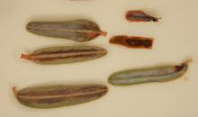  more photos...

Notes on taxonomy and nomenclature
Melampsora farlowii is an autoecious, microcyclic rust fungus with a telial stage and teliospores. Teliospores can germinate and produce basidia and basidiospores. The fungus species was first considered under the monotypic genus Necium J.C. Arthur, as N. farlowii, because of its host range and unique life cycle (Arthur 1907). Later on, Saccardo and Traverso (1910) considered the fungus under the genus Chrysomyxa as C. farlowii. Finally, Davis (1915) transferred this taxon from Necium to the genus Melampsora as M. farlowii.
Tsuga is a common host for the aecia of the macrocyclic (=long-cycled) rust Melampsora abietis-canadensis and for the telia of the microcyclic (=short-cycled) M. farlowii. M. abietis-canadensis and M. farlowii may be considered as ‘correlated species’ occurring on Tsuga (Arthur, 1934; Jackson, 1931).

HOSTS
The principal hosts are hemlock trees, Tsuga canadensis and T. caroliniana. Some Tsuga spp. have been introduced as ornamental trees in the EPPO region and T. heterophylla is a relatively important forest species in some EPPO countries (though not recorded as a host of M. farlowii).
Host list: Tsuga canadensis, Tsuga caroliniana, Tsuga sp.

GEOGRAPHICAL DISTRIBUTION
Hemlock rust caused by Melampsora farlowii has only been reported from eastern North America and Alaska, so far. In Canada, the pathogen is reported in Nova Scotia and Quebec on Tsuga canadensis. In the USA, the disease is reported as present in Alaska, Connecticut, Georgia, Maine, Massachusetts, Michigan, New Hampshire, New York, Pennsylvania, Tennessee, Vermont, Virginia, West Virginia, Wisconsin on T. canadensis and from North Carolina on T. caroliniana (Hepting and Toole 1939; Kenaley and Hudler, 2010; MyCoPortal, 2023). The rust fungus is found mainly at higher altitudes in the southern part of its range (CABI, 2019).
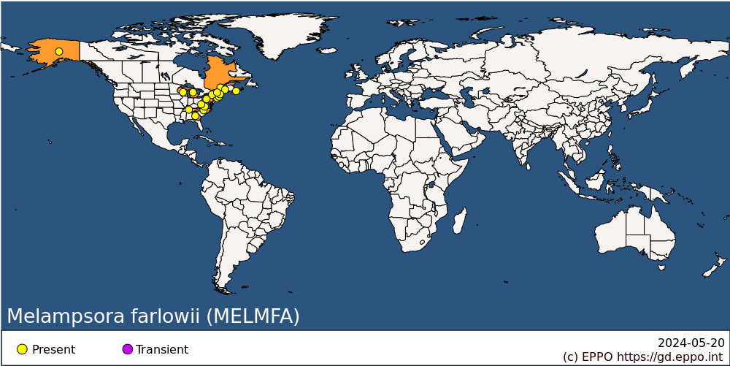
North America: Canada (Nova Scotia, Québec), United States of America (Alaska, Connecticut, Georgia, Maine, Massachusetts, Michigan, New Hampshire, New York, North Carolina, Pennsylvania, Tennessee, Vermont, Virginia, West Virginia, Wisconsin)

BIOLOGY
Melampsora farlowii is a microcyclic, autoecious rust on Tsuga, affecting leaves, twigs and cones, and for which only the telial and basidial stages are known. Telia overwinter on twigs and cones killed the previous spring, and spore release coincides with hemlock bud burst. Given favourable meteorological conditions (i.e., cool, wet weather), teliospores germinate in place, producing abundant basidiospores from early May to June. These basidiospores infect the current season's leaves and cones; further telia appear within 2-4 weeks of infection. Telia mature throughout the growing season and represent the overwintering state of the fungus as sori on cones and twigs, giving rise to basidiospores the following spring (Hepting and Toole, 1939; Hepting, 1971; Kenaley and Hudler, 2010; Peace, 1962).
Incidence of the disease is affected by rainfall, the duration of which is more important than the amount; short showers often do not last long enough for basidiospores to be produced. In spring (late April – early June), ten or more continuous hours of precipitation appear to be required for teliospore germination and the resultant production of basidiospores. Dew is insufficient for teliospore germination. Thus, cool (10 –18° C), wet weather lasting greater than one-day is sufficient for teliospore germination and the production of basidiospores. Disease severity seems to vary with altitude; it was reported as being severe in nurseries at 1200 and 1300 m and practically absent from a nursery nearby at 830 m; it may be that the lower temperatures at higher altitudes favour development of the fungus (CABI, 2019; Hepting and Toole, 1939; Kenaley and Hudler, 2010).

DETECTION AND IDENTIFICATION

Symptoms
Melampsora farlowii causes shoot blight and shoot curl of the current season’s shoots of T. canadensis and T. caroliniana. Leaves, cones and twigs are generally attacked. In addition to causing death and malformation of branches, the disease also causes abortion of newly formed cones. The first symptom in the spring is a yellowing of the new leaves, one month or so after bud burst. Seven to 10 days later, the shoots at the leaf bases turn orange and then become flaccid, causing the shoots to droop. Uninfected needles drop from affected twigs resulting in few needles remaining on the twig at points distal to the point of infection. Infected twigs later curl as the fungus invades the vascular tissue and remain on the tree for a year or more. Infected cones remain closed, do not produce seed and are frequently discoloured, shrivelled and mummified. Small swollen places on the cone scales indicate the presence of telia. Aborted cones often persist on affected trees (Hepting, 1971; Hepting and Toole, 1939; Kenaley and Hudler, 2010).
Hemlock rust can be destructive on Tsuga spp., particularly T. canadensis in nurseries. Nursery-grown hemlocks, 0.6-5 m high, are especially liable to severe attack. However, in the forest, this rust apparently does little damage, killing only occasional twigs and aborting cones, although trees up to 26 m may also be infected. Since diseased cones produce no seed, the rust can also affect the seed crop (CABI, 2019; Hepting and Toole, 1939; Hepting, 1971; Kenaley and Hudler, 2010).

Morphology
Telia are hypophyllous, occasionally epiphyllous and on cones and twigs, waxy, reddish to rust-brown, linear, confluent, composed of single palisades of sessile teliospores that form just beneath the epidermis (subepidermal). Teliospores are oblong or cylindric (7-10 x 35-58 µm), teliospore wall is yellowish-brown, smooth, uniformly 0.5-1 µm thick or slightly thicker on the upper part. Basidiospores are spherical, reddish yellow, with an average diameter of 8 µm. Spermogonia, aecia and uredinia have not been found (Arthur 1934, Kenaley and Hudler 2010, Peace 1962).

Detection and inspection methods
The disease can be identified based on symptoms and morphological descriptions of telia, teliospores and basidiospores previously described on this datasheet (see Detection and identification part).
The disease is detected by inspecting the abaxial surface of the needles or twigs for waxy linear telial pustules that are subepidermal, reddish to rust-brown and remaining covered. The fungus can be positively identified on the basis of symptoms and morphological features. Melampsora farlowii is the only rust fungus with a telial state has been reported on Tsuga spp.. It can be distinguished by its 1-celled, sessile, laterally adherent oblong or cylindric teliospores (Arthur, 1934; EFSA PLH Panel, 2018; Kenaley and Hudler, 2010).

PATHWAYS FOR MOVEMENT
Under natural conditions the spread of the disease is ensured by basidiospore dispersal (CABI, 2019). In international trade, M. farlowii is liable to be carried on infected host plants for planting.

PEST SIGNIFICANCE

Economic impact
Hemlock rust is the most destructive rust attacking Tsuga spp., particularly Tsuga canadensis. Although not generally a problem in forests in natural stands along the Appalachian range, hemlock twig rust can cause damage in commercial tree nurseries, where cultural conditions favour the development of the disease (Hepting and Toole, 1939; Kenaley & Hudler, 2010). In commercial nurseries raising ornamental trees, Tsuga plants a few years old are often rendered unsaleable following attack. In addition to causing death and malformation of branches, the disease also causes abortion of newly formed cones (Hepting and Toole, 1939; Hepting, 1971).

Control
Kenaley and Hudler (2010) recommend spraying with triadimefon, neem oil or mancozeb once when buds break and twice at 7 - 14-day intervals in commercial nurseries. As inoculum produced within infected nursery beds or cultures will persist, it is also recommended to not plant susceptible Tsuga species in areas where disease is severe (Kenaley and Hudler 2010).

Phytosanitary risk
In the EPPO region M. farlowii is potentially dangerous to all Tsuga spp. wherever these are grown in particular in commercial nurseries. The rust could probably cause damage to T. heterophylla which is a relatively important forest species in some EPPO countries, and may increase in importance in the future. Since M. farlowii occurs commonly in north-eastern North America, it is reasonable to expect that its optimum development at lower latitudes would be at higher elevations.

PHYTOSANITARY MEASURES
EPPO (EPPO, 2018) recommend that plants for planting (except seeds) and cut branches of Tsuga spp., should come from pest-free areas. In the EU, the importation of Tsuga plants other than fruit and seeds in prohibited from any non-European country (EFSA PLH Panel, 2018).

REFERENCES
Arthur JC (1907). Coleosporiaceae, Uredinaceae, Aecidiaceae (Pars). North American Flora 7 (2), 83-160.
Arthur JC (1934) Manual of the rusts in United States and Canada. Purdue Research Foundation, Purdue, Indiana, USA.
CABI (2019) Melampsora farlowii (hemlock rust) CABI Compendium. CABI, Wallingford, UK. https://www.cabidigitallibrary.org/doi/full/10.1079/cabicompendium.33287
Cummins GB & Hiratsuka Y (2003) Illustrated Genera of Rust Fungi. Third Edition. American Phytopathological Society, St. Paul, Minnesota.
Davis JJ (1915) Notes on parasitic fungi in Wisconsin – II. Transactions of the Wisconsin Academy of Sciences 18(1), 93-109.
EFSA PLH Panel (EFSA Panel on Plant Health), Bragard C, Di Serio F, Gonthier P, Jacques M, Jaques Miret JA, Fejer Justesen AM, MacLeod A, Magnusson CS, Milonas P, Navas-Cortes JA, Parnell S, Potting R, Reignault PL, Thulke HH, Van der Werf W, Vicent A, Yuen J, Zappala L, Boberg J, Jeger M, Pautasso M, Dehnen-Schmutz K (2018) Pest categorisation of Melampsora farlowii. EFSA Journal 16(10), 5442, 19 pp.
EPPO (2018) EPPO Standard on Commodity-specific phytosanitary measures. PM 8/2 (3) Coniferae. Available from https://gd.eppo.int/taxon/MELMFA/documents.
Hepting GH (1971) Diseases of forest and shade trees of the United States. Agricultural Handbook, Forest Service, US Department of Agriculture No. 386, 489-492.
Hepting GH & Toole ER (1939) The hemlock rust caused by Melampsora farlowii. Phytopathology 29, 463-473.
Jackson HS (1931) Present evolutionary tendencies and the origin of life cycle in the Uredinales. Memoirs of the Torrey Botanical Club 18, 1-108.
Kenaley SC & Hudler GW (2010) Hemlock twig rust caused by Melamspora farlowii (Arth.) Davis. Cornell University Factsheet, Ithaca, NY, USA.
MyCoPortal (2023) http://www.mycoportal.org/portal/index.php. Accessed on 2023-02-21.
Peace TR (1962) Pathology of trees and shrubs. Oxford University Press, Oxford, UK.
Saccardo PA & Traverso JB (1910) Index Iconum fungorum. In Saccardo PA (ed) Sylloge fungorum omnium hucusque cognitorum. Vol 19, Patavia.

ACKNOWLEDGEMENTS
This datasheet was extensively revised in 2023 by Mehrdad Abbasi, The University of British Columbia (CA). His valuable contribution is gratefully acknowledged.

How to cite this datasheet?
EPPO (2024) Melampsora farlowii. EPPO datasheets on pests recommended for regulation. Available online. https://gd.eppo.int

Datasheet history
This datasheet was first published in the EPPO Bulletin in 1980 and revised in the two editions of 'Quarantine Pests for Europe' in 1992 and 1997, as well as in 2023. It is now maintained in an electronic format in the EPPO Global Database. The sections on 'Identity', ‘Hosts’, and 'Geographical distribution' are automatically updated from the database. For other sections, the date of last revision is indicated on the right.
EPPO (1980) Data sheets on quarantine organisms No. 15, Melampsora farlowii. EPPO Bulletin 10(1), 9-12. https://doi.org/10.1111/j.1365-2338.1980.tb02687.x
CABI/EPPO (1992/1997) Quarantine Pests for Europe (1st and 2nd edition). CABI, Wallingford (GB).

