EPPO Datasheet: Neofusicoccum laricinum
Last updated: 2021-12-15

IDENTITY
Preferred name: Neofusicoccum laricinum  Authority: (Sawada) Y. Hattori & C. Nakashima  Taxonomic position: Fungi: Ascomycota: Pezizomycotina: Dothideomycetes: Botryosphaeriales: Botryosphaeriaceae  Other scientific names: Botryosphaeria laricina (Sawada) Shang, Guignardia laricina (Sawada) Yamamoto & K.Ito, Physalospora laricina Sawada  Common names in English: shoot blight of larch, twig die-back of larch  view more common names online...  EPPO Categorization: A2 list  EU Categorization: A1 Quarantine pest (Annex II A)  view more categorizations online...  EPPO Code: GUIGLA | 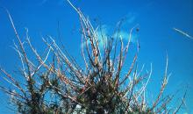  more photos...

HOSTS
The principal hosts of Neofusicoccum laricinum are Larix spp. The most susceptible ones are L. decidua, L. laricina and L. occidentalis. Intermediate resistance has been observed on L. x eurolepis and L. kaempferi. Resistance has been shown on L. gmelinii and L. olgensis var. koreana. The only other host in nature is Pseudotsuga menziesii. Many other conifers can be infected by artificial inoculation. For additional information, see Sato & Shouji (1962), Sato et al. (1963), Ito (1963), Imazeki & Ito (1963), Oguchi (1970), Sato et al. (1971).
L. decidua is widely distributed in Europe at various altitudes (e.g. in the Alps and also in the Polish plains). L. leptolepis is also planted in the EPPO region. Pseudotsuga menziesii is an important forest tree.
Host list: Larix decidua, Larix gmelinii var. japonica, Larix gmelinii var. olgensis, Larix gmelinii var. principis-ruprechtii, Larix gmelinii, Larix kaempferi, Larix laricina, Larix occidentalis, Larix sibirica, Larix x eurolepis, Pseudotsuga menziesii

GEOGRAPHICAL DISTRIBUTION
N. laricinum is reported from East Asia, i.e. Eastern China, Japan, the Korean Peninsula and the Russian Far East.
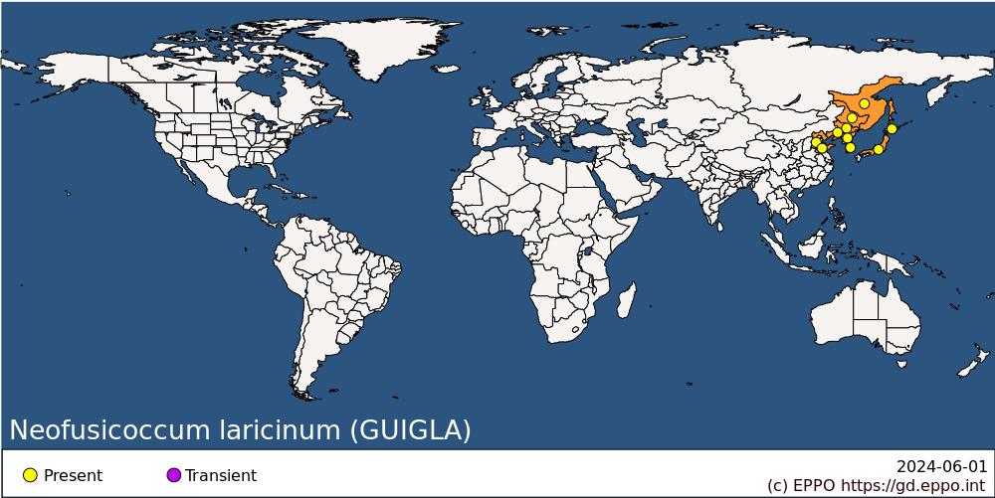
EPPO Region: Russia (Far East)
Asia: China (Hebei, Heilongjiang, Jilin, Liaoning, Shandong), Japan (Hokkaido, Honshu), Korea Dem. People's Republic, Korea, Republic

BIOLOGY
The biology of N. laricinum has mainly been studied in Japan (Uozomi, 1961; Yokota, 1966; Sato et al., 1971).
The asexual morph appears in abundance on the underside of needles and on young sprouts between July and November, and spores are dispersed by insects or rain. During this time, the pycnidiospores are released and give rise to secondary infections in late summer. Discharge of conidia occurs between 10 and 35°C (25°C optimum) and was observed to occur at 98% RH. A few spores in their pycnidia can overwinter until the following April.
The sexual morph appears on branches after October. The black pseudothecia, which occur in groups or singly, take 2 years to develop. Ascospores released between May and October (peak July-August) are the source of primary infections. Optimum temperature for infection is 20°C with free water. Ascospores can infect host plants throughout the season, but do so principally at the beginning of August; wounds do not appear necessary for penetration. Disease symptoms appear about 2 weeks after infection. Some spores may overwinter in the pseudothecia. Cool winters and short summers do not favour the disease.

DETECTION AND IDENTIFICATION

Symptoms
The disease is conspicuous as discoloration, wilting and death of the succulent current season's growth. Old twigs remain unaffected. Early attack, visible between June and September, causes hanging-down of the top of shoots, accompanied by a yellowing and browning of needles which may fall. The needles at the tops of shoots turn brown and often remain on the tree during winter. Dark, sunken lesions, abundant in sporulating bodies, and exuding resin appear on the stems of affected seedlings and on shoots, and usually girdle these parts. The resin hardens into whitish drops. Late infections, occurring in September to early October, do not show the characteristic hanging-down, owing to the lignified nature of the twigs. On needles, symptoms appear as brown spots with chlorotic haloes, which subsequently coalesce. Repeated infections result in stunted, bushy trees with many dead shoots.
For additional information, see Imazeki & Ito (1963), Ito (1963), Sato et al. (1971).

Morphology
Sexual morph: Diseased twigs defoliated from the middle to the tip, with exudate resin. Fruit bodies lined, erumpent. Ascomata epidermal, blackish, globose, 368 μm diam; ostiole erumpent, 60 μm diam; paraphyses developed, intricate, 3 μm. Ascus clavate, rounded at the apex, stipitate at the base, hyaline, 114–135 × 22–26 μm. Ascospores ellipsoid, smooth, hyaline, 24–27 × 13 μm (Sawada, 1950).
Asexual morph: Conidiomata pycnidial, epidermal, merged, solitary, globose, dark brown, subglobose, unilocular, with a central ostiole, 204–246 × 207–212 μm; pycnidial wall composed of depressed or irregular cells in three to four layers, brown to dark brown. Conidiophores reduced to conidiogenous cells; conidiogenous cells discrete, hyaline, cylindrical to ampulliform, determinate, with periclinal thickening, or proliferating percurrently, 9–23 × 2.4–5 μm. Paraphyses not seen. Conidia holoblastic sporulation for first conidia, phialidic sporulation for following conidia, hyaline, smooth, aseptate, slightly colored and septate with age, ellipsoid to fusiform, granulate, subtruncate to bluntly rounded at the base, rounded to subacute at the apex, with a short frill at both ends, 23–38 × 7–12 μm, 29.85 × 8.50 μm on average, L/W = 3.57 (Hattori et al. 2021).

Detection and inspection methods
The fungal fruiting bodies may be observed directly or isolated and cultured on a medium containing 3 g yeast extract, 10 g soluble starch, 0.25 g MgSO₄ 7H₂O, 15 g agar in 1 L distilled water, maintained at 20°C (Hara & Ito, 1963; Ito, 1963). To identify species in the genus Neofusicoccum, it is now essential to use molecular phylogenetic analysis using the regions of rDNA ITS, rpb2, tef1-α, and tub2. The deposit numbers for each ex-epitype (FFPRI 411215 = MUCC 2662) sequence are LC589129 for ITS, LC589140 for tef1, LC589151 for tub2, LC589164 for rpb2 (Hattori et al., 2021).

PATHWAYS FOR MOVEMENT
Under natural conditions, N. laricinum spreads by dispersal of ascospores and conidia. In international trade, spread is possible on diseased host trees, including artificially dwarfed plants. Cut branches may also be a possible pathway (EFSA, 2018). Pollen or seed is unlikely to harbour the pathogen.

PEST SIGNIFICANCE

Economic impact
N. laricinum caused the most serious disease of Larix forests and nurseries in Japan. It had long been known locally, but started to cause large-scale damage in Larix plantations after 1959 - at which time, areas planted with Larix were increasing rapidly. In 1963, more than 80 000 ha of plantations were diseased, with 100% of the trees affected. Although young diseased trees do not usually die, their subsequent growth is retarded or stopped. N. laricinum causes severe damage in areas with strong winds, but after changing the tree species planted in these areas and using appropriate management measures, this disease is now under control.

Control
In Japan, chemical control is applied against this disease (Oguchi, 1980; Okada, 2000). In addition, intensive testing of disease-resistant clones and observation of their growth in forest plantations has been carried out (Oguchi, 1963; Sato, 1970; Kobayashi, 1980).
In nursery fields, fungicides can be applied every 2 weeks during the infection period (June to September). In highly infested nurseries, dipping of Larix seedlings into fungicide solution in spring is also used. In forest plantations, it is important to avoid bringing in diseased seedlings. When the disease is not widespread, early detection is important to eradicate the disease. If damage is widespread, it is necessary to reduce the density of the pathogen by prioritizing the felling of diseased trees during thinning. Removal and burning of the infected trees and reforestation by other species are also carried out in heavily diseased stands.

Phytosanitary risk
In the EPPO region, N. laricinum could be potentially dangerous to Larix and P. menziesii, wherever present. Considering the distribution of N. laricinum in East Asia, climatic conditions prevailing in Europe are assumed not to be a limiting factor (EFSA, 2018).

PHYTOSANITARY MEASURES
Considering the risk that this fungus could present to the EPPO region it is recommended that all countries should prohibit importation of plants for planting and cut branches of Larix and P. menziesii from countries where N. laricinum this fungus occurs.

REFERENCES
EFSA PLH Panel (EFSA Panel on Plant Health) Jeger M, Bragard C, Caffier D, Candresse T, Chatzivassiliou E, Dehnen-Schmutz K, Gilioli G, Gregoire J-C, Jaques Miret JA, MacLeod A, Navajas Navarro M, Niere B, Parnell S, Potting R, Rafoss T, Rossi V, Urek G, Van Bruggen A, Van der Werf W, West J, Winter S, Boberg J, Gonthier P, Pautasso M (2018) Scientific Opinion on the pest categorisation of Guignardia laricina. EFSA Journal 16(6), 5303, 24 pp. https://doi.org/10.2903/j.efsa.2018.5303
Hara K & Ito K (1963) [Agar-media for sporulation of Guignardia laricina (Sawada) W. Yamamoto et K. ITo, the shoot blight fungus of larch (Preliminary report)]. Journal of the Japanese Forest Society 45, 238-241 (In Japanese)
Hattori Y, Ando Y & Nakashima C (2021) Taxonomical re-examination of the genus Neofusicoccum in Japan. Mycoscience 62, 250-259.
Imazeki R & Ito K (1963) Dangerous forest diseases in Japan. Shoot blight of larch. In: Internationally dangerous forest tree diseases. Miscellaneous Publications, Forest Service, US Department of Agriculture No. 939, 48-49.
Ito K (1963) Shoot blight of larches. A destructive disease in larch plantations of Japan. Bulletin of the Government Forest Experiment Station, Tokyo 159, 89-103.
Kobayashi T (1980) Important forest diseases and their control measures. Plant Protection in Japan, Agriculture Asia, Special Issue No. 11, 298 pp.
Okada M (2000) カラマツ先枯病[The shoot blight disease of Larch], 技術情報, No. 103 (in Japanese).
Oguchi T (1963) カラマツ先枯病に対するカラマツクローンの耐病性差異[Differential resistance of Larch clones to the shoot blight of Larch], 北海道光珠内林木育種場報告, N0. 2 (in Japanese).
Oguchi T (1970) Growth of three species of larch and their infecting period to the shoot blight disease. Bulletin, Hokkaido Forest Experiment Station 8, 35-40.
Oguchi T (1980) カラマツの四大樹病[Forest Diseases Series 1: Four Major Diseases of Japanese Larch]. 光珠内季報, 44, 46 (in Japanese).
Sato K & Shouji T (1962) [Ditto V (Preliminary report). Pathogenicity of Guignardia laricina, the causal fungus of the disease]. Transactions of the 73rd Annual Meetings of the Japanese Forestry Society, 217-219 (In Japanese).
Sato K, Yokozawa Y, Shoji T (1963) Studies on the shoot blight disease of larch I. Bulletin of the Government Forest Experimental Station, Tokyo 156, 85–137.
Sato K (1970) 東北地方における造林樹種とその品種の病害抵抗性[Disease resistance of silvicultural tree species and their cultivars in the Tohoku region]. 東北の林木育種, No. 26 (in Japanese).
Sato K, Yoshinori Y, Shoji T, Kojima C (1971) Studies on the shoot blight of larch II. Bulletin of the Government Forest Experiment Station, Meguro 236, 27-91.
Sawada (1950) Fungi inhabiting conifers in the Tohoku district. II. Fungi on various conifers except ‘Sugi’. Bulletin of the Government Forest Experimental Station, Meguro 46, 144–148.
Uozumi T (1961) Studies on the shoot blight disease of larch. With special reference to life history of the causal fungus, Physalospora laricina Sawada. Bulletin of the Government. Forest Experiment Station, Meguro 132, 47-54.
Yokota S (1966) Ecological studies on Guignardia laricina, the causal fungus of the shoot blight of larch trees and climatic factors influencing the outbreak of the disease. Bulletin of the Government Forest Experiment Station, Meguro 184, 79 pp.

ACKNOWLEDGEMENTS
This datasheet was extensively revised in 2021 by Yukako Hattori, Forestry and Forest Products Research Institute (FFPRI), Japan Society for the Promotion of Science (JSPS). Her valuable contribution is gratefully acknowledged.

How to cite this datasheet?
EPPO (2024) Neofusicoccum laricinum. EPPO datasheets on pests recommended for regulation. Available online. https://gd.eppo.int

Datasheet history
This datasheet was first published in the EPPO Bulletin in 1978, revised in the two editions of 'Quarantine Pests for Europe' in 1992 and 1997, as well as in 2021. It is now maintained in an electronic format in the EPPO Global Database. The sections on 'Identity', ‘Hosts’, and 'Geographical distribution' are automatically updated from the database. For other sections, the date of last revision is indicated on the right.
CABI/EPPO (1992/1997) Quarantine Pests for Europe (1st and 2nd edition). CABI, Wallingford (GB).
EPPO (1978) Data sheets on quarantine organisms No. 12, Guignardia laricina. EPPO Bulletin 8(2), 2 pp.https://doi.org/10.1111/j.1365-2338.1978.tb02759.x

