EPPO Datasheet: Bactrocera tsuneonis
Last updated: 2020-09-23

IDENTITY
Preferred name: Bactrocera tsuneonis
Authority: (Miyake)
Taxonomic position: Animalia: Arthropoda: Hexapoda: Insecta: Diptera: Tephritidae
Other scientific names: Dacus cheni Chao, Dacus tsuneonis Miyake, Tetradacus tsuneonis (Miyake)
Common names in English: Japanese orange fly, Japanese orange fruit fly
view more common names online...
EPPO Categorization: A1 list
EU Categorization: A1 Quarantine pest (Annex II A)
view more categorizations online...
EPPO Code: DACUTS

Notes on taxonomy and nomenclature
Bactrocera tsuneonis belongs to the subgenus Tetradacus, within the genus Bactrocera. As such it can be referred to in the literature as Bactrocera (Tetradacus) tsuneonis. A recent review of, and identification key to all species of the subgenus Tetradacus is given by Hancock & Drew (2019).
B. minax has erroneously been considered synonymous with B. tsuneonis (EPPO/CABI, 1996).

HOSTS
B. tsuneonis is found exclusively on Rutaceae, such as Citrus, especially mandarin (C. reticulata), and Fortunella spp., the former being the main potential hosts in the EPPO region. The USDA Compendium of Fruit Fly Host Information (CoFFHI) (Liquido et al., 2019) provides an extensive host list with detailed references.
Host list: Citrus reticulata, Citrus x aurantium var. sinensis, Citrus x aurantium var. tangerina, Citrus x aurantium var. unshiu, Citrus x aurantium, Fortunella crassifolia, Fortunella japonica, Fortunella margarita

GEOGRAPHICAL DISTRIBUTION
This species is restricted to parts of Japan and southern China. Older records from Taiwan and Vietnam are considered unsubstantiated and not confirmed.
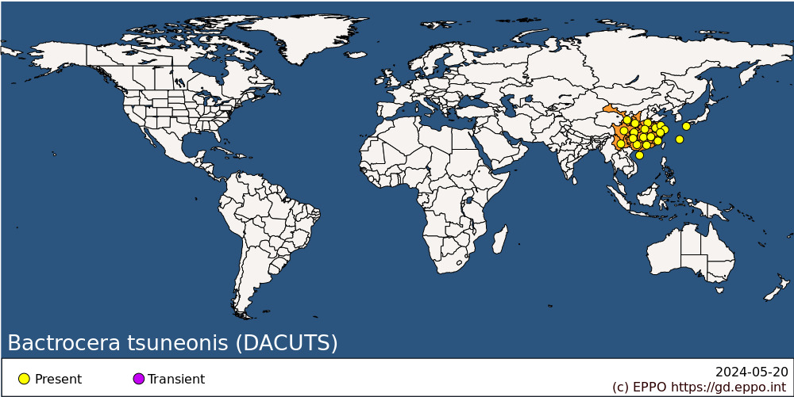
Asia: China (Anhui, Chongqing, Fujian, Gansu, Guangdong, Guangxi, Guizhou, Hainan, Henan, Hubei, Hunan, Jiangsu, Jiangxi, Shaanxi, Shanghai, Sichuan, Yunnan, Zhejiang), Japan (Kyushu, Ryukyu Archipelago)

BIOLOGY
Little is known about the biology of B. tsuneonis. The general life cycle is considered similar to the one of other Bactrocera species infesting fruits: eggs are laid below the skin of the host fruit. Three larval stages develop inside the fruit, feeding on the plant tissue. Once mature the third instar larva will leave the fruit, dig down into the soil and turn into a pupa enclosed in a puparium. In China, B. tsuneonis is reported to have a single generation per year and to overwinter as a pupa in the soil (Zhang, 1989). Yasuda et al. (1994) suggest that the species has a pupal diapause. Hou et al. (2018) mention the presence of adults from April to September in Guangdong and Guangxi, China, while in Japan adults are present from early June till October. In general, B. tsuneonis has a similar biology to B. minax but adults of B. tsuneonis can be found over a longer time in the field.

DETECTION AND IDENTIFICATION

Symptoms
Attacked fruit have tiny oviposition punctures, but these and other symptoms of damage are often difficult to detect in the early stages of infestation. Considerable damage may occur inside the fruit before symptoms are visible externally, often as networks of tunnels accompanied by rotting.

Morphology
Larva
Fruit fly larvae in general have a typical shape, i.e., cylindrical maggot-shape, elongate, anterior end narrowed and somewhat recurved ventrally, with anterior mouth hooks, and flattened caudal end. Their length varies from 5 to 15 mm. Identification to species level is not possible based on larvae. A key for the 3rd-instar larvae is available in White & Elson- Harris (1992) and is useful for an identification to the genus level. The larva of B. tsuneonis is described in some detail by Carroll et al. (2014).
Adult
Redescription, as given by Drew & Romig (2013).
Male
Head. Red-brown with fuscous on anteromedial hump; orbital setae black: 1 superior 2 inferior; lunule red-brown. Vertex red-brown. Face fulvous with a pair of small- to medium-sized oval black spots. Genae fulvous with a very small dark fuscous subocular spot; black seta present. Occiput red-brown, fulvous along eye margins; occipital row with a large number of small black setae. Antennae with all segments red-brown.
Thorax. Scutum red-brown with a mottled appearance from dorsoventral flight muscles and occasionally with irregularly shaped small areas of fuscous. Pleural areas red-brown without dark markings. Yellow markings as follows: postpronotal lobes; notopleura; a moderately broad lateral yellow band joining postpronotal lobe and notopleuron; mesopleural stripe reaching the anterior notopleural seta dorsally, continuing to the katepisternum as a large yellow spot, anterior margin convex; almost entire surfaces of anatergite and katatergite; a pair of moderately broad parallel-sided lateral postsutural vittae ending at intra-alar. seta and turned inwards along notopleural suture; a short medial postsutural vitta. Yellow spot anterior to notopleural suture absent. Postnotum red-brown. Scutellum yellow except for narrow red-brown basal band.
Setae: 2 scutellar, 1 intra-alar, 1 anterior supra-alar, 1 posterior supra-alar, 1 mesopleural, 1 notopleural, 2 scapular; prescutellar absent.
Legs. Femora fulvous except fuscous on extreme apical ventral surfaces of mid femora; fore and mid tibiae entirely fulvous, hind tibia red-brown; fore and hind tarsal segments with basal segment fulvous and apical four segments red-brown, mid tarsie with all segment; mid tibiae each with an apical black spur.
Wings. Length 9.2mm; cells bc and c with a strong pale fulvous tint; microtrichia in outer corner of cell c only; remainder of wings colourless except dark fuscous cell sc, broad fuscous costal band confluent with R4+5 basally overlapping this vein just beyond r-m crossvein to apex of the wing, anal streak reduced to pale fuscous within cell cup; no dense aggregation of microtrichia around A1+CuA2; supernumerary lobe weak.
Abdomen. Elongate oval (not as petiolate in Bactrocera minax); terga free; pecten present on tergum III. Tergum I and sterna I and II wider than long. Terga I and II vary from red-brown to fulvous; terga III-V red-brown to fulvous with a dark black ‘T’ pattern consisting of a narrow transverse dark fuscous to black band across anterior margin of tergum III and a narrow medial longitudinal band over all three terga (in some specimens the anterolateral corners of tergum IV are fuscous to dark fuscous); a pair of oval red-brown shining spots on tergum V. Posterior lobe of surstylus short, sternum V with a slight concavity on posterior margin. Abdominal sterna pale.
Female
As for male except pecten of cilia on abdominal tergum III absent; ovipositor basal segment red-brown and strongly bulbous and rounded basally and narrowing to a cylinder apically, ratio of length of oviscape to length of tergum V, 1.8:1; apex of piercer trilobed.
Bactrocera tsuneonis is morphologically similar to B. minax but anterior supra-alar setae are present. It has a complete lateral yellow band joining postpronotal lobe and the notopleuron and the female has a short ovipositor with a trilobed apex. Full details of the separation of these species were given by Drew & Romig (2013). Hancock & Drew (2019) provide an identification key for all representatives of the subgenus Tetradacus.

DNA barcoding
In BOLD, B. tsuneonis only forms monospecific Barcoding Index Number Systems (BINs) including representatives from the geographical distribution of this species. For this reason, DNA barcoding might be considered as a suitable tool for the molecular identification of this species. Sequences are available in the Barcode of Life Data Systems (BOLD).

Detection and inspection methods
Though most Bactrocera spp. can be monitored using traps baited with male lures, B. tsuneonis is not known to be attracted to any male lure. Both sexes can be monitored by traps baited with protein-based attractants (Hou et al., 2018). Detection is also possible by examination of fruit for oviposition punctures and then rearing the larvae through to the adult stage.

PATHWAYS FOR MOVEMENT
Transport of infested fruits is the main mean of movement and dispersal to previously uninfested areas. Adult flight can also result in dispersal but previous citations of long (50-100 km) dispersal movements for Bactrocera spp. are unsubstantiated according to a recent review by Hicks et al. (2019). Dispersal up to 2 km is considered more typical.

PEST SIGNIFICANCE

Economic impact
Bactrocera tsuneonis is stenophagous, only attacking citrus fruits. It is a serious pest of citrus in parts of China (Zhang, 1989) and Japan.

Control
Management for this species includes the general control measures for Bactrocera spp. (see Vargas et al., 2015 for an overview of management options). These include sanitation (to gather all fallen and infested host fruits and destroy them). Insecticidal protection is possible by using a cover spray or a bait spray. Bait sprays work on the principle that both male and female tephritids are strongly attracted to a protein source from which ammonia emanates. Bait sprays have the advantage over cover sprays in that they can be applied as a spot treatment so that the flies are attracted to the insecticide and there is minimal impact on natural enemies and other beneficials.

Phytosanitary risk
Citrus species are important crops in the EPPO region. B. tsuneonis is a known pest of Citrus in the area where it is present. It can be moved in trade with infested fruit. Although no detailed study was made on climatic suitability of the EPPO region for this species, B. tsuneonis is known to occur in areas with similar climate. Transient populations could also have negative impacts on export of host fruit from the EPPO region. The EFSA Panel on Plant Health, in their Pest Categorization of non-EU Tephritidae (EFSA, 2020) placed B. tsuneonis on the list of fruit flies that satisfy the criteria to be regarded as a potential Union quarantine pest.

PHYTOSANITARY MEASURES
Consignments of fruits of Citrus and Fortunella from countries where B. tsuneonis occurs should be inspected for symptoms of infestation and fruit suspected to be infested should be cut open in order to look for larvae. Possible measures include that such fruits should come from an area where B. tsuneonis does not occur, or from a place of production found free from the pest by regular inspections in the 3 months before harvest. Fruits may also be treated, but specific treatment schedules have mostly not been developed for the Asiatic citrus fruit flies, since citrus has not been much exported from the countries where they occur. However, such trade has recently developed from China to the EPPO region. It is unknown whether schedules for cold treatment developed for other species such as Ceratitis capitata on citrus will be adequate.
Plants of host species transported with roots from countries where B. tsuneonis occurs should be free from soil, or the soil should be treated against puparia. The plants should not be bearing fruits. Citrus plants are in any case prohibited from importation in many countries because of other quarantine pests.

REFERENCES
Carroll LE, Norrbom AL, Dallwitz MJ & Thompson FC (2004). Pest fruit flies of the world – larvae. Version 9th April 2019. https://www.delta-intkey.com/ffl/www/bac_tsun.htm (accessed 12/04/2020)
Drew RAI & Romig MC (2013) Tropical Fruit Flies (Tephritidae: Dacinae) of South-East Asia. CAB International, Wallingford (UK).
EFSA PLH Panel (EFSA Panel on Plant Health), Bragard C, Dehnen-Schmutz K, Di Serio F, Gonthier P, Jacques MA, Jaques Miret JA, Justesen AF, Magnusson CS, Milonas P, Navas-Cortes JA, Parnell S, Potting R, Reignault PL, Thulke HH, Van der Werf W, Vicent Civera A, Yuen J, Zappalà L, Bali EM, Papadopoulos N, Papanastassiou S, Czwienczek E & MacLeod A (2020) Pest categorization of non-EU Tephritidae. EFSA Journal 18: 5931, 62pp. https://doi.org/10.2903/j.efsa.2020.5931
EPPO/CABI (1996) Bactrocera tsuneonis. In: Quarantine pests for Europe. 2nd edition (Ed. by Smith, I.M.; McNamara, D.G.; Scott, P.R.; Holderness, M.). CAB INTERNATIONAL, Wallingford, GB.
Hancock DL & Drew RAI (2019) Further notes on subgenus Tetradacus Miyake of Bactrocera Macquart (Diptera: Tephritidae: Dacinae), with a revised key to species. Australian Entomologist 46, 43-46.
Hicks CB, Bloem K, Pallipparambil GR & Hartzog HM (2019) Reported long-distance flight of the invasive Oriental fruit fly and its trade implications. In Area-Wide Management of Fruit Flies (eds Pérez-Staples D, Diaz-Fleischer F, Montoya P. & Vera MT), pp. 9-26. CRC Press, Boca Raton (US)
Hou BH, Ouyang GC, Lu HL, Ma J, Lu YY & Xia Y (2018) First detection of Bactrocera tsuneonis (Diptera: Tephritidae) in Guangdong Province of China. Florida Entomologist 101, 533-535.
Liquido NJ, Chang CL, Ching AJF & Nakamichi KAA (2019) Host plant records of the Japanese orange fly, Bactrocera tsuneonis (Miyake) (Diptera: Tephritidae), Version 1.0 March 26, 2019. United States Department of Agriculture, 9pp. Available online at https://coffhi.cphst.org/ (accessed 12/04/2020)
Vargas RI, Pinero JC & Leblanc L (2015) An overview of pest species of Bactrocera fruit flies (Diptera: Tephritidae) and the integration of biopesticides with other biological approaches for their management with a focus on the Pacific region. Insects 6, 297-318.
White IM & Elson-Harris MM (1992) Fruit flies of economic significance; their identification and bionomics. CAB International, Wallingford (GB).
Yasuda T, Narahara M, Tanaka S & Wakamura S (1994) Thermal responses in the citrus fruit fly, Dacus tsuneonis: evidence for a pupal diapause. Entomologia Experimentalis et Applicata 71, 257-261.
Zhang Y (1989) Citrus fruit flies of Sichuan Province (China). Bulletin OEPP/EPPO Bulletin 19, 649-654.

ACKNOWLEDGEMENTS
This datasheet was extensively revised in 2020 by Dr M. de Meyer. His valuable contribution is gratefully acknowledged.

How to cite this datasheet?
EPPO (2024) Bactrocera tsuneonis. EPPO datasheets on pests recommended for regulation. Available online. https://gd.eppo.int

Datasheet history
This datasheet was first published in 1992 in 'Quarantine Pests for Europe' as Bactrocera spp. (non-European), then as 'Bactrocera tsuneonis' in the second edition of the book in 1997, and revised in 2020. It is now maintained in an electronic format in the EPPO Global Database. The sections on 'Identity', ‘Hosts’, and 'Geographical distribution' are automatically updated from the database. For other sections, the date of last revision is indicated on the right.
CABI/EPPO (1992/1997) Quarantine Pests for Europe(1st and 2nd edition). CABI, Wallingford (GB).

