EPPO Datasheet: Cherry rusty mottle associated virus
Last updated: 2023-08-01

IDENTITY
Preferred name: Cherry rusty mottle associated virus
Taxonomic position: Viruses and viroids: Riboviria: Orthornavirae: Kitrinoviricota: Alsuviricetes: Tymovirales: Betaflexiviridae: Robigovirus
Other scientific names: CRMaV, Cherry rusty mottle virus
view more common names online...
EU Categorization: A1 Quarantine pest (Annex II A)
view more categorizations online...
EPPO Code: CRMAV0

Notes on taxonomy and nomenclature
Cherry rusty mottle associated virus (CRMaV) is a positive-sense single-stranded RNA (+ssRNA) virus with a monopartite genome of approximately 8.4 kb encapsidated flexuous rod-like virions (Villamor et al., 2013). A reference genomic sequence of CRMaV is available in GenBank (NC_020996.1). The disease cherry rusty mottle was initially described in Washington State (USA) in 1940 (Reeves, 1940). Later on, mild and severe forms of the disease were described in Oregon (USA) and a similarly named disease described in Europe (Posnette, 1951). It was later determined that despite being similarly named, the disease in the USA in Europe were different (Posnette & Cropley, 1961). The causal agent of the cherry rusty mottle (European) disease has not been identified to date but might be a viral complex. CRMaV was initially described from cherry sources affected by cherry rusty mottle (American) disease and consequently named cherry rusty mottle associated virus. The Koch's postulates have been completed following agroinoculation of an infectious cDNA clone (Villamor et al., 2021) demonstrating that CRMaV is a distinct virus and is the causal agent of the disease in North America (Villamor & Eastwell, 2013; Villamor et al., 2015; 2021). This in turn has led some authors to suggest a renaming of the virus to cherry rusty mottle virus (CRMV), a step that has not yet been agreed upon by the ICTV, so that the virus official name remains to date cherry rusty mottle associated virus.

HOSTS
The main host of CRMaV is sweet cherry (Prunus avium), on which symptoms are most frequently observed. The virus has been anecdotally reported on, or experimentally shown to be able to infect, a few Prunus hosts, i.e. P. lusitanica (Villamor et al., 2014), P. mahaleb (Villamor & Eastwell, 2013), P. serrulata and Prunus x yedoensis (Poudel & Scott, 2017).
Host list: Prunus avium, Prunus lusitanica, Prunus mahaleb, Prunus serrulata, Prunus x yedoensis

GEOGRAPHICAL DISTRIBUTION
Cherry rusty mottle associated virus has so far only been reported from North America, in Canada (British Columbia, Mink, 1995) and in the USA in several west coast states (Mink, 1995; Villamor et al., 2014; Reinhold & Pscheidt, 2023) as well as once on the east coast, in North Carolina (Poudel & Scott, 2017). The virus has to date not been reported from other areas in the world.
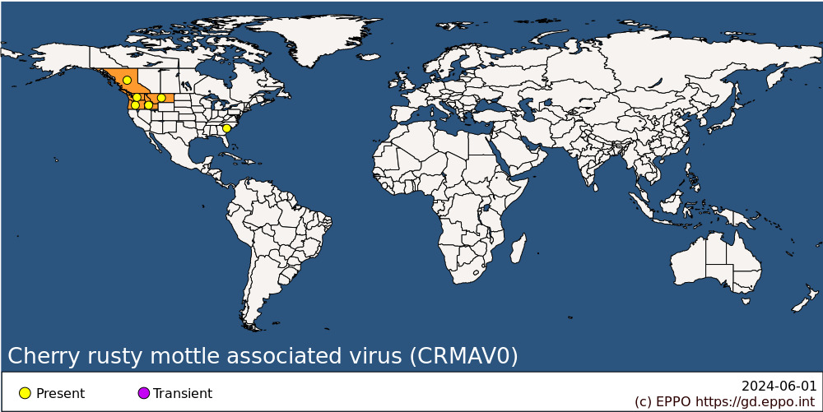
North America: Canada (British Columbia), United States of America (Idaho, Montana, Oregon, South Carolina, Washington)

BIOLOGY
CRMaV is systemic in its host plants and infects all plant parts. It is transmitted by grafting (Rott & Jelkmann, 2011) and other vegetative propagation techniques. It has no known vector and is not known to be seed- or pollen-transmitted (Rott & Jelkmann; EFSA, 2019). No herbaceous host of CRMaV is known.

DETECTION AND IDENTIFICATION

Symptoms
Affected P. avium trees begin to show symptoms of light green or yellow mottling on small basal leaves a few weeks after blooming (Rott & Jelkmann, 2011; Villamor and Eastwell, 2013). Chlorotic areas then turn bright yellow, brownish or show late-season reddening, hence the name ‘rusty’ mottle given to the disease. Affected leaves fall rapidly leading to partial tree defoliation (Rott & Jelkmann, 2011). Remaining leaves develop chlorotic mottling. In severely affected trees, leaf colouring and early senescence resembling fall colours may occur, together with fruit size reduction, late ripening and quality loss (tasteless fruits). In milder forms leaf bronzing occurs without early leaf fall, and fruits’ size and quality are less affected. Trees also show decline and dieback (Rott & Jelkmann, 2011). Typical cherry rusty mottle symptoms were reproduced in the Mazzard sweet cherry indicator following grafting of the Krymsk6 cherry rootstock [P. cerasus x (P. cerasus x P. maackii)] following its agroinoculation of a cloned CRMaV infectious cDNA construct (Villamor et al., 2021).
There are indications that all varieties of P. serrulata may not be equally susceptible and develop symptoms of CRMaV infection (Poudel & Scott, 2017). However at least some varieties are known to express light green or yellow mottling symptoms, such as the cv. Kwanzan P. serrulata indicator (Villamor & Eastwell 2013).
Chlorotic yellow leaf blotch symptoms were observed on Portuguese laurel (Prunus lusitanica) infected by CRMaV (Villamor et al., 2014). However, the presence of additional viruses that may have contributed to these symptoms cannot be completely excluded.

Morphology
The viral particles of CRMaV have yet to be observed by electron microscopy. However, by analogy with other Betaflexiviridae members, they would be expected to be flexuous and elongated particles of 10-15 x 600-1000 nm.

Detection and inspection methods
Visual examination may allow the detection of symptoms but is not considered reliable enough since symptoms are not highly specific and are not always obvious in infected plants. A procedure for inspection of places of production of Prunus trees is provided in Standard PM 3/76 (EPPO, 2021).
CRMaV can be detected by biological indexing on woody indicators such as Prunus avium cv. Bing, Sam or F12/1 Mazzard and P. serrulata cv. Kwanzan (Rott & Jelkmann, 2011; Villamor & Eastwell, 2013; Villamor et al., 2021). However, such tests are relatively lenghty and low-throughput and results may be complicated to interpret in the case of mixed infections.
There are no commercially available antisera that could be used for detection of CRMaV using serological tests. The molecular characterization of CRMaV and the sequencing of the genome of several isolates have allowed the development of primer pairs that can be used in RT-PCR tests. The broad-spectrum nested RT-PCR tests developed by Foissac et al. (2005) and Villamor et al. (2013), or the specific test developed by Villamor & Eastwell (2013) may be used. However, the analytical specificity of these tests requires further evaluation. HTS based approaches can also be used for the detection of CRMaV.

PATHWAYS FOR MOVEMENT
Movement and trade of contaminated propagation materials is considered the most significant pathway for movement since CRMaV is readily transmitted by grafting.

PEST SIGNIFICANCE

Economic impact
Trees of sweet cherry infected with CRMaV show defoliation, decline and dieback. More or less pronounced fruit size reduction and fruit quality loss are also observed. Detailed data on yield losses caused by CRMaV are not available but the intensity of defoliation reported in severe cases (30 to 70% leaf loss by fruit maturity, Wadley & Nyland, 1976) suggest the potential for severe impact on sweet cherry production.

Control
The most efficient control strategy is the development and use of CRMaV-free propagation material, as described in EPPO Standard PM 4/29(1) Certification scheme for cherry (EPPO, 2001). No control measures are known in the field, besides the destruction of infected plants and the limitation of movement of host plants outside the infected area.

Phytosanitary risk
The virus typically infects and has its main impact in sweet cherry (P. avium). Sweet cherry is widely grown in the EPPO region and represents an important fruit crop. A few other Prunus species are known to be susceptible. There are no known ecoclimatic constraints for CRMaV establishment, except those affecting its hosts; and sweet cherry cultivation occurs widely in Europe (EFSA, 2019). It was therefore considered justified by some EPPO countries (e.g. in the EU) to prevent establishment and spread of CRMaV.

PHYTOSANITARY MEASURES
Appropriate phytosanitary measures to import plants for planting (excluding seeds and pollen) of Prunus hosts into the EPPO region could require that these plants are produced in a pest free area, in a pest free place/site of production, or shown to be free from CRMaV by appropriate diagnostic methods. A number of EPPO countries already ban the import of Prunus (other than fruits and seeds) from areas where the pest is present (EU, 2019).

REFERENCES
EFSA Panel on Plant Health (PLH), Bragard C, Dehnen-Schmutz K, Gonthier P, Jacques M-A, Jaques Miret JA, Justesen AF, MacLeod A, Magnusson CS, Milonas P, Navas-Cortes JA, Parnell S, Potting R, Reignault PL, Thulke H-H, Van der Werf W, Vicent Civera A, Yuen J, Zappala L, Candresse T, Chatzivassiliou E, Finelli F, Winter S, Bosco D, Chiumenti M, Di Serio F, Kaluski T, Minafra A & Rubino L (2019) Pest categorisation of non-EU viruses and viroids of Prunus L. EFSA Journal 17, e05735. https://doi.org/10.2903/j.efsa.2019.5735
EPPO (2001) Production of healthy plants for planting. EPPO Standard PM 4/29(1) Certification scheme for cherry. EPPO Bulletin 31, 447-461. https://doi.org/10.1111/j.1365-2338.2001.tb01027.x
EPPO (2021) Phytosanitary procedures. EPPO Standard PM 3/76(2) Trees of Malus, Pyrus, Cydonia and Prunus spp.: Inspection of places of production. EPPO Bulletin 52, 354-386. https://doi.org/10.1111/epp.12771
EU (2019) Commission implementing regulation (EU) 2019/2072 of 28 November 2019 establishing uniform conditions for the implementation of Regulation (EU) 2016/2031 of the European Parliament and the Council, as regards protective measures against pests of plants, and repealing Commission Regulation (EC) No 690/2008 and amending Commission Implementing Regulation (EU) 2018/2019. Official Journal of the European Union, L 319, 1-279.
Foissac X, Svanella-Dumas L, Gentit P , Delucq M-J, Marais A & Candresse T (2005) Polyvalent degenerate oligonucleotides reverse transcription-polymerase chain reaction: a polyvalent detection and characterization tool for trichoviruses, capilloviruses, and foveaviruses. Phytopathology 95, 617-625. https://doi.org/10.1094/PHYTO-95-0617
Mink GI (1995) Cherry rusty mottle. In: Compendium of Stone Fruit Diseases (eds Ogawa JM, Zehr EI, Bird GW, Ritchie DF, Uriu K & Uyemoto JK). APS Press, St Paul, MN (US), 75
Posnette AF (1951) Virus diseases of sweet cherries. Annual Report of the East Malling Research Station A34, 209-210.
Posnette AF & Cropley R (1961) European rusty mottle disease of sweet cherry. Annual. Report of the East Malling Research Station A44, 85-86.
Poudel B & Scott SW (2017) A report of cherry rusty mottle-associated virus in South Carolina. Australasian Plant Diseases Notes 12, 15. https://doi.org/10.1007/s13314-017-0239-4
Reeves E (1940) Rusty-mottle, a new virosis of cherry. Phytopathology 30, 789.
Reinhold LA & Pscheidt JW (2023) Diagnostic and historical surveys of sweet cherry (Prunus avium) virus and virus-like diseases in Oregon. Plant Disease 107, 633-643. https://doi.org/10.1094/PDIS-02-21-0327-SR
Rott M & Jelkmann W (2011) Cherry necrotic rusty mottle and Cherry rusty mottle viruses. In: Virus and Virus-like Diseases of Pome and Stone Fruits. (eds Hadidi A, Barba M, Candresse T, Jelkmann W). American Phytopathological Society, St. Paul, MN (US), 133-136
Villamor DE & Eastwell KC (2013) Viruses associated with rusty mottle and twisted leaf diseases of sweet cherry are distinct species. Phytopathology 103, 1287-1295. https://doi.org/10.1094/PHYTO-05-13-0140-R
Villamor DEV, Susaimuthu J & Eastwell KC (2015) Genomic analyses of cherry rusty mottle group and cherry twisted leaf-associated viruses reveal a possible new genus within the family Betaflexiviridae. Phytopathology 105, 399-408. https://doi.org/10.1094/PHYTO-03-14-0066-R
Villamor DEV, Ward KF, Collman SJ & Eastwell KC (2014) First report of infection of cherry rusty mottle associated virus in Portuguese laurel (Prunus lusitanica) in Washington State. Plant Disease 98, 699. https://doi.org/10.1094/PDIS-09-13-0921-PDN
Villamor DV, Druffel KL & Eastwell KC (2013) Complete nucleotide sequence of a virus associated with rusty mottle disease of sweet cherry (Prunus avium). Archives of Virology 158, 1805-1810. https://doi.org/10.1007/s00705-013-1668-9
Villamor DEV, Pillai SS & Eastwell KC (2021) Systemic infection and symptom development of agro-inoculated cDNA clone of cherry rusty mottle-associated virus in sweet cherry (Prunus avium). Virus Research 296, 198330. https://doi.org/10.1016/j.virusres.2021.198330
Wadley BN & Nyland G (1976) Rusty mottle group. in: Virus Diseases and Noninfectious Disorders of Stone Fruits in North America (eds Gilmer RM, Moore JD, Nyland G, Welsh MF & Pine TS). U.S. Department of Agriculture. Agricultural Handbook 437,242-249

ACKNOWLEDGEMENTS
This datasheet was prepared in 2023 by Thierry Candresse [INRAE, France] and by Miroslav Glasa [Slovak Academy of Sciences, Slovak Republic]. Their valuable contribution is gratefully acknowledged.

How to cite this datasheet?
EPPO (2024) Cherry rusty mottle associated virus. EPPO datasheets on pests recommended for regulation. Available online. https://gd.eppo.int

Datasheet history
This datasheet was first published online in 2023. It is maintained in an electronic format in the EPPO Global Database. The sections on 'Identity', ‘Hosts’, and 'Geographical distribution' are automatically updated from the database. For other sections, the date of last revision is indicated on the right.

