EPPO Datasheet: Choristoneura occidentalis occidentalis
Last updated: 2021-12-07

IDENTITY
Preferred name: Choristoneura occidentalis occidentalis
Authority: Freeman
Taxonomic position: Animalia: Arthropoda: Hexapoda: Insecta: Lepidoptera: Tortricidae
Other scientific names: Choristoneura freemani Razowski, Choristoneura occidentalis Freeman
Common names in English: Western spruce budworm
view more common names online...
EPPO Categorization: A1 list
EU Categorization: A1 Quarantine pest (Annex II A)
view more categorizations online...
EPPO Code: ARCHOC

Notes on taxonomy and nomenclature
The taxonomy and nomenclature of Choristoneura occidentalis occidentalis Freeman, 1967 has been the subject of some controversy in recent years. Freeman (1967) first described this species based on the examination of specimens from extensive collections of conifer-feeding budworms across North America. Razowski (2008) proposed C. freemani as a replacement name after moving the West African species Cacoecia occidentalis Walsingham, 1981 to Choristoneura. This new name was largely ignored until Gilligan & Brown (2014) discussed the taxonomic issues created by Razowski’s (2008) generic reassignment, but provisionally accepted the new name until further evidence was published or a formal challenge was made. Brunet et al. (2017) formally challenged Razowski’s 2008 transfer of Cacoecia occidentalis to Choristoneura following a genetic analysis of the Choristoneura fumiferana species group in western Canada. Additionally, Brunet et al. (2017) demoted the two-year cycle budworm, C. biennis, to a subspecies of C. occidentalis. More recently, Fagua et al. (2019) redefined Choristoneura Lederer, 1859 based on a genetic analysis of 105 species of Archipini and other Tortricidae. They exclude C. freemani Razowski from Choristoneura.

HOSTS
Choristoneura occidentalis occidentalis occurs principally on Pseudotsuga menziesii and also on other forest trees such as Abies concolor, A. grandis, A. lasiocarpa, Larix occidentalis, Picea engelmannii, P. glauca and P. pungens. In the EPPO region these host plants can be found in Northern and Central European forests.
Host list: Abies concolor, Abies grandis, Abies lasiocarpa, Larix occidentalis, Picea engelmannii, Picea glauca, Picea pungens, Pseudotsuga menziesii

GEOGRAPHICAL DISTRIBUTION
C. occidentalis occidentalis is confined to North America, where outbreaks were first recorded in 1909 in Vancouver Island (British Columbia, Canada), and in Idaho (USA) in 1922. C. occidentalis occidentalis then established itself as a serious pest throughout the Pacific Coast States, British Columbia and Rocky Mountain States. Recent molecular studies of Choristoneura in Western Canada have identified populations in southern Alberta and southwest Saskatchewan (Lumley & Sperling, 2011).
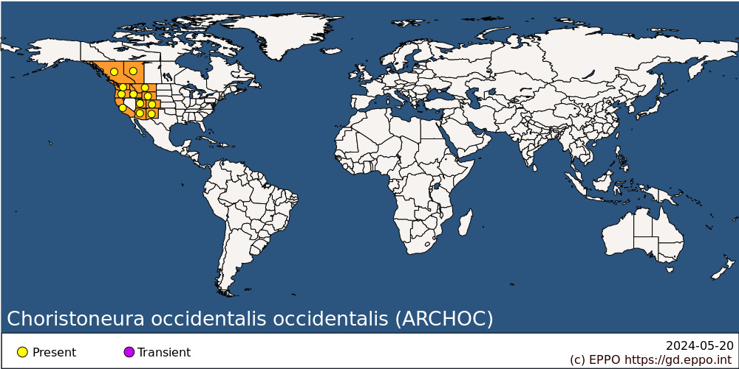
North America: Canada (Alberta, British Columbia), United States of America (Arizona, California, Colorado, Idaho, Montana, New Mexico, Oregon, Utah, Washington, Wyoming)

BIOLOGY
Eggs are laid in summer (July and August) and hatch in about 10 days. The newly hatched larvae do not feed but spin silken shelters among lichens and under bark scales in which they hibernate. In the following spring, they mine old needles until bud swelling, and then bore into the buds and feed upon the growing needles. Later they loosely web the growing tips and feed upon new needles. Pupation takes place after six larval instars. Predictive models of phenology of this pest for use in integrated pest management have been described (Dennis et al., 1986; Kemp et al., 1986; Nealis & Régnière, 2014).

DETECTION AND IDENTIFICATION

Symptoms
The larvae of C. occidentalis occidentalis feed principally in buds and on foliage of forest trees and heavy attacks can cause complete defoliation in 4-5 years. Infested trees can show a growth reduction, deformity, top killing and may die (Alfaro et al., 1982). Damage to cones and seeds has also been observed on Pseudotsuga menziesii and Larix occidentalis in the Rocky Mountains.

Morphology
Eggs
The eggs are light-green, oval, and about 1.2 long. They are laid in masses (like shingles) on the underside of needles with between 30 and 60 eggs per mass (Carolin, 1987).
Larva
Newly hatched larvae are light-green with brown heads. Head capsules are, on average, 0.27 mm wide in first instar larvae and increase to an average of 1.86 mm wide in sixth instars (Stein, 1981). Fully-grown larvae are 25-32 mm long with a brownish head, olive and reddish-brown body and prominent ivory spots at the setal bases (Carolin, 1987).
Pupa
12-16 mm long, broad at the head end but tapering rapidly toward the tail. Colouration is typically reddish brown.
Adult
Generally, the adults are mottled orange-brown or rust coloured, occasionally grey, approximately 11 mm long with a wing-span of 22-28 mm (Freeman, 1967).

Detection and inspection methods
Eggs are predominantly laid on the underside of needles and due to their cryptic coloration are difficult to see. Acciavatti & Jennings (1976) found that examining branches under UV light increased the probability of egg detection.
Second-instar larvae overwintering in silken hibernacula can only be reliably detected by washing foliated branches for several hours in a 2% solution of heated sodium hydroxide, followed by sieving and separating the small larvae using hexane floatation (Allen et al., 1984).
Actively feeding C. occidentalis ssp. larvae can be distinguished from other associated larvae using the key of Stevens et al. (1984).

PATHWAYS FOR MOVEMENT
Passive wind dispersal can occur as larvae spin down on long silken threads (Fellin, 1984), and spread is also ensured by moth flight. In international trade, C. occidentalis occidentalis is liable to be carried by plants for planting and cut foliage of conifer host plants as second-instar hibernating larvae. Egg masses are only laid on live foliage and, as they typically hatch within 10 days, present minimal risk (Carolin, 1987).

PEST SIGNIFICANCE

Economic impact
C. occidentalis occidentalis is one of the most destructive forest defoliators in Western North America. Heavy and repeated attacks can lead to top-killing of the trees and tree mortality (Alfaro et al., 1982, 1985).

Control
Population control and foliage protection can be achieved through the use of aerial applications of Bacillus thuringiensis subsp. kurstaki (Cunningham, 1984). Applications of baculoviruses against C. occidentalis occidentalis do not appear to be sufficiently effective (Otvos et al., 1989). Natural enemies such as the parasitoids Glypta fumiferanae, Apanteles fumiferanae and Phytodietus fumiferanae can affect populations of C. occidentalis occidentalis (Furniss & Carolin, 1977), but do not seem to prevent outbreaks and subsequent defoliation in most parts of its range (Nealis, 2016). Silvicultural methods, such as thinning (Carlson et al., 1984) and nitrogen fertilization, may have an influence on pest populations, though they do not appear to be predominant environmental factors (Mason et al., 1992).

Phytosanitary risk
This serious pest of forest trees presents a definite risk for Northern and Central European forests.

PHYTOSANITARY MEASURES
Prohibition of the import of plants and cut foliage of Abies, Larix, Picea and Pseudotsuga from infested countries can be recommended as appropriate measures to prevent introduction of C. occidentalis occidentalis.

REFERENCES
Acciavatti RE, Jennings DT, Forest RM & Station RE (1976) Locating western spruce budworm egg masses with ultraviolet light. Research Note RM-313. U.S. Dept. of Agriculture, Forest Service, Rocky Mountain Forest and Range Experiment Station.
Alfaro RI, van Sickle GA, Thomson AJ & Wegwitz E (1982) Tree mortality and radial growth losses caused by the western spruce budworm in a Douglas-fir stand in British Columbia. Canadian Journal of Forest Research 12, 780-787.
Alfaro RI, Thomson AJ & van Sickle GA (1985) Quantification of Douglas-fir growth losses caused by western spruce budworm defoliation using stem analysis. Canadian Journal of Forest Research 15, 5-9.
Allen DC, Dorais L & Kettela EG (1984) Survey and detection. In Spruce budworm handbook: managing the spruce budworm in eastern North America. Agricultural Handbook 620, 21-36.
Brunet BMT, Blackburn GS, Muirhead K, Lumley LM, Boyle B, Lévesque RC, Cusson M & Sperling FAH (2017) Two's company, three's a crowd: new insights on spruce budworm species boundaries using genotyping-by-sequencing in an integrative species assessment (Lepidoptera: Tortricidae). Systematic Entomology 42, 317-328.
Carlson CE, Schmidt WC, Fellin DG & Wulf NW (1984) Silvicultural Approaches to Western Spruce Budworm Management in the Northern U.S. Rocky Mountains. In Recent Advances in Spruce Budworms Research (eds Sanders C, Stark RW, Mullins EJ & Murphy J). Canadian Forest Service, Ottawa.
Carolin VM (1987) Life History and Behavior. In Western Spruce Budworm (eds Brookes MH, Campbell RW, Colbert JJ, Mitchell RG & Stark RW), pp. 29-42. United States Department of Agriculture, Washington DC.
Cunningham JC (1984) Biorationales for Control of Spruce Budworms. In Recent Advances in Spruce Budworms Research (eds Sanders C, Stark RW, Mullins EJ & Murphy J). Canadian Forest Service, Ottawa.
Dennis B, Kemp WP & Beckwith RC (1986) Stochastic model of insect phenology: estimation and testing. Environmental Entomology 15, 540-546.
Fagua G, Condamine FL, Dombroskie JJ, Byun BK, De Prins J, Simonsen TJ, Baez M, Brunet BMT & Sperling FAH (2019) Genus delimitation, biogeography and diversification of Choristoneura Lederer (Lepidoptera: Tortricidae) based on molecular evidence. Systematic Entomology 44, 19-38.
Fellin, DG (1984) Dispersal of Western Spruce Budworm Larvae and Adults as related to Silvicultural Treatments. In Recent Advances in Spruce Budworms Research (eds Sanders C, Stark RW, Mullins EJ & Murphy J). Canadian Forest Service, Ottawa.
Freeman TN (1967) On coniferophagous species of Choristoneura (Lepidoptera: Tortricidae) in North America: I. Some new forms of Choristoneura allied to C. fumiferana. The Canadian Entomologist 99, 449-455.
Furniss RL & Carolin VM (1977) Western forest insects, pp. 168-173. Miscellaneous Publication No. 1339, USDA Forest Service, Washington, USA.
Gilligan TM & Brown JW (2014) A new name for the western spruce budworm (Lepidoptera: Tortricidae)? The Canadian Entomologist 146, 583-589.
Kemp WP, Dennis B & Beckwith RC (1986) Stochastic phenology model for the western spruce budworm (Lepidoptera: Tortricidae). Environmental Entomology 15, 547-554.
Lumley LM & Sperling FAH (2011) Utility of microsatellites and mitochondrial DNA for species delimitation in the spruce budworm (Choristoneura fumiferana) species complex (Lepidoptera: Tortricidae). Molecular Phylogenetics and Evolution 58, 232-243.
Mason RR, Wickman BE, Beckwith RC & Paul HG (1992) Thinning and nitrogen fertilization in a grand fir stand infested with western spruce budworm. Part I. Insect response. Forest Science 38, 235-251.
Nealis V & Régnière J (2014) An individual-based phenology model for western spruce budworm (Lepidoptera: Tortricidae). The Canadian Entomologist 146, 306-320.
Nealis VG (2016) Comparative ecology of conifer-feeding spruce budworms (Lepidoptera: Tortricidae). The Canadian Entomologist 148, S33-S57.
Otvos IS, Cunningham JC & Kaupp WP (1989) Aerial application of two baculoviruses against the western spruce budworm Choristoneura occidentalis Freeman (Lepidoptera: Tortricidae) in British Columbia. Canadian Entomologist 121, 209-217.
Razowski J (2008) Tortricidae (Lepidoptera) from South Africa. 6: Choristoneura Hubner and Procrica Diakonoff. Polish Journal of Entomology 77, 245-254.
Stein JD (1981) Notes on the biology of the western spruce budworm, Choristoneura occidentalis (Lepidoptera: tortricidae), in north central Washington. Pacific Insects 23, 101-106.
Stevens RE, Carolin VM & Markin GP (1984) Lepidoptera associated with western spruce budworm. In Spruce budworms handbook. United States Cooperative State Research Service, Canada/United States Spruce Budworms Program. U.S. Department of Agriculture, Forest Service, Cooperative State Research Service, Agricultural Handbook No. 622, p. 5-8.

ACKNOWLEDGEMENTS
This datasheet was extensively revised in 2021 by Dr Brian Van Hezewijk, Natural Resources Canada – Canadian Forest Service. His valuable contribution is gratefully acknowledged.

How to cite this datasheet?
EPPO (2024) Choristoneura occidentalis occidentalis. EPPO datasheets on pests recommended for regulation. Available online. https://gd.eppo.int

Datasheet history
This datasheet was first published in 1997 in the second edition of 'Quarantine Pests for Europe', and revised in 2021. It is now maintained in an electronic format in the EPPO Global Database. The sections on 'Identity', ‘Hosts’, and 'Geographical distribution' are automatically updated from the database. For other sections, the date of last revision is indicated on the right.
CABI/EPPO (1997) Quarantine Pests for Europe (2nd edition). CABI, Wallingford (GB).

