EPPO Datasheet: Anthonomus bisignifer
Last updated: 2023-04-20

IDENTITY
Preferred name: Anthonomus bisignifer
Authority: Schenkling
Taxonomic position: Animalia: Arthropoda: Hexapoda: Insecta: Coleoptera: Curculionidae: Curculioninae
Other scientific names: Minyrus albopilosus Matsumara, Minyrus japonicus Matsumara
Common names in English: Japanese strawberry blossom weevil, Japanese strawberry weevil
view more common names online...
EPPO Categorization: A1 list
EU Categorization: A1 Quarantine pest (Annex II A)
view more categorizations online...
EPPO Code: ANTHBI

Notes on taxonomy and nomenclature
The correct taxonomic name for this species is Anthonomus bisignifer Schenkling 1934. Other older scientific names for this species are all junior homonyms. A complete nomenclatural history is given in Alonso-Zarazaga et al. (2017).

HOSTS
Strawberries are the main economically important host crop. A. bisignifer has also been recorded on Rubus and on wild roses. Within the EPPO region, strawberries, which are widely grown, would be the principal crop at risk. Kojima and Morimoto (1994) note that damage to strawberry is negligible in modern horticultural practices. They further state it is common on Rosa spp., Rubus spp. and some other Rosaceae and is often injurious to garden roses. Some specimens were captured on Rosa rugosa along with Anthonomus terreus Gyllenhal in Hokkaido.
Host list: Fragaria x ananassa, Rosa, Rubus

GEOGRAPHICAL DISTRIBUTION
This species is known from Japan (Hokkaido, Honshu, Shikoku, Kyushu, Tsushima), Kurils, Sakhalin, the Korean peninsula, and Russian (Siberia, Far East).
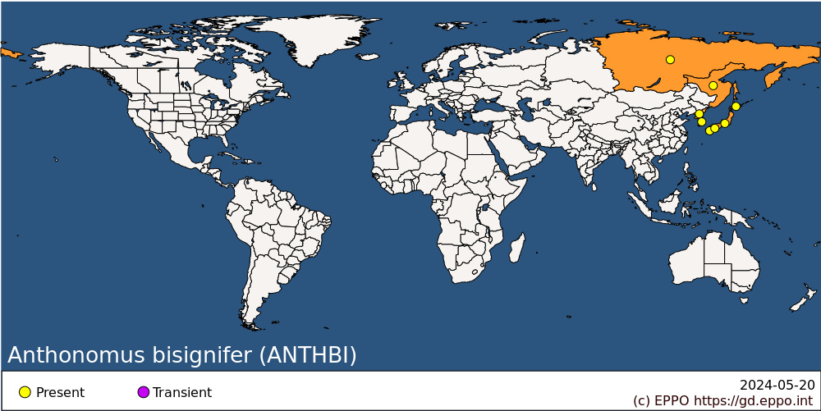
EPPO Region: Russia (Eastern Siberia, Far East)
Asia: Japan (Hokkaido, Honshu, Kyushu, Shikoku), Korea Dem. People's Republic, Korea, Republic

BIOLOGY
Anthonomus bisignifer has one generation a year. In Sendai, Japan, A. bisignifer females emerge from hibernation in late April, mate and begin egg laying (Katô, 1936). Further south in the region of Nara, southern Honshu, adults emerge from overwintering between late March and early April (Imura, 2011). The female lays eggs in holes excavated in the flower buds of strawberries. The female then bites through the stalk a few millimetres below the bud. Most of the flower buds fall off, but a few remain hanging on the plants. The eggs are laid, mostly during the day, and egg laying reaches a peak in mid- to late-May in Sendai. The number of eggs laid increases with air and soil surface temperature and hours of sunshine, being highest when sunshine approaches 12 h and the temperature is above 20°C, but many eggs are laid even when the temperature is around 12°C (Katô, 1936; 1937). About 77 eggs are laid per female (Kinoshita & Shinkai, 1926). The durations of the immature stages are: egg 4-9 days, larva 10-50 days, pupa 4-9 days (Kinoshita & Shinkai, 1926). The adults do not mate before hibernation (Kinoshita & Shinkai, 1926).
The weevils usually rest at night and under cool cloudy conditions by day, but start to crawl in the field at an air temperature of 7.2°C, combined with a black bulb temperature of 8.4°C. In the laboratory under low radiation conditions, the low temperature limit is around 10°C. Flight begins at around 23°C in the laboratory and in the field at 18°C, combined with a black bulb temperature of about 23°C (Katô, 1938a, b).
It is not known where the adults overwinter. However, EFSA (2017) note that it is possible overwintering occurs under plant debris within fields and in soil around host plants. In addition, adults may over winter in vegetation adjacent to field boundaries.

DETECTION AND IDENTIFICATION

Symptoms
The most obvious symptoms of damage are partially severed buds hanging from the plants and severed buds on the ground (Katô, 1936).

Morphology
Eggs
0.59 mm long, 0.41 mm wide (Iwata, 1966).
Larva
The larva is undescribed but is probably similar to that of Anthonomus rubi Herbst described by Scherf (1964). Lee & Morimoto (1988) gave a key to the genera of weevils larvae of Japan including Anthonomus.
Pupa
The pupa is undescribed but is probably similar to that of A. rubi illustrated by Scherf (1964).
Adult
Length 2.5-4.0 mm; rostrum with very fine dorsal median keel; head and pronotum dark-brown or black; pronotum narrowed anteriorly, usually with median and two lateral bands of whitish elongate scales, remainder sparsely covered with similarly shaped brownish scales; scutellum small, densely covered with whitish scales; elytra pale-brown to dark red-brown, darker triangular lateral area demarcated by margin of dense whitish elongate scales, this triangle-shaped area extending from stria 2 to elytral margin in posterior half of elytra and extending forwards as broad margin to elytral base; entire surface with sparse whitish elongate scales; legs pale-brown, sometimes apical half to two-thirds of femora dark-brown; anterior femora bearing single small tooth, much shorter than width of femur; tibiae slender; ventrally entirely dark-brown or black, moderately densely covered with elongate whitish scales. Kôno (1939) and Kojima and Morimoto (1994) gave keys to the Anthonomus species of Japan. Katô (1938c) described the local variation in morphometrics of the adults. Kojima and Morimoto (1994) gives a comprehensive description of the adult. For a colour figure of the adult, see Hayashi et al. (1984). Kojima and Morimoto (1994) note that some specimens from the northern part of Japan are smaller in size and often darker in colour.
This species is closely related to A. signatus (Say) from North America, but the body of A. bisignifer is slender and the fifth and sixth segments of the antenna 1 funicle are almost as long as broad, whereas in A. signatus these segments are clearly broader than they are long (Kojima and Morimoto, 1994).

Detection and inspection methods
The most obvious symptoms of damage are partially severed buds hanging from the plants and severed buds on the ground (Katô, 1936). When inspecting plants, inspectors should look for adults and inspect severed buds, which may contain eggs, larvae or pupae.
The EPPO Standard PM 3/83 Fragaria plants for planting- inspection of places of production (EPPO, 2017) and EPPO Standard PM 3/73 Consignment inspection of Fragaria plants for planting (EPPO, 2008) provide a detailed procedure for inspection of place of production and consignments of Fragaria plants for planting.

PATHWAYS FOR MOVEMENT
Anthonomus bisignifer is most likely to be transported as a casual contaminant of planting material or fresh fruit or in the horticulture industry through movement of cultivated rose plants for planting.
There is no information on the dispersal rate of A. bisignifer. EFSA (2017) note that its dispersal ability is probably similar to that of A. signatus where adults are reported to rarely fly or walk more than 10 m in search of food or oviposition sites.

PEST SIGNIFICANCE

Economic impact
Anthonomus bisignifer has been included in lists of the important pests of agricultural crops in Japan (Shiraki, 1952; Anon., 1968). Imura (2011) reported damage to strawberry in 2006 in Nara Prefecture (Honshu, Japan), Studies showed variable amounts of damage including impacts on strawberry plants grown within protected conditions. Up to 50 % of strawberry plants were reported to be attacked (Imura, 2011). However, with the exception of Imura (2011), there is a complete lack of publications on any aspect of pest status within the past decades. Modern horticultural practices may have an impact on the weevil and chemical control targeted at other pest species may have a negative impact on the weevil.

Control
There is no published information on the control of this weevil. However, insecticides successfully used against A. rubi in Europe would probably be effective. Martin (1965) recommended the use of the chlorinated hydrocarbon, tetrachlorodiphenylethane as a spray, applied as soon as the first damage is seen. Scopes & Stables (1989) recommended the application of carbaryl or gamma-HCH. Pokozii & Gadzalo (1988) found that the most effective pyrethroids against A. rubi were permethrin, cypermethrin, fenvalerate and deltamethrin.
Little is known regarding natural control agents. Yasumatsu & Watanabe (1964) listed Catolaccus endonis (Hymenoptera: Pteromalidae) as a parasite of this weevil in Hokkaido, Japan.

Phytosanitary risk
There is the potential of damage to strawberry production and other fruit production (e.g. fruit from Rubus species), and/or rose cultivation in the EPPO region. However, as already stated, the potential for damage is not clear under modern cultivation practices.

PHYTOSANITARY MEASURES
For plants for planting of strawberries, Rubus or Rosa from countries where A. bisignifer occurs, it would be sufficient to require that host plants are sourced from a pest free area or pest free production site. Ensuring host plants are free from soil or plant debris can reduce the risk of entry for all life stages of the pest.

REFERENCES
Alonso-Zarazaga MA et al. (2017) Cooperative catalog of Palearctic Coleoptera. Monografías electrónicas SEA 8 Sociedad Entomológica Aragonesa S.E.A. Zaragoza (Spain), 729 pp. http://sea-entomologia.org/monoelec.html
Anon. (1968) List of important diseases and pests of economic plants in Japan. Japan Plant Protection Society, 591 pp. Seizo, Tokyo, Japan.
EFSA (2017) Scientific Opinion on the pest categorisation of Anthonomus bisignifer. EFSA Journal 15(12), 5073, 21 pp.
EPPO (2017) PM 3/83 Fragaria plants for planting- inspection of places of production. EPPO Bulletin 47, 349-365.
EPPO (2008) PM 3/73 Consignment inspection of Fragaria plants for planting. EPPO Bulletin 38, 396-406.
Hayashi M, Morimoto K & Kimoto S (editors) (1984) [The Coleoptera of Japan in colour. Volume IV]. Hoikusha Publishing Co. Ltd, Osaka, Japan.
Imura T (2011) Spring occurrence of the strawberry blossom weevil, Anthonomus bisignifer Schenkling on forced strawberry in Nara Prefecture and toxicities of some insecticides to adults. Annual Report of the Kansai Plant Protection Society 53, 1-6.
Iwata K (1966) Large-sized eggs in Curculionoidea (Coleoptera). Science Report of the Hyogo University of Agriculture 7, 43-47.
Katô M (1936) On the activity of oviposition of the strawberry weevil, Anthonomus bisignatus Roelofs. Science Reports of the Tôhoku Imperial University 4th Series (Biology) 10, 697-708.
Katô M (1937) A statistical investigation of the correlation between climatic conditions and the egg-laying activity of the strawberry weevil, Anthonomus bisignifer Schenkling. Science Reports of the Tôhoku Imperial University 4th Series (Biology) 11, 307-321.
Katô M (1938a) The temperature limit of activity of the strawberry weevil, Anthonomus bisignifer Schenkling. Science Reports of the Tôhoku Imperial University 4th Series (Biology) 12, 501-510.
Katô M (1938b) The diurnal activity of the strawberry weevil, Anthonomus bisignifer Schenkling, with a note on the ecological meaning of the solar radiant energy. Science Reports of the Tôhoku Imperial University 4th Series (Biology) 12, 511-530.
Katô M (1938c) [Local variation of bodily dimensions in the strawberry weevil, Anthonomus bisignatus Schenkling]. Ecological Review 4, 332- 344.
Kinoshita S, & Shinkai S (1926) [On Anthonomus signatus Roelofs (Curculionidae)]. Agriculture & Horticulture 1, 3-12. (Abstract in Review of Applied Entomology, Series A 14, 560).
Kojima H & Morimoto K (1994) Taxonomic study of the subfamily Anthonominae from Japan (Coleoptera: Curculionidae). Esakia 34, 147-186.
Kôno H (1939) [New and little known beetles of Japan. VI The genus Anthonomus (Col. Curc.)]. Insecta Matsumarana 13, 76-80.
Lee CY & Morimoto K (1988) Larvae of the weevil family Curculionidae of Japan Part 1. Key to genera and the short-nosed group (Insecta: Coleoptera). Journal of the Faculty of Agriculture, Kyushu University 33, 109-130.
Martin H (editor) (1965) Insecticide and fungicide handbook for crop protection. Blackwell Scientific Publications, Oxford, UK.Pokozii IT, Gadzalo YM (1988) [Pyrethroids against pests of raspberry]. Zashchita Rastenii 3, 35-36.
Scherf H (1964) [The developmental stages of the Curculionidae of Central Europe (Morphology, Bionomics, Ecology)]. Abhandlungen herausgegeben von der Senckenbergischen Naturforschenden Gesellschaft 506, 1-335.
Scopes N & Stables L (editors) (1989) Pest and disease control handbook, 3rd edition. British Crop Protection Council, Thornton Heath, UK.
Shiraki T (1952) Catalogue of injurious insects in Japan. Natural Resources Division, G.H.Q. Allied Powers, Preliminary Study, No. 71.
Yasumatsu K & Watanabe C (1964) A tentative catalogue of insect natural enemies of injurious insects in Japan. Part 1. Parasite-predator host catalogue. Entomology Laboratory, Faculty of Agriculture, Kyushu University, Fukuoka, Japan.

ACKNOWLEDGEMENTS
This datasheet was extensively revised in 2023 by Robert S Anderson, Canadian Museum of Nature. His valuable contribution is gratefully acknowledged.

How to cite this datasheet?
EPPO (2024) Anthonomus bisignifer. EPPO datasheets on pests recommended for regulation. Available online. https://gd.eppo.int

Datasheet history
This datasheet was first published in 1997 in the second edition of 'Quarantine Pests for Europe', and revised in 2023. It is now maintained in an electronic format in the EPPO Global Database. The sections on 'Identity', ‘Hosts’, and 'Geographical distribution' are automatically updated from the database. For other sections, the date of last revision is indicated on the right.
CABI/EPPO (1997) Quarantine Pests for Europe (2nd edition). CABI, Wallingford (GB).

