EPPO Datasheet: Aculops fuchsiae
Last updated: 2022-02-24

IDENTITY
Preferred name: Aculops fuchsiae  Authority: Keifer  Taxonomic position: Animalia: Arthropoda: Chelicerata: Arachnida: Acarida: Eriophyidae  Common names in English: fuchsia gall mite, fuchsia mite  view more common names online...  EPPO Categorization: A2 list  EU Categorization: RNQP (Annex IV)  view more categorizations online...  EPPO Code: ACUPFU | 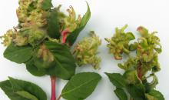  more photos...

HOSTS
Hosts of A. fuchsiae are Fuchsia species and cultivars. This mite has been found to survive on all Fuchsia species investigated. The three species: F. coccinea, F. magellanica, F. procumbens and over 30 cultivars are recorded as being particularly susceptible. There is however, considerable variation in susceptibility and three species (F. arborescens, F. microphylla and F. thymifolia) and 11 cultivars have been noted as being resistant to A. fuchsiae, although these cultivars and species were able to host the mite they showed little sign of damage (Koehler et al., 1985, Salisbury et al. 2014). Fuchsia cultivars bred from the Encliandra and Schufia taxonomic fuchsia groups and native to Central America may show more resistance than those from the Procumbentes and Quelusia taxonomic groups (Salisbury et al., 2014).
Host list: Fuchsia arborescens, Fuchsia coccinea, Fuchsia hybrids, Fuchsia magellanica, Fuchsia microphylla, Fuchsia procumbens, Fuchsia thymifolia, Fuchsia

GEOGRAPHICAL DISTRIBUTION
Aculops fuchsiae is thought to originate from South America, where it was described from specimens collected in Southern Brazil (Sao Paulo) but is likely to occur more widely. It was discovered in the San Francisco area of California (USA) in 1981 (Koehler et al., 1985), and has since spread rapidly in the southern part of this state. The mite has also occurred in Western Washington and Oregon, these intermittent populations are thought to periodically be wiped out by winter cold (Anon, 2012). In Europe the mite has probably been present since 2002 in Brittany, France and had become widespread in that region by 2012 (CABI, 2020). Elsewhere in Europe the mite has become widespread in the Channel Islands (Jersey and Guernsey) since being detected in 2006 (Ostojá-Starzewski & Eyre, 2012) and in Southern England since 2007, it has also been reported from Wales (Salisbury et al., 2014; RHS, 2022).
Outbreaks of Aculops fuchsiae have been reported in several other European countries in relation with movement of plants from infested areas (EPPO, 2012).
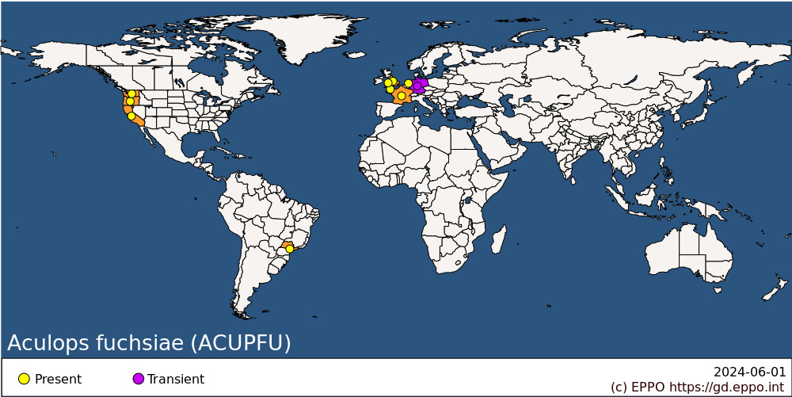
EPPO Region: France (mainland), Germany, Guernsey, Jersey, Netherlands, United Kingdom (England, Wales)
North America: United States of America (California, Oregon, Washington)
South America: Brazil (Sao Paulo)

BIOLOGY
Although the development of A. fuchsiae has not been described in detail, it is assumed that there are three life stages that precede the adult: egg, larva and nymph.. Only one female was described by Keifer (1972) and immature stages remain undescribed (Baker et al., 2014).
The mites live and reproduce within the folds of galled tissue and among plant hairs, but not within the galls (Keesey, 1985). As the plants grow, mites leave the galled area and move upwards to new growth. The female lays about 50 eggs at a time, which hatch after 4 to 7 days at 18°C (Ostojá-Starzewski & Eyre, 2012). The life cycle is completed in 21 days at 18°C and there are several generations during the growing season (Keesey, 1985). All life stages of the mites can overwinter within the bud scales, (Natter 1982; Crawford (1983). The mite tolerates a winter temperature of 5°C (Koehler et al. 1985). Information on suitable temperature ranges is supported by its spread in England where the mite has been present on hardy outdoor fuchsias since 2007 and some winters have seen prolonged periods below 0°C (Salisbury et al., 2014). In addition, following its initial discovery, it spread along approximately 900 km of coastal California in 4 years, in contrast to its spread inland was slower (Koehler et al. 1985). It was difficult to inoculate plants with the mite in glasshouses, but relatively easy to do so in the field, implying that the mite is not favoured by hot growing conditions (Koehler et al., 1985) and therefore may not survive well on plants grown under protection. More extreme cold, temperatures below -7°C for 3 to 4 nights are thought to kill the mite, limiting its establishment in the Pacific Northwest of the USA (Anon, 2012).

DETECTION AND IDENTIFICATION

Symptoms
In susceptible hosts A. fuchsiae causes deformation of the leaves, growths (galls) becoming grotesquely swollen and blistered, terminal shoots are often the most heavily affected. These galls often start as a yellowish green colour with a felt-like appearance, and as become reddened they age. Eventually further plant growth is often suppressed (Ostojá-Starzewski & Eyre, 2012). Affected flower buds often result in grossly abnormal blooms. Aculops fuchsiae is the only gall mite known to occur on Fuchsia and the galls are characteristic. Examination with a hand lens should reveal masses of yellowish fusiform mites especially within folds and leaf hairs of the deformed tissues.

Morphology
Type specimens of A. fuchsiae are held at Instituto Agronomico, Campinas, Estado São Paulo, Brazil and paratype specimens at the Entomological Research Division, USDA, Beltsville, Maryland, USA (CABI, 2020). The mite is about 200-250 µm long and 55-60 µm wide and pale yellowish-white in colour. A. fuchsiae is the only described species of eriophyoid mite that has fuchsia as a host however, confirmation of identity requires examination of cleared adult female specimens under a high-power microscope. Keifer (1972) gives an illustrated description of the female and mentions the short acuminate anterior shield lobe over the rostrum which is truncate underneath, and the presence of granules on the shield surface that obscure the pattern on the rear part of the shield as diagnostic of the species.

Detection and inspection methods
The galling symptoms induced on affected fuchsias are generally accepted as diagnostic of the presence of A. fuchsiae. However, due to their small size the mites require microscopic examination to confirm identify beyond all doubt. Examination of galls with a hand lens will usually reveal masses of the yellowish fusiform mites especially within folds of and leaf hairs of the deformed tissues will usually be enough to confirm the mites’ presence. The mite can be difficult to detect on resistant cultivars or at early stages where galling may not be severe, examination with a hand lens should focus on the base of leaves, leaf buds and flower buds where mites are more likely to be present.

PATHWAYS FOR MOVEMENT
On plants in the field, dispersal can be expected to be principally by wind, insects, especially pollinators, and in its native range possibly hummingbirds (Koehler et al., 1985). Movement of infested plants and cuttings is also important given the ease of vegetative propagation in fuchsias: this is considered to be the pathway of introduction into mainland Europe, the Channel Islands and the United Kingdom (Ostojá-Starzewski & Eyre, 2012; EFSA PHL, 2014). In the case of introductions to Jersey and Germany it is known that the mite was introduced with live plant material which avoided plant health checks by being brought in with personal luggage by Fuchsia enthusiasts from South America and the USA (Anderson and MacLeod, 2007; EPPO, 2012).

PEST SIGNIFICANCE

Economic impact
There has been no formal economic impact assessment of A. fuchsiae. The mite causes severe damage to fuchsias and must be ranked as a major pest of all but the most resistant species and cultivars. In California, where some growers had ceased to grow Fuchsia due to this mite (Koehler et al., 1985) it has been rated as a class B pest, enabling county authorities to take exclusion measures. In the United Kingdom commercial Fuchsia production had a value of 4 million GBP in 2004 (EFSA PHL, 2014) and there are national and local societies dedicated to the plant. More than 55 million cuttings or rooted plants were imported into the EU in 2010 (EPPO, 2012). Anderson and MacLeod (2007) and EFSA PHL (2014) concluded that, due to this relatively high economic value of Fuchsia production, there was a risk not only to production nurseries but there may be a decline in the popularity of fuchsia. This effect may apply across the EPPO region if the mite spreads across Western Europe.

Control
Good sanitation is an essential aspect of control. Affected material should be removed and destroyed and the risks of mite spread associated movement of plants and cuttings from areas where A. fuchsiae is prevalent should be carefully considered (Koehler et al., 1985, Salisbury et al., 2014). Enclosing affected material in a polythene bag and exposing to the sun for a few hours will kill the mites, but selective heat treatment (e.g. 3 h at 45°C) damages the plants unacceptably (Koehler et al., 1985). For the less susceptible cultivars, pruning alone was moderately successful in maintaining a good appearance (Koehler et al., 1985), but may not control mite numbers. See notes under 'Hosts' for details of resistant species.
Control with pesticides is difficult and pre-symptom treatment is required to be effective (Ostojá-Starzewski & Eyre, 2012). Several pesticides (many now unavailable) were tested in California and some suppression of the mite population was achieved for some products, in some cases lasting several weeks (Koehler et al., 1985). It has been suggested that at least three applications of acaricides at four-day intervals may break the mite life cycle, based on egg hatching time of 4 to 7 days (Ostojá-Starzewski & Eyre, 2012).
There are several mesostigmatid mites (Phytoseiidae) that feed on eriophyoid mites, although A. fuchsiae are relatively inaccessible to these predators once the galls have formed. Neoseiulus californicus has been found associated with A. fuchsiae in California and was thought to be one of the predators responsible for some reduction in fuchsia gall mite populations (Koehler et al., 1985). Amblyseius andersoni is advertised as controlling A. fuchsiae by some suppliers of biological control agents to home gardeners in the United Kingdom (RHS, 2021), although detailed information on success with this predator is lacking.

Phytosanitary risk
Fuchsia plants can be found in open fields and under protected cultivation, as well as in gardens, in most of the EPPO region. In Europe, the climatic conditions do not seem to be the key limiting factor for the spread and establishment in open fields and under protected conditions (EFSA PHL 2014). With an apparent preference for mild oceanic conditions, it is considered to have the potential for becoming established in Atlantic areas of western Europe, and probably elsewhere, wherever suitable hosts are present, in the open ground or under protection (Baker et al 2014; CABI 2020). The mite is an extremely damaging pest of a moderately important ornamental plant, propagated commercially on a substantial scale. In addition it can be difficult to detect especially on more resistant cultivars, and it is difficult to control, and it is difficult to control. Therefore A. fuchsiae clearly presents a significant risk for Fuchsia production in the EPPO region.

PHYTOSANITARY MEASURES
As the main pathway is the movement of plants for planting, measures should be applied to guarantee that traded Fuchsia plants are pest-free. Possible measures are as follows (Picard et al., 2018): plants for planting of Fuchsia spp. should be produced in areas known to be free from Aculops fuchsiae, or in sites of production where inspections during the previous growing season did not detect symptoms on the plants, or on the mother plants from which they were derived. Alternatively, plants may be treated with an appropriate chemical treatment before dispatch, following which the plants have been inspected and no symptoms seen.
Where outbreaks do occur in new regions eradication measures should be attempted especially where there is a link to movement of plants rather than ‘natural’ spread.
Raising awareness among fuchsia enthusiasts is critical to avoid movement of infested plants to new areas and to allow rapid identification of new outbreaks.

REFERENCES
Anderson H, MacLeod A (2007) CSL Pest Risk Analysis for Aculops fuchsiae. CSL, York, UK. Available at https://pra.eppo.int/organism/ACUPFU (Accessed February 2022).
Anonymous (2012) Aculops fuchsiae: Fuchsia gall mite – an eriophyid mite. The Northwest Fuchsia Society. Available at http://nwfuchsiasociety.com/mitesold.htm (Accessed February 2022).
Crawford TE (1983) The fuchsia mite. American Fuchsia Society Bulletin 55(1).
CABI (2020) Datasheet on Pest Aculops fuchsiae https://www.cabi.org/isc/datasheet/56110
EFSA PLH Panel (EFSA Panel on Plant Health) (2014) Scientific Opinion on the pest categorisation of Aculops fuchsiae. EFSA Journal 12(10), 3853
EPPO (2012) EPPO technical document no. 1061: EPPO study on the risk of imports of plants for planting. Available at https://www.eppo.int/media/uploaded_images/RESOURCES/eppo_publications/td_1061_plants_for_planting.pdf (Accessed February 2022).
Keesey B (1985) Fuchsia gall mite report. American Fuchsia Society Bulletin 57(5).
Keifer HH (1972) Eriophyid studies C-6, 21. Agricultural Research Service, US Department of Agriculture, USA.
Koehler CS, Allen WW, Costello LR (1985) Fuchsia gall mite management. California Agriculture 39, 10-12.
Natter JR (1982) A grower's guide to the fuchsia mite. American Fuchsia Society Bulletin 54, 87-88.
Ostojá-Starzewski JC, Eyre D (2012). Fuchsia gall mite Aculops fuchsiae Keifer. Pest Factsheet, Fera, York.
Picard C, Afonso T, Benko‐Beloglavec A, Karadjova O, Matthews‐Berry S, Paunovic SA, Pietsch M, Reed P, Van Der Gaag DJ, Ward M (2018) Recommended regulated non‐quarantine pests (RNQPs), associated thresholds and risk management measures in the European and Mediterranean region. EPPO Bulletin 48(3), 552-568.
RHS (2021) Mail order suppliers of biological control for home gardeners http://www.rhs.org.uk/advice/pdfs/biological-control-suppliers (Accessed February 2022).
RHS (2022) Fuchsia Gall mite https://www.rhs.org.uk/biodiversity/fuchsia-gall-mite (Accessed February 2022).
Salisbury A, Ostojá-Starzewski J, Halstead AJ (2014) The establishment of fuchsia gall mite, Aculops fuchsiae (Acari: Eriophyidae) in England, a serious pest of Fuchsia. British Journal of Entomology and Natural History 27, 145-150.
Streito JC, Coroller MH, Kreiter S, Flechtmann CHW (2004) [A new gall mite of Fuchsia: discovery in France of Aculops fuchsiae, first record in Europe]. Phytoma 572, 32–34 (in French).

ACKNOWLEDGEMENTS
This datasheet was extensively revised in 2022 by Andrew Salisbury, Royal Horticultural Society. His valuable contribution is gratefully acknowledged.

How to cite this datasheet?
EPPO (2024) Aculops fuchsiae. EPPO datasheets on pests recommended for regulation. Available online. https://gd.eppo.int

Datasheet history
This datasheet was first published in 1997 in the second edition of 'Quarantine Pests for Europe', and revised in 2022. It is now maintained in an electronic format in the EPPO Global Database. The sections on 'Identity', ‘Hosts’, and 'Geographical distribution' are automatically updated from the database. For other sections, the date of last revision is indicated on the right.
CABI/EPPO (1997) Quarantine Pests for Europe (2nd edition). CABI, Wallingford (GB).

